**Crosslink of recombination hotspots with Hi-C contact points of the *Saccharomyces cerevisiae* genome**

To determine whether the recombination hotspots identified in the ***Saccharomyces cerevisiae*** genome are related or associated with contact points identified in the Hi-C data, we perform an intra and inter-chromosomal alignment of the recombination hotspots and Hi-C contact points of all the chromosomes (chr ) in a genome browser. The red dots indicate the active bins (hotspots that interacted) between any two chromosomes. The first group of alignments (Group A) are the intra and inter-chr chromosomal alignments of all the recombination hotspots in all 16 chromosomes. In this group, the recombination hotspots of each chromosome were mapped against the recombination hotspots of each of the remaining 15 chromosomes. The second group of alignments (Group B) are the intra and inter-chr chromosomal alignments of all Hi-C contact points in all the chromosomes. In this group, the Hi-C contact points of each chromosome were mapped against the Hi-C contact points of each of the remaining chromosomes. The last group of alignments (Group C) are the crosslinks between the recombination hotspots and the chromosomes' Hi-C contact points. In this group, each chromosome's recombination hotspots and Hi-C contact points were first mapped and then mapped against the Hi-C contact points of each of the remaining chromosomes. This was done to account for the unequal length of the chromosomes. This double mapping was done to eliminate bias in the statistical analysis.

**Group A alignments (Recombination Hotspots)**

Chr 1

Chr 1

****Fig. 1. Mapping of recombination hotspots on chr 1.

Chr 2

Chr 1

****Fig. 2. Mapping of recombination hotspots on chr 1 and chr 2

****Fig. 3. Mapping of recombination hotspots on chr 1 and chr 3

Chr 3

Chr 1

Chr 4

Chr 1

****Fig. 4. Mapping of recombination hotspots on chr 1 and chr 4

****Fig. 5. Mapping of recombination hotspots on chr 1 and chr 5

Chr 5

Chr 1

****Fig. 6. Mapping of recombination hotspots on chr 1 and chr 6

Chr 6

Chr 1

Chr 7

Chr 1

****Fig. 7. Mapping of recombination hotspots on chr 1 and chr 7

Chr 8

Chr 1

****Fig. 8. Mapping of recombination hotspots on chr 1 and chr 8

****Fig. 9. Mapping of recombination hotspots on chr 1 and chr 9

Chr 9

Chr 1

****Fig. 10. Mapping of recombination hotspots on chr 1 and chr 10

Chr 10

Chr 1

Chr 11

Chr 1

****Fig. 11. Mapping of recombination hotspots on chr 1 and chr 11

Chr 12

Chr 1

****Fig. 12. Mapping of recombination hotspots on chr 1 and chr 12

Chr 13

Chr 1

****Fig. 13. Mapping of recombination hotspots on chr 1 and chr 13

Chr 14

Chr 1

****Fig. 14. Mapping of recombination hotspots on chr 1 and chr 14

Chr 15

Chr 1

****Fig. 15. Mapping of recombination hotspots on chr 1 and chr 15

Chr 16

Chr 1

****Fig. 16. Mapping of recombination hotspots on chr 1 and chr 16

****Fig. 17. Mapping of recombination hotspots on chr 2 and chr 1

Chr 1

Chr 2



Chr 2

Chr 2

Fig. 18. Mapping of recombination hotspots on chr 2 and chr 2

Chr 3

Chr 2



Fig. 19. Mapping of recombination hotspots chr 2 and chr 3

Chr 4

Chr 2



Fig. 20. Mapping of recombination hotspots on chr 2 and chr 4

Chr 5

Chr 2



Fig. 21. Mapping of recombination hotspots on chr 2 and chr 5

Chr 6

Chr 2



Fig. 22. Mapping of recombination hotspots on chr 2 and chr 6



Chr 7

Chr 2

Fig. 23. Mapping of recombination hotspots on chr 2 and chr 7

****Fig. 24. Mapping of recombination hotspots on chr 2 and chr 8

Chr 8

Chr 2

Chr 9

Chr 2

****Fig. 25. Mapping of recombination hotspots on chr 2 and chr 9

Chr 10

Chr 2

****Fig. 26. Mapping of recombination hotspots on chr 2 and chr 10

Chr 11

Chr 2

****Fig. 27. Mapping of recombination hotspots chr 2 and chr 11

Chr 12

Chr 2

****Fig. 28. Mapping of recombination hotspots on chr 2 and chr 12

Chr 13

Chr 2

****Fig. 29. Mapping of recombination hotspots on chr 2 and chr 13

Chr 14

Chr 2



Fig. 31. Mapping of recombination hotspots on chr 2 and chr 14

****Fig. 31. Mapping of recombination hotspots on chr 2 and chr 15

Chr 15

Chr 2

Chr 16

Chr 2

****Fig. 32. Mapping of recombination hotspots on chr 2 and chr 16

Chr 1

Chr 3

****Fig. 33. Mapping of recombination hotspots on chr 3 and chr 1

Chr 2

Chr 3

****Fig. 34. Mapping of recombination hotspots on chr 3 and chr 2

****Fig. 35. Mapping of recombination hotspots on chr 3 and chr 3

Chr 3

Chr 3

****Fig. 36. Mapping of recombination hotspots on chr 3 and chr 4

Chr 4

Chr 3

****Fig. 37. Mapping of recombination hotspots on chr 3 and chr 5

Chr 5

Chr 3

Chr 6

Chr 3

****Fig. 38. Mapping of recombination hotspots on chr 3 and chr 6

Chr 7

Chr 3

****Fig. 39. Mapping of recombination hotspots on chr 3 and chr 7

Chr 8

Chr 3

****Fig. 40. Mapping of recombination hotspots on chr 3 and chr 8

Chr 9

Chr 3

****Fig. 41. Mapping of recombination hotspots on chr 3 and chr 9

Chr 10

Chr 3

****Fig. 42. Mapping of recombination hotspots on chr 3 and chr 10

Chr 11

Chr 3

****Fig. 43. Mapping of recombination hotspots on chr 3 and chr 11



Chr 12

Chr 3

Fig. 44. Mapping of recombination hotspots on chr 3 and chr 12

Chr 13

Chr 3

****Fig. 45. Mapping of recombination hotspots on chr 3 and chr 13

****Fig. 46. Mapping of recombination hotspots on chr 3 and chr 14

Chr 14

Chr 3

Chr 15

Chr 3

****Fig. 47. Mapping of recombination hotspots on chr 3 and chr 15

Chr 16

Chr 3

****Fig. 48. Mapping of recombination hotspots on chr 3 and chr 16

****Fig. 49. Mapping of recombination hotspots on chr 4 and chr 1

Chr 1

Chr 4

Chr 2

Chr 4

****Fig. 50. Mapping of recombination hotspots on chr 4 and chr 2

****Fig. 51. Mapping of recombination hotspots on chr 4 and chr 3

Chr 3

Chr 4

Chr 4

Chr 4

****Fig. 52. Mapping of recombination hotspots on chr 4 and chr 4

Chr 5

Chr 4

****Fig. 53. Mapping of recombination hotspots on chr 4 and chr 5

****Fig. 54. Mapping of recombination hotspots on chr 4 and chr 6

Chr 6

Chr 4

****Fig. 55. Mapping of recombination hotspots on chr 4 and chr 7

Chr 7

Chr 4

Chr 8

Chr 4

****Fig. 56. Mapping of recombination hotspots on chr 4 and chr 8

Chr 9

Chr 4

****Fig. 57. Mapping of recombination hotspots on chr 4 and chr 9

****Fig. 58. Mapping of recombination hotspots on chr 4 and chr 10

Chr 10

Chr 4

Chr 11

Chr 4

****Fig. 59. Mapping of recombination hotspots on chr 4 and chr 11

Chr 12

Chr 4

****Fig. 60. Mapping of recombination hotspots on chr 4 and chr 12

Chr 13

Chr 4

****Fig. 61. Mapping of recombination hotspots on chr 4 and chr 13

****Fig. 62. Mapping of recombination hotspots on chr 4 and chr 14

Chr 14

Chr 4

Chr 15

Chr 4

****Fig. 63. Mapping of recombination hotspots on chr 4 and chr 15

Chr 16

Chr 4

****Fig. 64. Mapping of recombination hotspots on chr 4 and chr 16

****Fig. 65. Mapping of recombination hotspots on chr 5 and chr 1

Chr 1

Chr 5

Chr 2

Chr 5

****Fig. 66. Mapping of recombination hotspots on chr 5 and chr 2

Chr 3

Chr 5

****Fig. 67. Mapping of recombination hotspots on chr 5 and chr 3

****Fig. 68. Mapping of recombination hotspots on chr 5 and chr 4

Chr 4

Chr 5

Chr 5

Chr 5



Fig. 69. Mapping of recombination hotspots on chr 5 and chr 5

****Fig. 70. Mapping of recombination hotspots on chr 5 and chr 6

Chr 6

Chr 5

Chr 7

Chr 5

****Fig. 71. Mapping of recombination hotspots on chr 5 and chr 7

****Fig. 72. Mapping of recombination hotspots on chr 5 and chr 8

Chr 8

Chr 5

****Fig. 73. Mapping of recombination hotspots on chr 5 and chr 9

Chr 9

Chr 5

Chr 10

Chr 5

****Fig. 74. Mapping of recombination hotspots on chr 5 and chr 10

Chr 11

Chr 5

****Fig. 75. Mapping of recombination hotspots on chr 5 and chr 11

Chr 12

Chr 5

****Fig. 76. Mapping of recombination hotspots on chr 5 and chr 12

Chr 13

Chr 5

****Fig. 77. Mapping of recombination hotspots on chr 5 and chr 13

****Fig. 78. Mapping of recombination hotspots on chr 5 and chr 14

Chr 14

Chr 5

****Fig. 79. Mapping of recombination hotspots on chr 5 and chr 15

Chr 15

Chr 5

Chr 16

Chr 5

****Fig. 80. Mapping of recombination hotspots on chr 5 and chr 16

Chr 1

Chr 6

****Fig. 81. Mapping of recombination hotspots on chr 6 and chr 1

Chr 2

Chr 6

****Fig. 82. Mapping of recombination hotspots on chr 6 and chr 2

Chr 3

Chr 6

****Fig. 83. Mapping of recombination hotspots on chr 6 and chr 3

Chr 4

Chr 6

****Fig. 84. Mapping of recombination hotspots on chr 6 and chr 4

Chr 5

Chr 6

****Fig. 85. Mapping of recombination hotspots on chr 6 and chr 5

****Fig. 86. Mapping of recombination hotspots on chr 6 and chr 6

Chr 6

Chr 6

Chr 7

Chr 6

****Fig. 87. Mapping of recombination hotspots on chr 6 and chr 7

Chr 8

Chr 6

****Fig. 88. Mapping of recombination hotspots on chr 6 and chr 8

Chr 9

Chr 6

****Fig. 89. Mapping of recombination hotspots on chr 6 and chr 9

Chr 10

Chr 6

****Fig. 80. Mapping of recombination hotspots on chr 6 and chr 10

Chr 11

Chr 6

****Fig. 81. Mapping of recombination hotspots on chr 6 and chr 11

Chr 12

Chr 6

****Fig. 82. Mapping of recombination hotspots on chr 6 and chr 12

Chr 13

Chr 6

****Fig. 83. Mapping of recombination hotspots on chr 6 and chr 13

****Fig. 84. Mapping of recombination hotspots on chr 6 and chr 14

Chr 14

Chr 6

Chr 15

Chr 6

****Fig. 85. Mapping of recombination hotspots on chr 6 and chr 15

Chr 16

Chr 6

****Fig. 86. Mapping of recombination hotspots on chr 6 and chr 16

Chr 1

Chr 7

****Fig. 87. Mapping of recombination hotspots on chr 7 and chr 1

Chr 2

Chr 7

****Fig. 88. Mapping of recombination hotspots on chr 7 and chr 2

Chr 3

Chr 7

****Fig. 89. Mapping of recombination hotspots on chr 7 and ch3

****Fig. 90. Mapping of recombination hotspots on chr 7 and chr 4

Chr 4

Chr 7

****Fig. 91. Mapping of recombination hotspots on chr 7 and chr 5

Chr 5

Chr 7

****Fig. 92. Mapping of recombination hotspots on chr 7 and chr 6

Chr 6

Chr 7

Chr 7

Chr 7

****Fig. 93. Mapping of recombination hotspots on chr 7 and chr 7

Chr 8

Chr 7

****Fig. 94. Mapping of recombination hotspots on chr 7 and chr 8

Chr 9

Chr 7

****Fig. 95. Mapping of recombination hotspots on chr 7 and chr 9

Chr 10

Chr 7

****Fig. 96. Mapping of recombination hotspots on chr 7 and chr 10

Chr 11

Chr 7

****Fig. 97. Mapping of recombination hotspots on chr 7 and chr 11

****Fig. 98. Mapping of recombination hotspots on chr 7 and chr 12

Chr 12

Chr 7

Chr 13

Chr 7

****Fig. 99. Mapping of recombination hotspots on chr 7 and chr 13

****Fig. 100. Mapping of recombination hotspots on chr 7 and chr 14

Chr 14

Chr 7

Chr 15

Chr 7

****Fig. 101. Mapping of recombination hotspots on chr 7 and chr 15

Chr 16

Chr 7

****Fig. 102. Mapping of recombination hotspots on chr 7 and chr 16

Chr 1

Chr 8

****Fig. 103. Mapping of recombination hotspots on chr 8 and chr 1

Chr 2

Chr 8

****Fig. 104. Mapping of recombination hotspots on chr 8 and chr 2

****Fig. 105. Mapping of recombination hotspots on chr 8 and chr 3

Chr 3

Chr 8

Chr 4

Chr 8

****Fig. 106. Mapping of recombination hotspots on chr 8 and chr 4

Chr 5

Chr 8

****Fig. 107. Mapping of recombination hotspots on chr 8 and chr 5

****Fig. 108. Mapping of recombination hotspots on chr 8 and chr 6

Chr 6

Chr 8

Chr 7

Chr 8

****Fig. 109. Mapping of recombination hotspots on chr 8 and chr 7

Chr 8

Chr 8

****Fig. 110. Mapping of recombination hotspots on chr 8 and chr 8

Chr 9

Chr 8

****Fig. 111. Mapping of recombination hotspots on chr 8 and chr 9

****Fig. 112. Mapping of recombination hotspots on chr 8 and chr 10

Chr 10

Chr 8

Chr 11

Chr 8

****Fig.113. Mapping of recombination hotspots on chr 8 and chr 11

Chr 12

Chr 8

****Fig. 114. Mapping of recombination hotspots on chr 8 and chr 12

Chr 13

Chr 8

****Fig. 115. Mapping of recombination hotspots on chr 8 and chr 13

****Fig. 116. Mapping of recombination hotspots on chr 8 and chr 14

Chr 14

Chr 8

Chr 15

Chr 8

****Fig. 117. Mapping of recombination hotspots on chr 8 and chr 15

Chr 16

Chr 8

****Fig. 118. Mapping of recombination hotspots on chr 8 and chr 16

****Fig. 119. Mapping of recombination hotspots on chr 9 and chr 1

Chr 1

Chr 9

****Fig. 120. Mapping of recombination hotspots on chr 9 and chr 2

Chr 2

Chr 9

****Fig. 121. Mapping of recombination hotspots on chr 9 and chr 3

Chr 3

Chr 9

Chr 4

Chr 9

****Fig. 122. Mapping of recombination hotspots on chr 9 and chr 4

Chr 5

Chr 9

****Fig. 123. Mapping of recombination hotspots on chr 9 and chr 5

Chr 6

Chr 9

****Fig. 124. Mapping of recombination hotspots on chr 9 and chr 6

Chr 7

Chr 9

****Fig. 125. Mapping of recombination hotspots on chr 9 and chr 7

****Fig. 125. Mapping of recombination hotspots on chr 9 and chr 8

Chr 8

Chr 9

Chr 9

Chr 9

****Fig. 126. Mapping of recombination hotspots on chr 9 and chr 9

Chr 10

Chr 9

****Fig. 127. Mapping of recombination hotspots on chr 9 and chr 10

Chr 11

Chr 9

****Fig. 128. Mapping of recombination hotspots on chr 9 and chr 11

Chr 12

Chr 9

****Fig. 129. Mapping of recombination hotspots on chr 9 and chr 12

Chr 13

Chr 9

****Fig. 130. Mapping of recombination hotspots on chr 9 and chr 13

Chr 14

Chr 9

****Fig. 131. Mapping of recombination hotspots on chr 9 and chr 14

****Fig. 132. Mapping of recombination hotspots on chr 9 and chr 15

Chr 15

Chr 9

Chr 16

Chr 9

****Fig. 133. Mapping of recombination hotspots on chr 9 and chr 16

Chr 1

Chr 10

****Fig. 134. Mapping of recombination hotspots on chr 10 and chr 1

Chr 2

Chr 9

****Fig. 135. Mapping of recombination hotspots on chr 10 and chr 2

Chr 3

Chr 10

****Fig. 136. Mapping of recombination hotspots on chr 10 and chr 3

Chr 4

Chr 10

****Fig. 137. Mapping of recombination hotspots on chr 10 and chr 4

Chr 5

Chr 10

****Fig. 138. Mapping of recombination hotspots on chr 10 and chr 5

****Fig. 139. Mapping of recombination hotspots on chr 10 and chr 6

Chr 6

Chr 10

****Fig. 140. Mapping of recombination hotspots on chr 10 and chr 7

Chr 7

Chr 10

Chr 8

Chr 10

****Fig. 141. Mapping of recombination hotspots on chr 10 and chr 8

Chr 9

Chr 10

****Fig. 142. Mapping of recombination hotspots on chr 10 and chr 9

Chr 10

Chr 10

****Fig. 143. Mapping of recombination hotspots on chr 10 and chr 10

Chr 11

Chr 10

****Fig. 144. Mapping of recombination hotspots on chr 10 and chr 11

Chr 12

Chr 10

****Fig. 145. Mapping of recombination hotspots on chr 10 and chr 12

Chr 13

Chr 10

****Fig. 146. Mapping of recombination hotspots on chr 10 and chr 13

Chr 14

Chr 10

****Fig. 147. Mapping of recombination hotspots on chr 10 and chr 14

****Fig. 148. Mapping of recombination hotspots on chr 10 and chr 15

Chr 15

Chr 10

Chr 16

Chr 10

****Fig. 149. Mapping of recombination hotspots on chr 10 and chr 16

Chr 1

Chr 11

****Fig. 150. Mapping of recombination hotspots on chr 11 and chr 1

Chr 2

Chr 11

****Fig. 151. Mapping of recombination hotspots on chr 11 and chr 2

Ch3

Chr 11

****Fig. 152. Mapping of recombination hotspots on chr 11 and chr 3

Chr 4

Chr 11

****Fig. 153. Mapping of recombination hotspots on chr 11 and chr 4

Chr 5

Chr 11

****Fig. 154. Mapping of recombination hotspots on chr 11 and chr 5

Chr 6

Chr 11

****Fig. 155. Mapping of recombination hotspots on chr 11 and chr 6

****Fig. 156. Mapping of recombination hotspots on chr 11 and chr 7

Chr 7

Chr 11

Chr 8

Chr 11

****Fig. 157. Mapping of recombination hotspots on chr 11 and chr 8

Chr 9

Chr 11

****Fig. 158. Mapping of recombination hotspots on chr 11 and chr 9

Chr 10

Chr 11

****Fig. 159. Mapping of recombination hotspots on chr 11 and chr 10

Chr 11

Chr 11

****Fig. 160. Mapping of recombination hotspots on chr 11 and chr 11

Chr 12

Chr 11

****Fig. 161. Mapping of recombination hotspots on chr 11 and chr 12

Chr 13

Chr 11

****Fig. 162. Mapping of recombination hotspots on chr 11 and chr 13

Chr 14

Chr 11

****Fig. 163. Mapping of recombination hotspots on chr 11 and chr 14

****Fig. 164. Mapping of recombination hotspots on chr 11 and chr 15

Chr 15

Chr 11

Chr 16

Chr 11

****Fig. 165. Mapping of recombination hotspots on chr 11 and chr 16

Chr 1

Chr 12

****Fig. 166. Mapping of recombination hotspots on chr 12 and chr 1

Chr 2

Chr 12

****Fig. 167. Mapping of recombination hotspots on chr 12 and chr 2

Chr 3

Chr 12

****Fig. 168. Mapping of recombination hotspots on chr 12 and chr 3

Chr 4

Chr 12

****Fig. 169. Mapping of recombination hotspots on chr 12 and chr 4

Chr 5

Chr 12

****Fig. 170. Mapping of recombination hotspots on chr 12 and chr 5

Chr 6

Chr 12

****Fig. 171. Mapping of recombination hotspots on chr 11 and chr 6

****Fig. 172. Mapping of recombination hotspots on chr 12 and chr 7

Chr 7

Chr 12

Chr 8

Chr 12

****Fig. 173. Mapping of recombination hotspots on chr 12 and chr 8

Chr 9

Chr 12

****Fig. 174. Mapping of recombination hotspots on chr 12 and chr 9

Chr 10

Chr 12

****Fig. 175. Mapping of recombination hotspots on chr 12 and chr 10

Chr 11

Chr 12

****Fig. 176. Mapping of recombination hotspots on chr 12 and chr 11

Chr 12

Chr 12

****Fig. 177. Mapping of recombination hotspots on chr 12 and chr 12

Chr 13

Chr 12

****Fig. 178. Mapping of recombination hotspots on chr 12 and chr 13

Chr 14

Chr 12

****Fig. 179. Mapping of recombination hotspots on chr 12 and chr 14

****Fig. 180. Mapping of recombination hotspots on chr 12 and chr 15

Chr 15

Chr 12

Chr 16

Chr 12

****Fig. 181. Mapping of recombination hotspots on chr 12 and chr 16

Chr 1

Chr 13

****Fig. 182. Mapping of recombination hotspots on chr 13 and chr 1

Chr 2

Chr 13

****Fig. 183. Mapping of recombination hotspots on chr 13 and chr 2

Chr 3

Chr 13

****Fig. 184. Mapping of recombination hotspots on chr 13 and chr 3

Chr 4

Chr 13

****Fig. 185. Mapping of recombination hotspots on chr 13 and chr 4

Chr 5

Chr 13

****Fig. 186. Mapping of recombination hotspots on chr 13 and chr 5

****Fig. 187. Mapping of recombination hotspots on chr 13 and chr 6

Chr 6

Chr 13

****Fig. 188. Mapping of recombination hotspots on chr 13 and chr 7

Chr 7

Chr 13

Chr 8

Chr 13

****Fig. 189. Mapping of recombination hotspots on chr 13 and chr 8

Chr 9

Chr 13

****Fig. 190. Mapping of recombination hotspots on chr 13 and chr 9

Chr 10

Chr 13

****Fig. 191. Mapping of recombination hotspots on chr 13 and chr 10

Chr 11

Chr 13

****Fig. 192. Mapping of recombination hotspots on chr 13 and chr 11

Chr 12

Chr 13

****Fig. 193. Mapping of recombination hotspots on chr 13 and chr 12

Chr 13

Chr 13

****Fig. 194. Mapping of recombination hotspots on chr 13 and chr 13

Chr 14

Chr 13

****Fig. 195. Mapping of recombination hotspots on chr 13 and chr 14

****Fig. 196. Mapping of recombination hotspots on chr 13 and chr 15

Chr 15

Chr 13

Chr 16

Chr 13

****Fig. 197. Mapping of recombination hotspots on chr 13 and chr 16

Chr 1

Chr 14

****Fig. 198. Mapping of recombination hotspots on chr 14 and chr 1

Chr 2

Chr 14

****Fig. 199. Mapping of recombination hotspots on chr 14 and chr 2

****Fig. 200. Mapping of recombination hotspots on chr 14 and chr 3

Chr 3

Chr 14

Chr 4

Chr 14

****Fig. 201. Mapping of recombination hotspots on chr 14 and chr 4

Chr 5

Chr 14

****Fig. 202. Mapping of recombination hotspots on chr 14 and chr 5

Chr 6

Chr 14

****Fig. 203. Mapping of recombination hotspots on chr 14 and chr 6

****Fig. 204. Mapping of recombination hotspots on chr 14 and chr 7

Chr 7

Chr 14

Chr 8

Chr 14

****Fig. 205. Mapping of recombination hotspots on chr 14 and chr 8

Chr 9

Chr 14

****Fig. 206. Mapping of recombination hotspots on chr 14 and chr 9

Chr 10

Chr 14

****Fig. 207. Mapping of recombination hotspots on chr 14 and chr 10

Chr 11

Chr 14

****Fig. 208. Mapping of recombination hotspots on chr 14 and chr 11

Chr 12

Chr 14

****Fig. 209. Mapping of recombination hotspots on chr 14 and chr 12

Chr 13

Chr 14

****Fig. 210. Mapping of recombination hotspots on chr 14 and chr 13

Chr 14

Chr 14

****Fig. 211. Mapping of recombination hotspots on chr 14 and chr 14

****Fig. 212. Mapping of recombination hotspots on chr 14 and chr 15

Chr 15

Chr 14

Chr 16

Chr 14

****Fig. 213. Mapping of recombination hotspots on chr 14 and chr 16

Chr 1

Chr 15

****Fig. 214. Mapping of recombination hotspots on chr 15 and chr 1

Chr 2

Chr 15

****Fig. 215. Mapping of recombination hotspots on chr 15 and chr 2

Chr 3

Chr 15

****Fig. 216. Mapping of recombination hotspots on chr 15 and chr 3

Chr 4

Chr 15

****Fig.217. Mapping of recombination hotspots on chr 15 and chr 4

Chr 5

Chr 15

****Fig. 218. Mapping of recombination hotspots on chr 15 and chr 5

****Fig. 219. Mapping of recombination hotspots on chr 15 and chr 6

Chr 6

Chr 15

Chr 7

Chr 15

****Fig. 220. Mapping of recombination hotspots on chr 15 and chr 7

Chr 8

Chr 15

****Fig. 221. Mapping of recombination hotspots on chr 15 and chr 8

Chr 9

Chr 15

****Fig. 223. Mapping of recombination hotspots on chr 15 and chr 9

Chr 10

Chr 15

****Fig. 224. Mapping of recombination hotspots on chr 15 and chr 10

Chr 11

Chr 15

****Fig. 225. Mapping of recombination hotspots on chr 15 and chr 11

Chr 12

Chr 15

****Fig. 226. Mapping of recombination hotspots on chr 15 and chr 12

Chr 13

Chr 15

****Fig. 227. Mapping of recombination hotspots on chr 15 and chr 13

****Fig. 228. Mapping of recombination hotspots on chr 15 and chr 14

Chr 14

Chr 15

Chr 15

Chr 15

****Fig. 229. Mapping of recombination hotspots on chr 15 and chr 15

Chr 16

Chr 15

****Fig. 230. Mapping of recombination hotspots on chr 15 and chr 16

Chr 1

Chr 16

****Fig. 231. Mapping of recombination hotspots on chr 16 and chr 1

Chr 2

Chr 16

****Fig. 232. Mapping of recombination hotspots on chr 16 and chr 2

Chr 3

Chr 16

****Fig. 233. Mapping of recombination hotspots on chr 16 and chr 3

Chr 4

Chr 16

****Fig. 234. Mapping of recombination hotspots on chr 16 and chr 4

Chr 5

Chr 16

****Fig. 235. Mapping of recombination hotspots on chr 16 and chr 5

****Fig. 236. Mapping of recombination hotspots on chr 16 and chr 6

Chr 6

Chr 16

Chr 7

Chr 16

****Fig. 237. Mapping of recombination hotspots on chr 16 and chr 7

Chr 8

Chr 16

****Fig. 238. Mapping of recombination hotspots on chr 16 and chr 8

Chr 9

Chr 16

****Fig. 239. Mapping of recombination hotspots on chr 16 and chr 9

Chr 10

Chr 16

****Fig. 240. Mapping of recombination hotspots on chr 16 and chr 10

Chr 11

Chr 16

****Fig. 241. Mapping of recombination hotspots on chr 16 and chr 11

Chr 12

Chr 16

****Fig. 242. Mapping of recombination hotspots on chr 16 and chr 12

Chr 13

Chr 16

****Fig. 243. Mapping of recombination hotspots on chr 16 and chr 13

****Fig. 244. Mapping of recombination hotspots on chr 16 and chr 14

Chr 14

Chr 16

Chr 15

Chr 16

****Fig. 245. Mapping of recombination hotspots on chr 16 and chr 15

Chr 16

Chr 16

****Fig. 246. Mapping of recombination hotspots on chr 16 and chr 16

**Group B alignments (Hi-C contact points)**

In this group, we mapped the Hi-C contact points of each chromosome onto itself and then each of the 15 other chromosomes. Crosslinked \contact points are indicated with red dots.

Chr 1

Chr 1

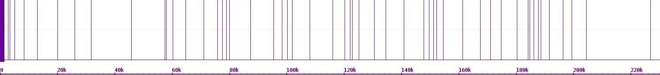Fig. 247. Mapping of Hi-C contact points on chr 1 and chr 1

Chr 2

Chr 1

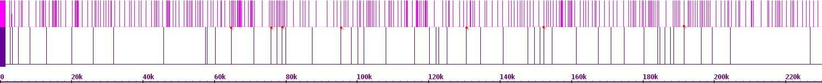Fig. 248. Mapping of Hi-C contact points on chr 1 and chr 2

Chr 3

Chr 1

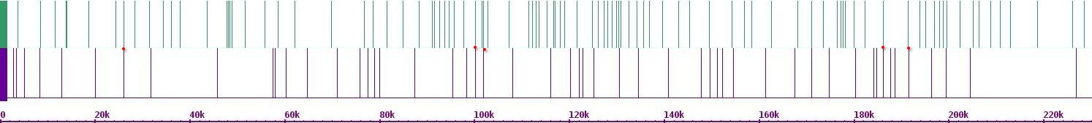Fig. 249. Mapping of Hi-C contact points on chr 1 and chr 3

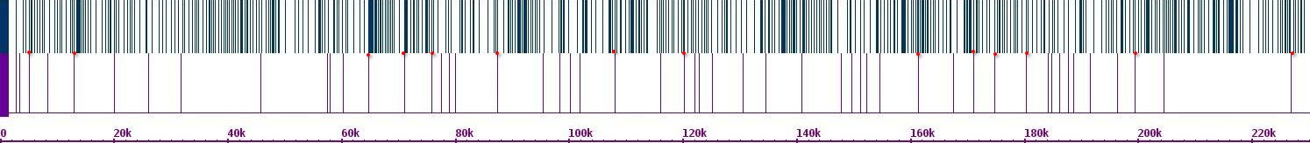Fig. 250. Mapping of Hi-C contact points on chr 1 and chr 4

Chr 4

Chr 1

Chr 5

Chr 1

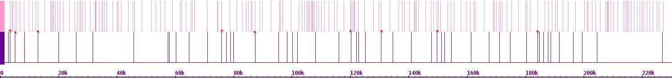Fig. 251. Mapping of Hi-C contact points on chr 1 and chr 5

Chr 6

Chr 1

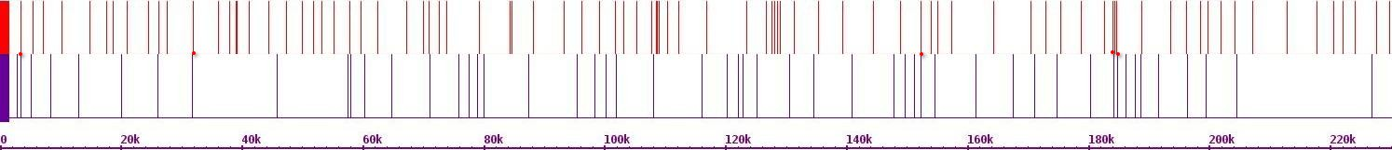Fig. 252. Mapping of Hi-C contact points on chr 1 and chr 6

Chr 7

Chr 1

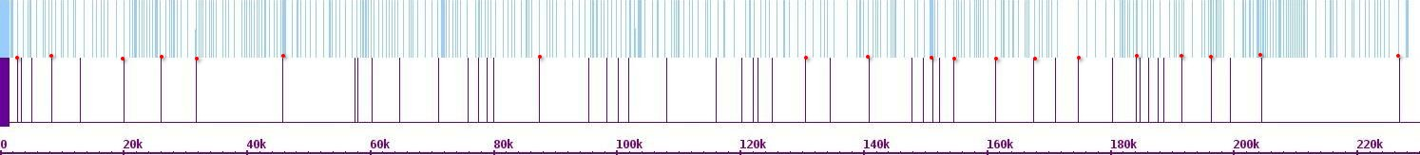Fig. 253. Mapping of Hi-C contact points on chr 1 and chr 7

Chr 8

Chr 1

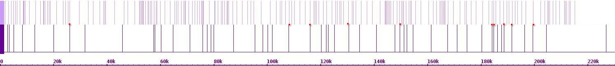Fig. 254. Mapping of Hi-C contact points on chr 1 and chr 8

Chr 9

Chr 1

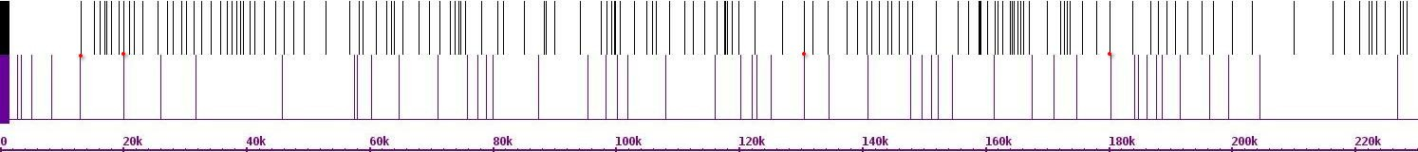Fig. 255. Mapping of Hi-C contact points on chr 1 and chr 9

Chr 10

Chr 1

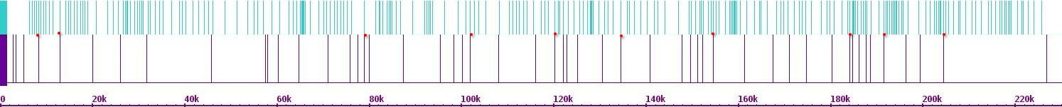Fig. 256. Mapping of Hi-C contact points on chr 1 and chr 10

****Fig. 257. Mapping of Hi-C contact points on chr 1 and chr 11

Chr 11

Chr 1

Chr 12

Chr 1

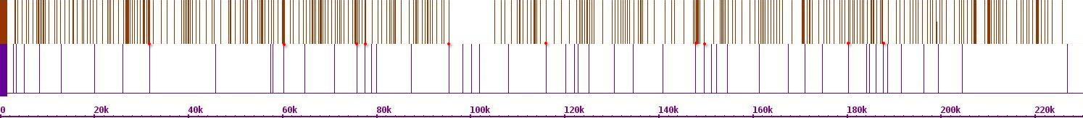Fig. 258. Mapping of Hi-C contact points on chr 1 and chr 12

Chr 13

Chr 1

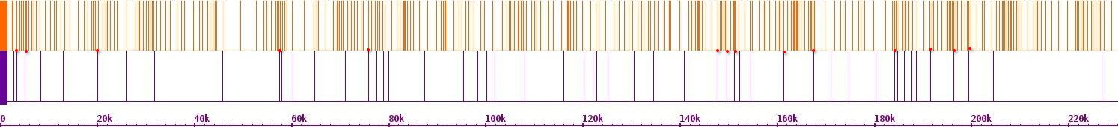Fig. 259. Mapping of Hi-C contact points on chr 1 and chr 13

Chr 14

Chr 1

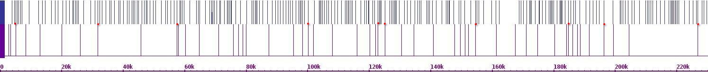Fig. 260. Mapping of Hi-C contact points on chr 1 and chr 14

Chr 15

Chr 1

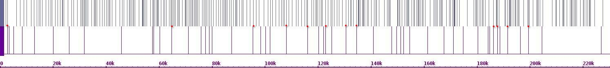Fig. 261. Mapping of Hi-C contact points on chr 1 and chr 15

Chr 16

Chr 1

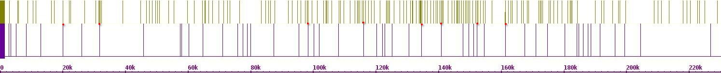Fig. 262. Mapping of Hi-C contact points on chr 1 and chr 16

Chr 1

Chr 2

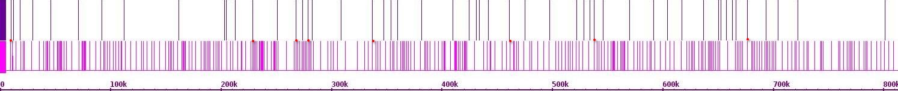Fig. 263. Mapping of Hi-C contact points on chr 2 and chr 1

****Fig. 264. Mapping of Hi-C contact points on chr 2 and chr 2

Chr 2

Chr 2

Chr 3

Chr 2

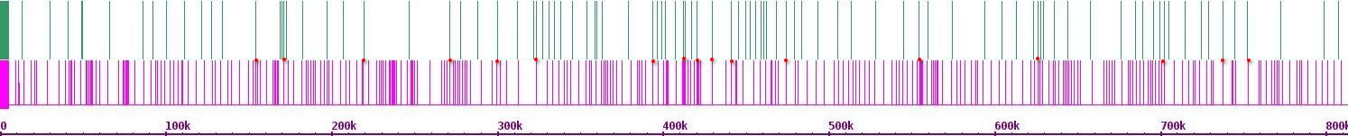Fig. 265. Mapping of Hi-C contact points on chr 2 and chr 3

Chr 4

Chr 2

****Fig. 266. Mapping of Hi-C contact points on chr 2 and chr 4

Chr 5

Chr 2

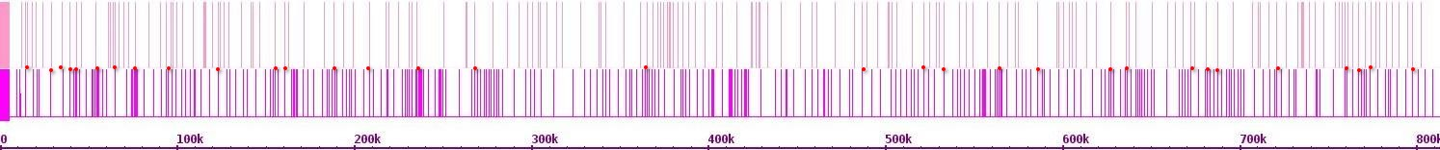Fig. 267. Mapping of Hi-C contact points on chr 2 and chr 5

****Fig. 268. Mapping of Hi-C contact points on chr 2 and chr 6

Chr 6

Chr 2

Chr 7

Chr 2

****Fig. 269. Mapping of Hi-C contact points on chr 2 and chr 7

Chr 8

Chr 2

****Fig. 270. Mapping of Hi-C contact points on chr 2 and chr 8

****Fig. 271. Mapping of Hi-C contact points on chr 2 and chr 9

Chr 9

Chr 2

Chr 10

Chr 2

****Fig. 272. Mapping of Hi-C contact points on chr 2 and chr 10

Chr 11

Chr 2

****Fig. 273. Mapping of Hi-C contact points on chr 2 and chr 11

Chr 12

Chr 2

****Fig. 274. Mapping of Hi-C contact points on chr 2 and chr 12

Chr 13

Chr 2

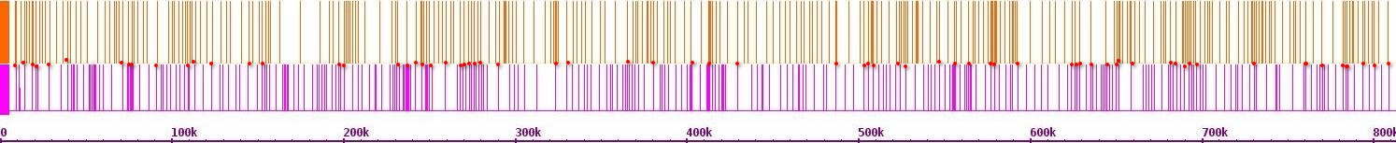Fig. 275. Mapping of Hi-C contact points on chr 2 and chr 13

Chr 14

Chr 2

****Fig. 276. Mapping of Hi-C contact points on chr 2 and chr 14

Chr 15

Chr 2

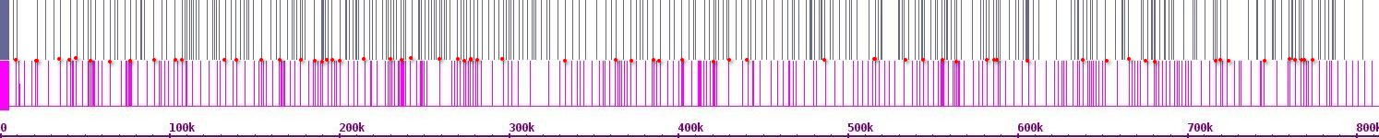Fig. 277. Mapping of Hi-C contact points on chr 2 and chr 15

Chr 16

Chr 2

****Fig. 278. Mapping of Hi-C contact points on chr 2 and chr 16

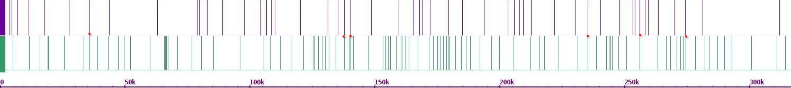Fig. 279. Mapping of Hi-C contact points on chr 3 and chr 1

Chr 1

Chr 3

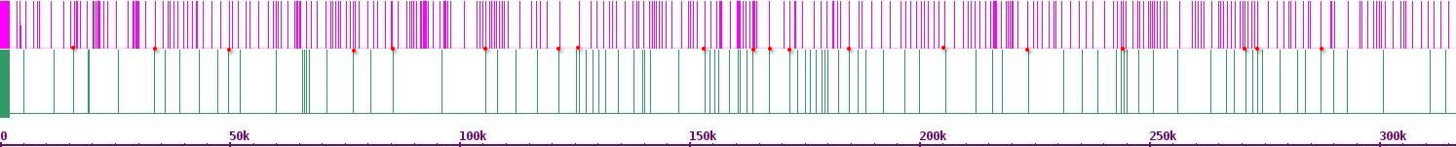Fig. 280. Mapping of Hi-C contact points on chr 3 and chr 2

Chr 2

Chr 3

Chr 3

Chr 3

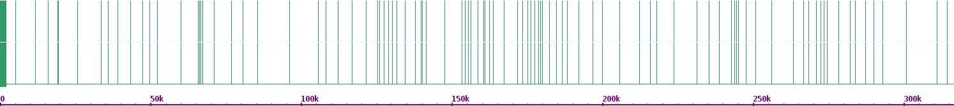Fig. 281. Mapping of Hi-C contact points on chr 3 and chr 3

Chr 4

Chr 3

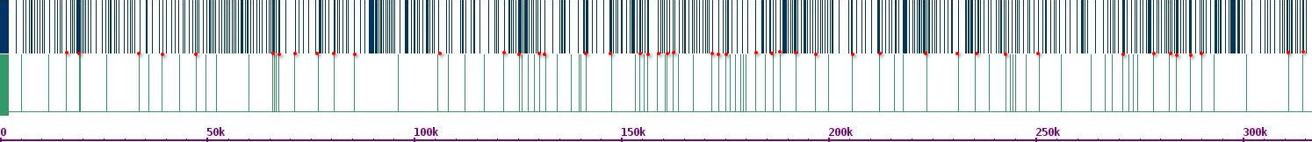Fig. 282. Mapping of Hi-C contact points on chr 3 and chr 4

Chr 5

Chr 3

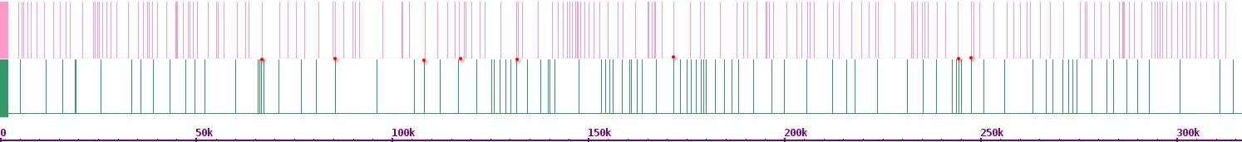Fig. 283. Mapping of Hi-C contact points on chr 3 and chr 5

Chr 6

Chr 3

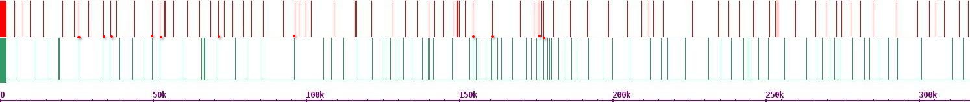Fig. 284. Mapping of Hi-C contact points on chr 3 and chr 6

Chr 7

Chr 3

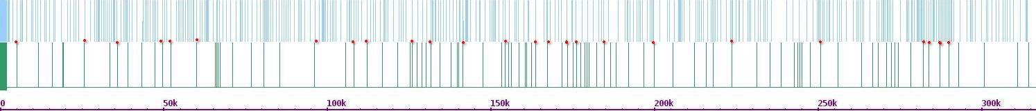Fig. 285. Mapping of Hi-C contact points on chr 3 and chr 7

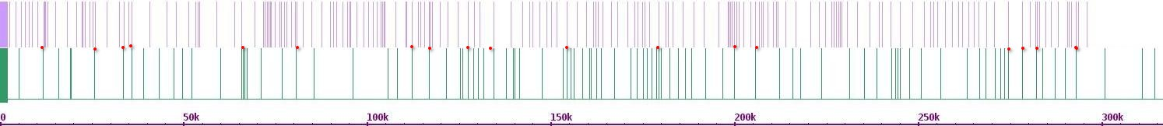Fig. 286. Mapping of Hi-C contact points on chr 3 and chr 8

Chr 8

Chr 3

Chr 9

Chr 3

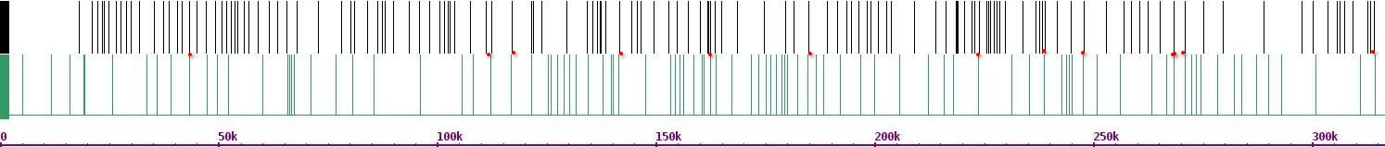Fig. 287. Mapping of Hi-C contact points on chr 3 and chr 9

Chr 10

Chr 3

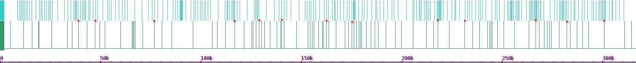Fig. 289. Mapping of Hi-C contact points on chr 3 and chr 10

Chr 11

Chr 3

****Fig. 290. Mapping of Hi-C contact points on chr 3 and chr 11

Chr 12

Chr 3

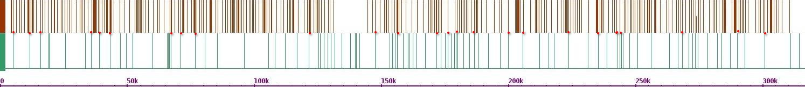Fig. 291. Mapping of Hi-C contact points on chr 3 and chr 12

Chr 13

Chr 3

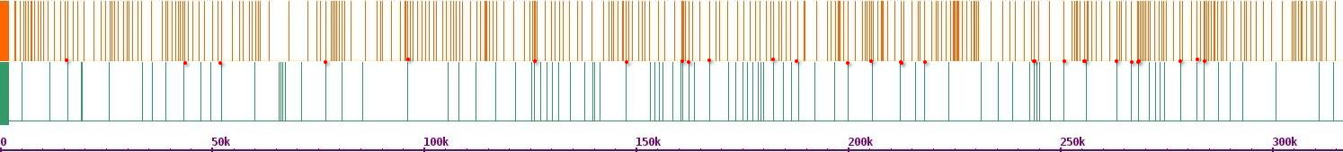Fig. 292. Mapping of Hi-C contact points on chr 3 and chr 13

Chr 14

Chr 3

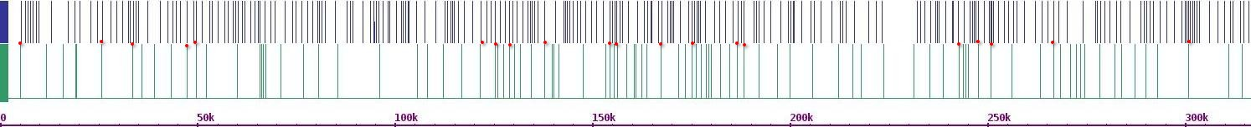Fig. 293. Mapping of Hi-C contact points on chr 3 and chr 14

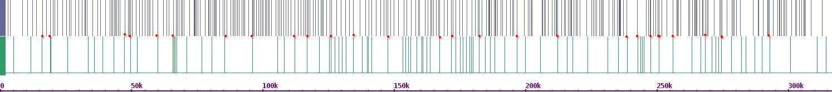Fig. 294. Mapping of Hi-C contact points on chr 3 and chr 15

Chr 15

Chr 3

Chr 16

Chr 3

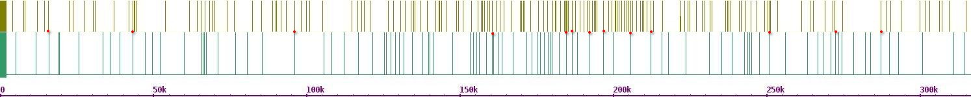Fig. 295. Mapping of Hi-C contact points on chr 3 and chr 16

Chr 1

Chr 4

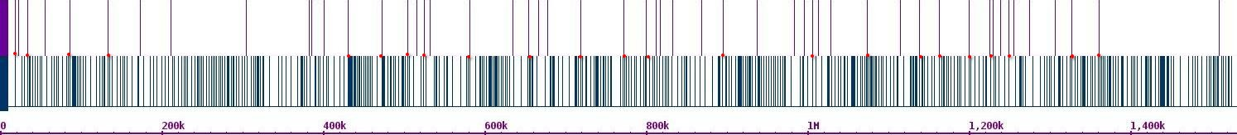Fig. 296. Mapping of Hi-C contact points on chr 4 and chr 1

Chr 2

Chr 4

****Fig. 297. Mapping of Hi-C contact points on chr 4 and chr 2

Chr 3

Chr 4

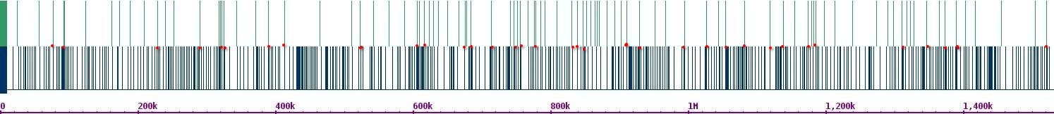Fig. 298. Mapping of Hi-C contact points on chr 4 and chr 3

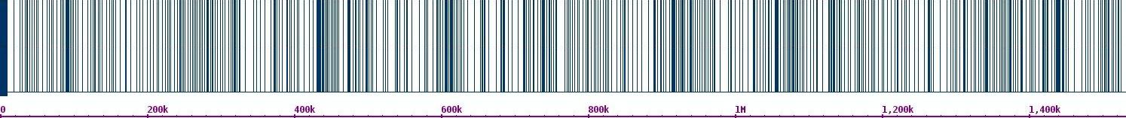Fig. 299. Mapping of Hi-C contact points on chr 4 and chr 4

Chr 4

Chr 4

Chr 5

Chr 4

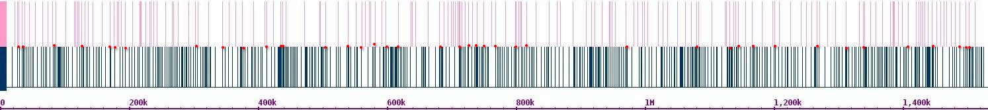Fig. 300. Mapping of Hi-C contact points on chr 4 and chr 5

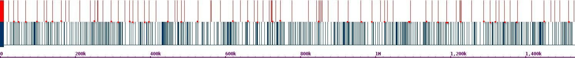Fig. 301. Mapping of Hi-C contact points on chr 4 and chr 6

Chr 6

Chr 4

Chr 7

Chr 4

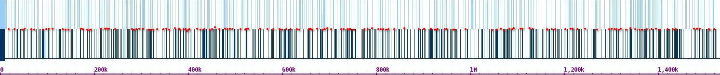Fig. 302. Mapping of Hi-C contact points on chr 4 and chr 7

Chr 8

Chr 4

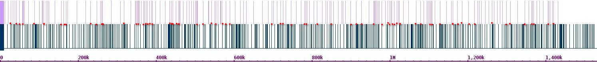Fig. 303. Mapping of Hi-C contact points on chr 4 and chr 8

Chr 9

Chr 4

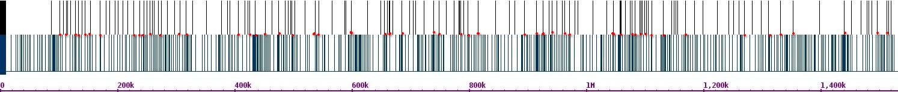Fig. 304. Mapping of Hi-C contact points on chr 4 and chr 9

Chr 10

Chr 4

****Fig. 305. Mapping of Hi-C contact points on chr 4 and chr 10

Chr 11

Chr 4

****Fig. 306. Mapping of Hi-C contact points on chr 4 and chr 11

Chr 12

Chr 4

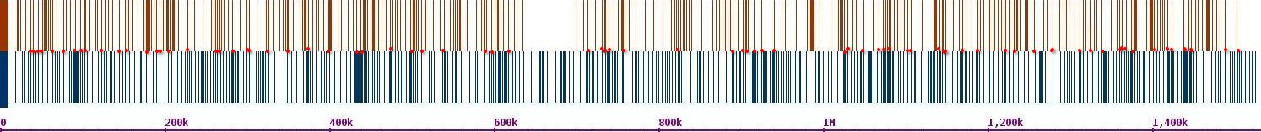Fig. 307. Mapping of Hi-C contact points on chr 4 and chr 12

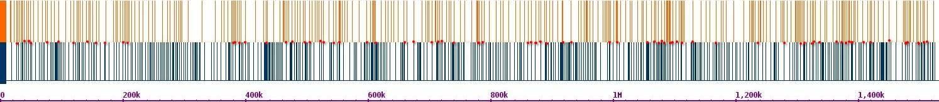Fig. 308. Mapping of Hi-C contact points on chr 4 and chr 13

Chr 13

Chr 4

Chr 14

Chr 4

****Fig. 309. Mapping of Hi-C contact points on chr 4 and chr 14

Chr 15

Chr 4

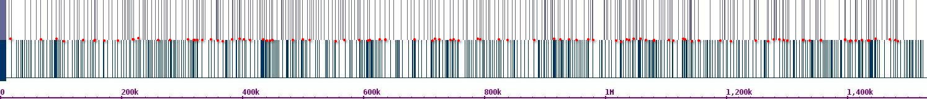Fig. 310. Mapping of Hi-C contact points on chr 4 and chr 15

Chr 16

Chr 4

****Fig. 311. Mapping of Hi-C contact points on chr 4 and chr 16

Chr 1

Chr 5

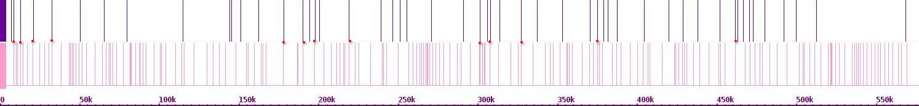Fig. 312. Mapping of Hi-C contact points on chr 5 and chr 1

Chr 2

Chr 5

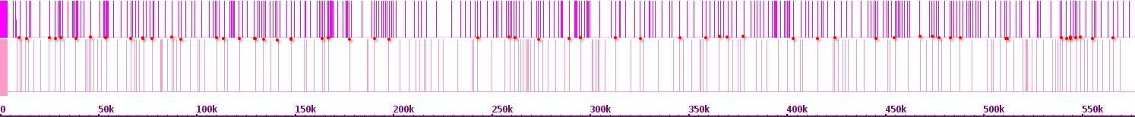Fig. 313. Mapping of Hi-C contact points on chr 5 and chr 2

Chr 3

Chr 5

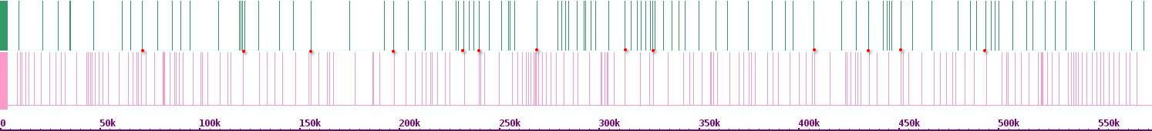Fig. 314. Mapping of Hi-C contact points on chr 5 and chr 3

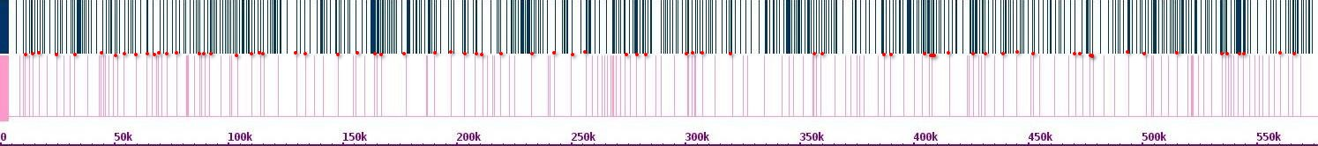Fig. 315. Mapping of Hi-C contact points on chr 5 and chr 4

Chr 4

Chr 5

Chr 5

Chr 5

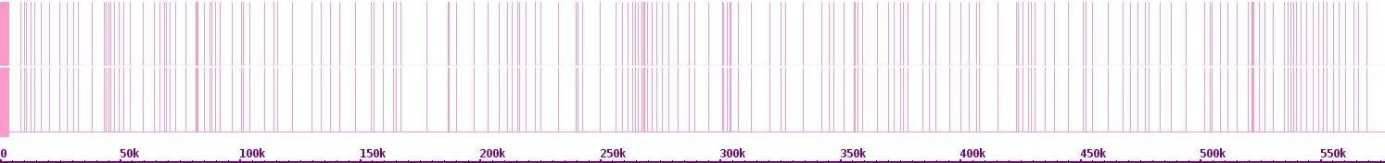Fig. 316. Mapping of Hi-C contact points on chr 5 and chr 5

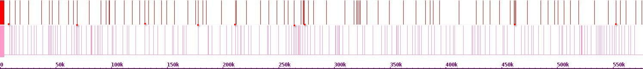Fig. 317. Mapping of Hi-C contact points on chr 5 and chr 6

Chr 6

Chr 5

Chr 7

Chr 5

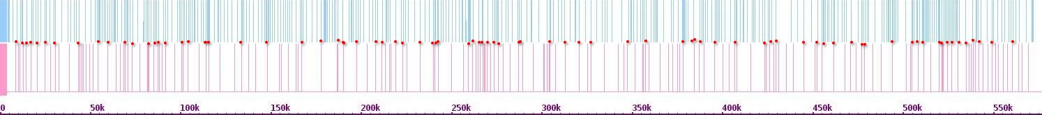Fig. 318. Mapping of Hi-C contact points on chr 5 and chr 7

Chr 8

Chr 5

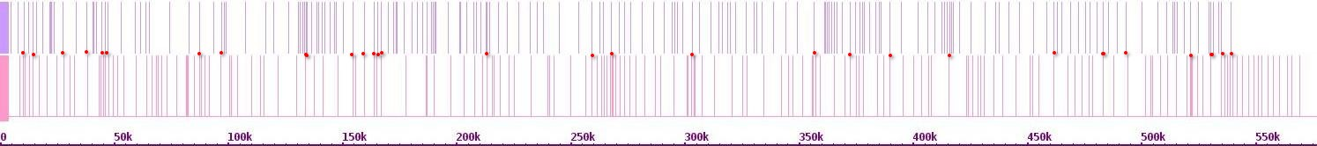Fig. 319. Mapping of Hi-C contact points on chr 5 and chr 8

Chr 9

Chr 5

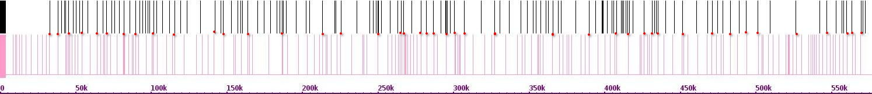Fig. 320. Mapping of Hi-C contact points on chr 5 and chr 9

Chr 10

Chr 5

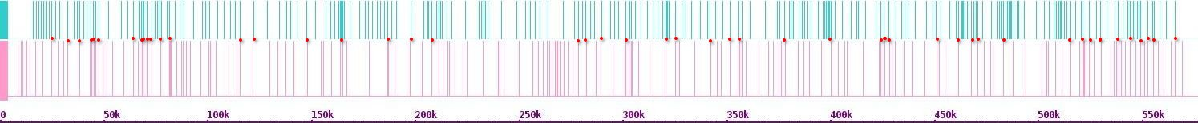Fig. 321. Mapping of Hi-C contact t points on chr 5 and chr 10

****Fig. 322. Mapping of Hi-C contact points on chr 5 and chr 11

Chr 11

Chr 5

Chr 12

Chr 5

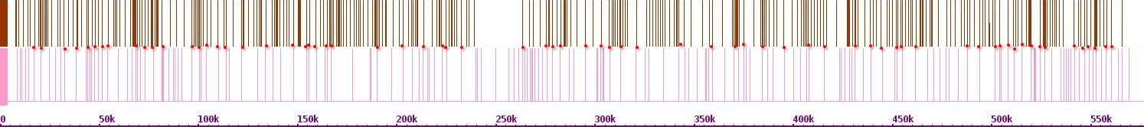Fig. 323. Mapping of Hi-C contact points on chr 5 and chr 12

Chr 13

Chr 5

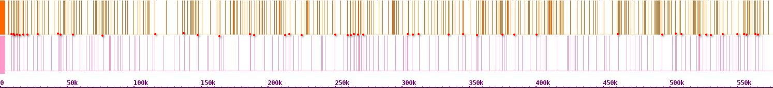Fig. 324. Mapping of Hi-C contact points on chr 5 and chr 13

Chr 14

Chr 5

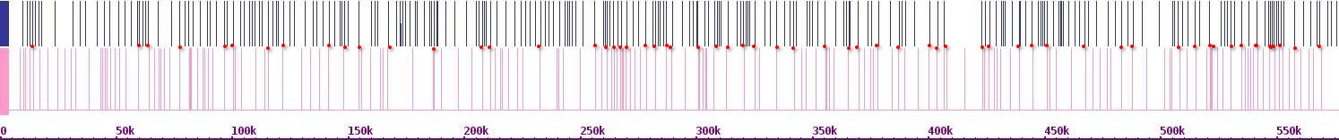Fig. 325. Mapping of Hi-C contact points on chr 5 and chr 14

Chr 15

Chr 5

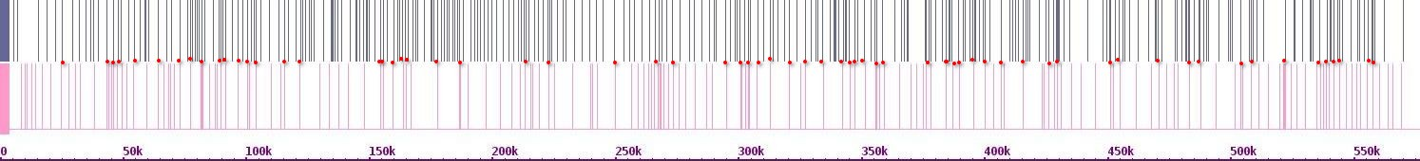Fig. 326. Mapping of Hi-C contact points on chr 5 and chr 15

Chr 16

Chr 5

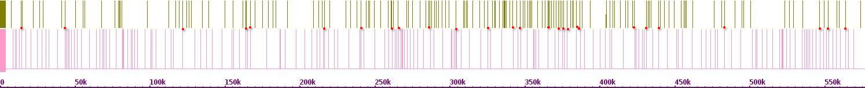Fig. 327. Mapping of Hi-C contact points on chr 5 and chr 16

Chr 1

Chr 6

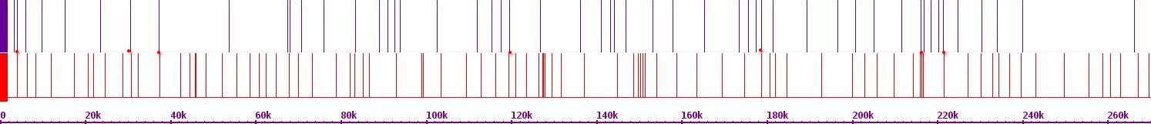Fig. 328. Mapping of Hi-C contact points on chr 6 and chr 1

****Fig. 329. Mapping of Hi-C contact points on chr 6 and chr 2

Chr 2

Chr 6

Chr 3

Chr 6

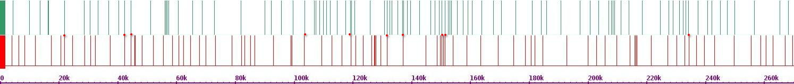Fig. 330. Mapping of Hi-C contact points on chr 6 and chr 3

Chr 4

Chr 6

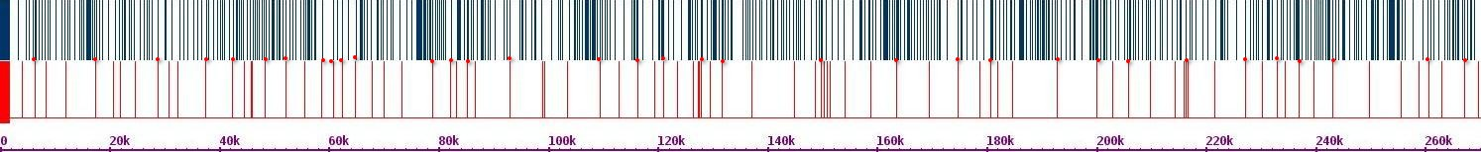Fig. 331. Mapping of Hi-C contact t points on chr 6 and chr 4

Chr 5

Chr 6

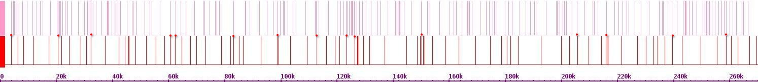Fig. 332. Mapping of Hi-C contact on chr 6 and chr 5

Chr 6

Chr 6

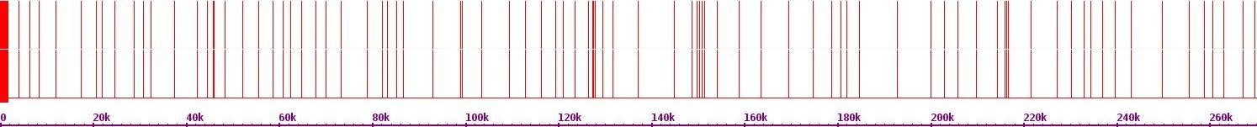Fig. 333. Mapping of Hi-C contact points on chr 6 and chr 6

Chr 7

Chr 6

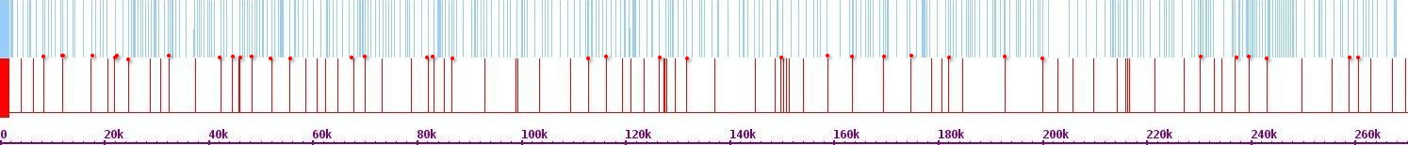Fig. 334. Mapping of Hi-C contact points on chr 6 and chr 7

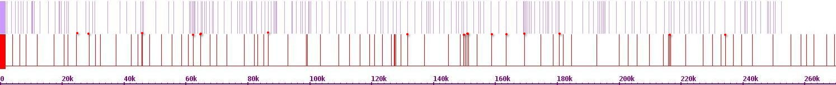Fig. 335. Mapping Hi-C contact points on chr 6 and chr 8

Chr 8

Chr 6

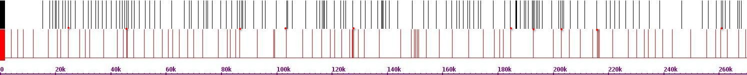Fig. 336. Mapping of Hi-C contact points on chr 6 and chr 9

Chr 9

Chr 6

Chr 10

Chr 6

****Fig. 337. Mapping of Hi-C contact points on chr 6 and chr 10

Chr 11

Chr 6

****Fig. 338. Mapping of Hi-C contact t points on chr 6 and chr 11

Chr 12

Chr 6

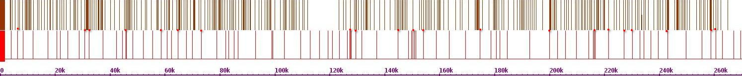Fig. 339. Mapping of Hi-C contact points on chr 6 and chr 12

Chr 13

Chr 6

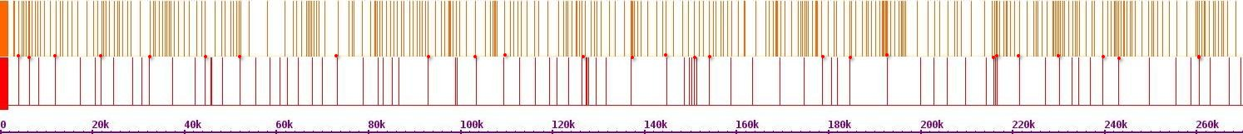Fig. 340. Mapping of Hi-C contact points on chr 6 and chr 13

Chr 14

Chr 6

****Fig. 341. Mapping of Hi-C contact points on chr 6 and chr 14

Chr 15

Chr 6

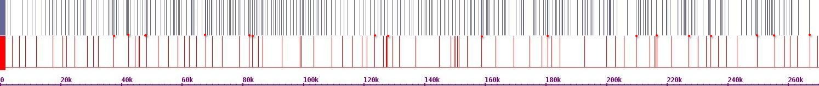Fig. 342. Mapping of Hi-C contact points on chr 6 and chr 15

****Fig. 343. Mapping of Hi-C contact points on chr 6 and chr 16

Chr 16

Chr 6

Chr 1

Chr 7

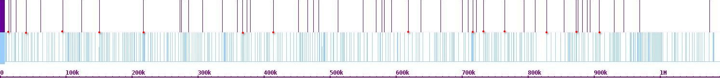Fig. 344. Mapping of Hi-C contact points on chr 7 and chr 1

Chr 2

Chr 7

****Fig. 345. Mapping of Hi-C contact t points on chr 7 and chr 2

Chr 3

Chr 7

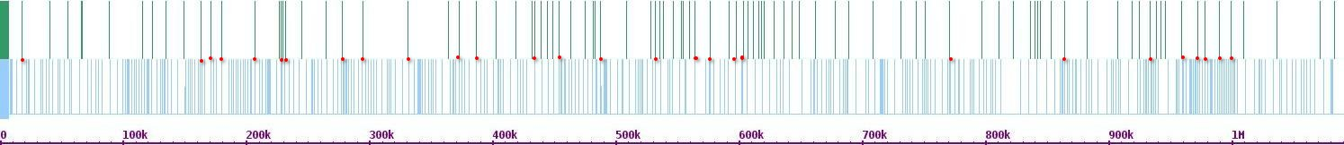Fig. 346. Mapping of Hi-C contact points on chr 7 and chr 3

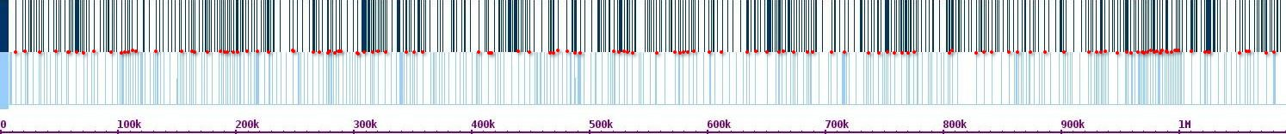Fig. 347. Mapping of Hi-C contact points on chr 7 and chr 4

Chr 4

Chr 7

Chr 5

Chr 7

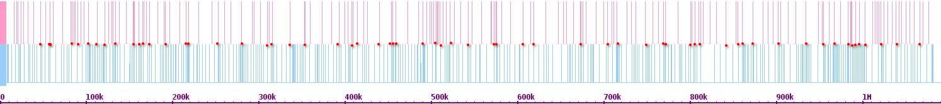Fig. 348. Mapping of Hi-C contact points on chr 7 and chr 5

Chr 6

Chr 7

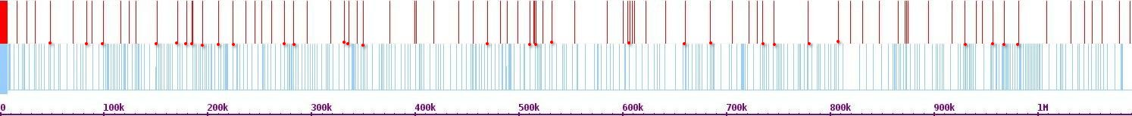

Fig. 349. Mapping of Hi-C contact points on chr 7 and chr 6

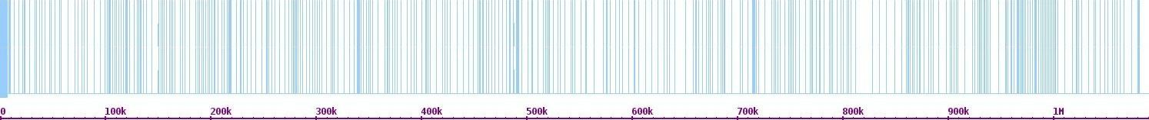Fig. 350. Mapping of Hi-C contact points on chr 7 and chr 7

Chr 7

Chr 7

Chr 8

Chr 7

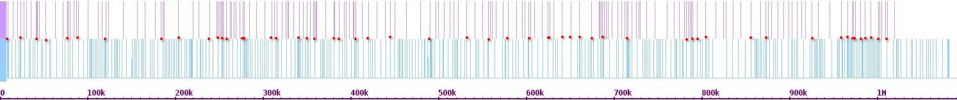Fig. 351. Mapping of Hi-C contact points on chr 7 and chr 8

Chr 9

Chr 7

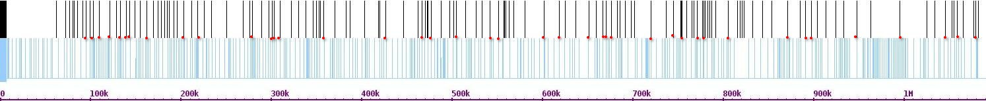Fig. 352. Mapping of Hi-C contact points on chr 7 and chr 9

Chr 10

Chr 7

****Fig. 353. Mapping of Hi-C contact points on chr 7 and chr 10

Chr 11

Chr 7

****Fig. 353. Mapping of Hi-C contact points on chr 7 and chr 11

Chr 12

Chr 7

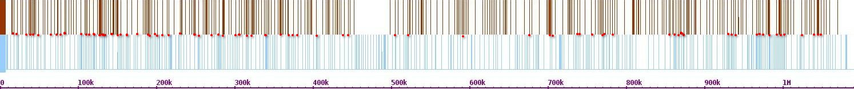Fig. 354. Mapping of Hi-C contact points on chr 7 and chr 12

Chr 12

Chr 7

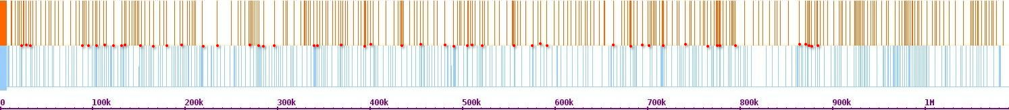Fig. 355. Mapping of Hi-C contact points on chr 7 and chr 13

****Fig. 356. Mapping of Hi-C contact points on chr 7 and chr 14

Chr 14

Chr 7

Chr 15

Chr 7

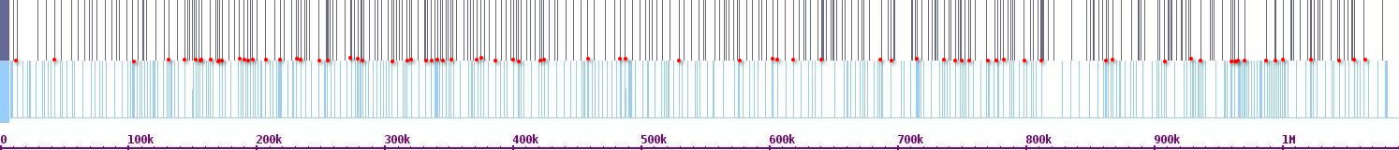Fig. 357. Mapping of Hi-C contact points on chr 7 and chr 15

Chr 16

Chr 7

****Fig. 358. Mapping of Hi-C contact points on chr 7 and chr 16

Chr 1

Chr 8

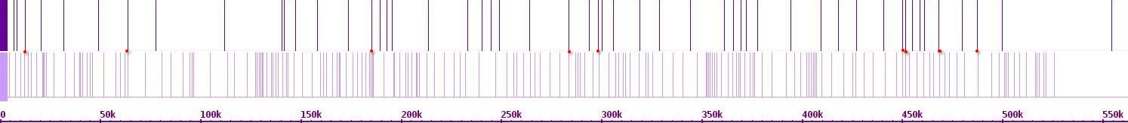Fig. 359. Mapping of Hi-C contact points on chr 8 and chr 1

Chr 2

Chr 8

****Fig. 360. Mapping of Hi-C contact points on chr 8 and chr 2

Chr 3

Chr 8

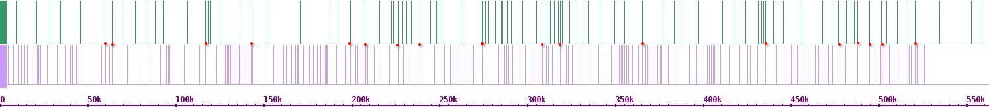Fig. 361. Mapping of Hi-C contact points on chr 8 and chr 3

Chr 4

Chr 8

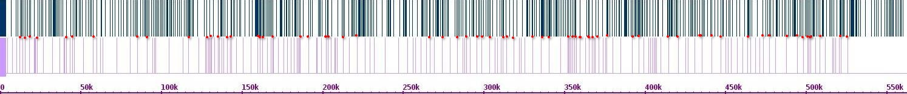Fig. 362. Mapping of Hi-C contact points on chr 8 and chr 4

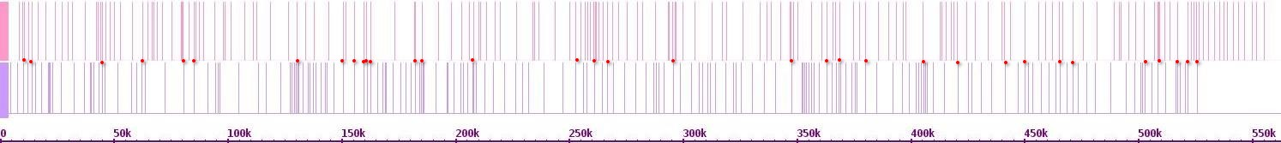Fig. 363. Mapping of Hi-C contact points on chr 8 and chr 5

Chr 5

Chr 8

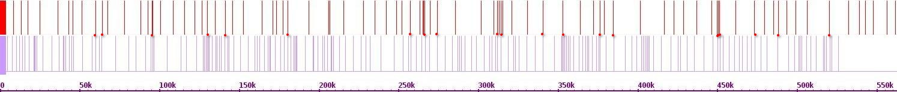Fig. 364. Mapping of Hi-C contact points on chr 8 and chr 6

Chr 6

Chr 8

Chr 7

Chr 8

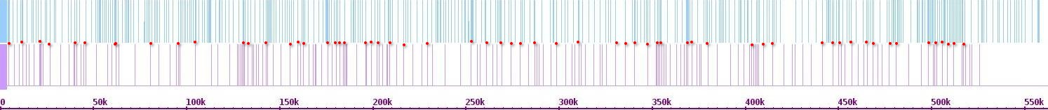Fig. 365. Mapping of Hi-C contact points on chr 8 and chr 7

Chr 8

Chr 8

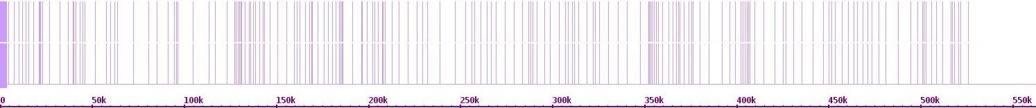Fig. 366. Mapping of Hi-C contact points on chr 8 and chr 8

Chr 9

Chr 8

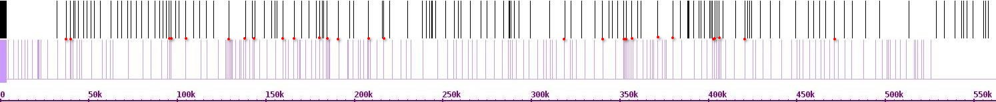Fig. 367. Mapping of Hi-C contact points on chr 8 and chr 9

Chr 10

Chr 8

****Fig. 368. Mapping of Hi-C contact points on chr 8 and chr 10

Chr 11

Chr 8

****Fig. 369. Mapping of Hi-C contact points on chr 8 and chr 11

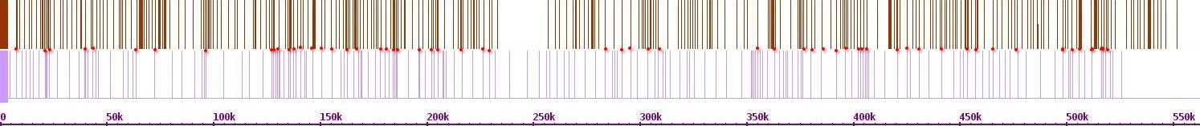Fig. 370. Mapping of Hi-C contact points on chr 8 and chr 12

Chr 12

Chr 8

Chr 13

Chr 8

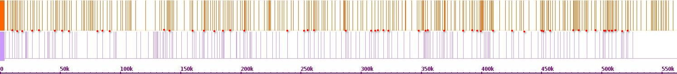Fig. 371. Mapping of Hi-C contact points on chr 8 and chr 13

Chr 14

Chr 8

****Fig. 372. Mapping of Hi-C contact points on chr 8 and chr 14

Chr 15

Chr 8

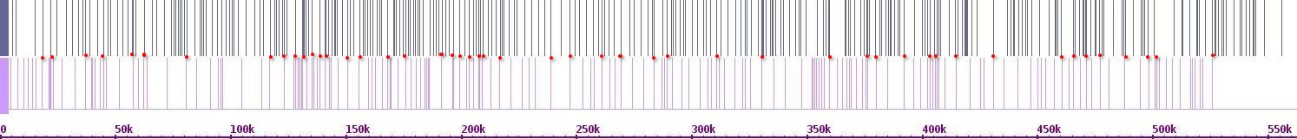Fig. 372. Mapping of Hi-C contact points on chr 8 and chr 15

Chr 16

Chr 8

****Fig. 373. Mapping of Hi-C contact points on chr 8 and chr 16

Chr 1

Chr 9

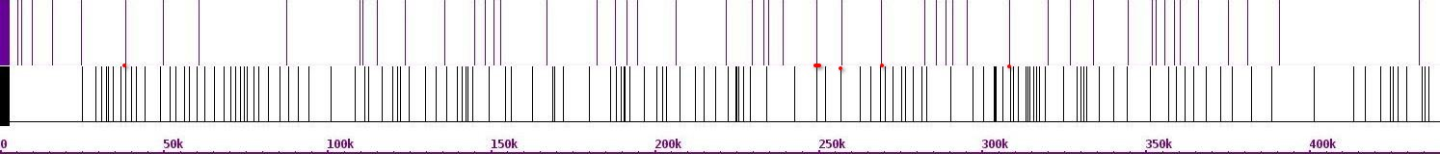Fig. 374. Mapping of Hi-C contact points on chr 9 and chr 1

****Fig. 375. Mapping of Hi-C contact points on chr 9 and chr 2

Chr 2

Chr 9

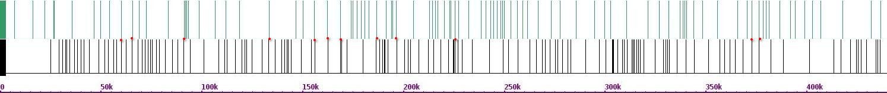Fig. 376. Mapping of Hi-C contact points on chr 9 and chr 3

Chr 3

Chr 9

Chr 4

Chr 9

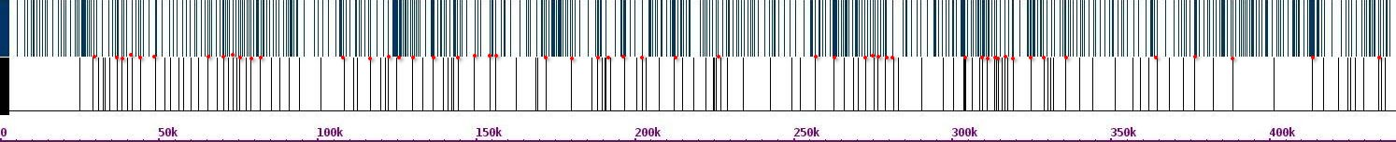Fig. 377. Mapping of Hi-C contact points on chr 9 and chr 4

Chr 5

Chr 9

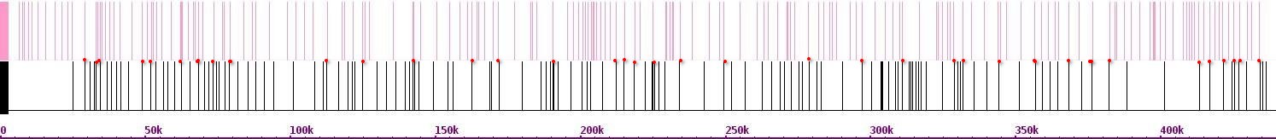Fig. 378. Mapping of Hi-C contact points on chr 9 and chr 5

Chr 6

Chr 9

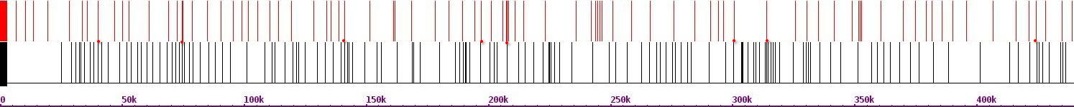Fig. 379. Mapping of Hi-C contact points on chr 9 and chr 6

Chr 7

Chr 9

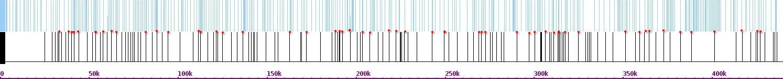Fig. 380. Mapping of Hi-C contact points on chr 9 and chr 7

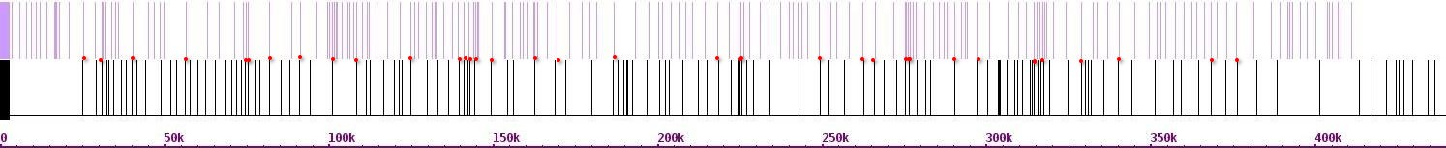Fig. 381. Mapping of Hi-C contact points on chr 9 and chr 8

Chr 8

Chr 9

Chr 9

Chr 9

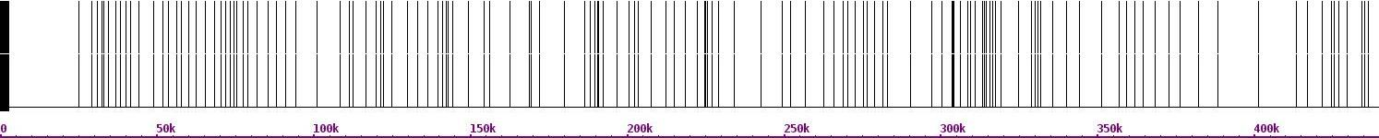Fig. 382. Mapping of Hi-C contact points on chr 9 and chr 9

****Fig. 383. Mapping of Hi-C contact points on chr 9 and chr 10

Chr 10

Chr 9

Chr 11

Chr 9

****Fig. 384. Mapping of Hi-C contact points on chr 9 and chr 11

Chr 12

Chr 9

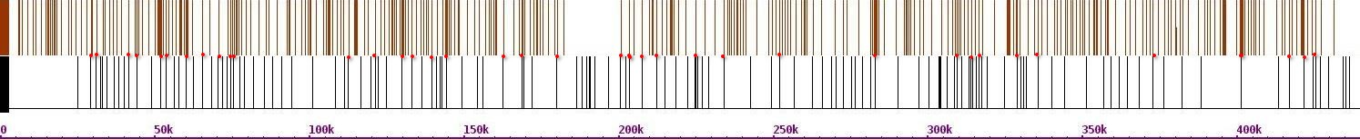Fig. 385. Mapping of Hi-C contact points on chr 9 and chr 12

Chr 13

Chr 9

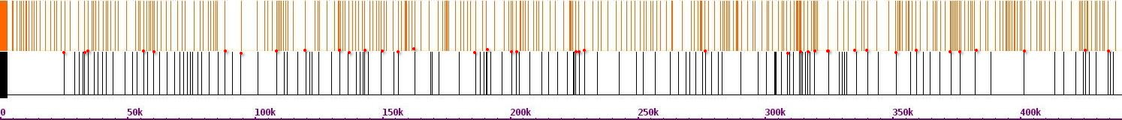Fig. 386. Mapping of Hi-C contact points on chr 9 and chr 13

Chr 14

Chr 9

****Fig. 387. Mapping of Hi-C contact points on chr 9 and chr 14

Chr 15

Chr 9

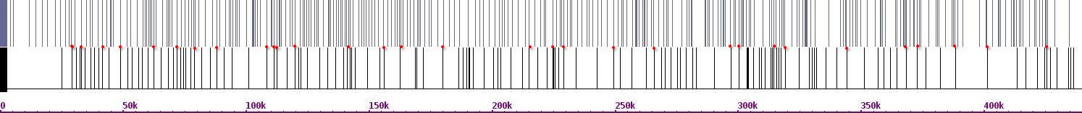Fig. 388. Mapping of Hi-C contact points on chr 9 and chr 15

Chr 16

Chr 9

****Fig. 388. Mapping of Hi-C contact points on chr 9 and chr 16

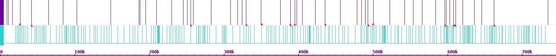Fig. 389. Mapping of Hi-C contact points on chr 10 and chr 1

Chr 1

Chr 10

Chr 2

Chr 10

****Fig. 390. Mapping of Hi-C contact points on chr 10 and chr 2

Chr 3

Chr 10

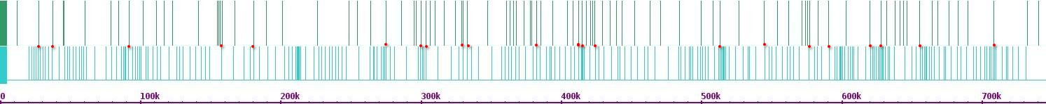Fig. 391. Mapping of Hi-C contact points on chr 10 and chr 3

Chr 4

Chr 10

****Fig. 392. Mapping of Hi-C contact points on chr 10 and chr 4

Chr 5

Chr 10

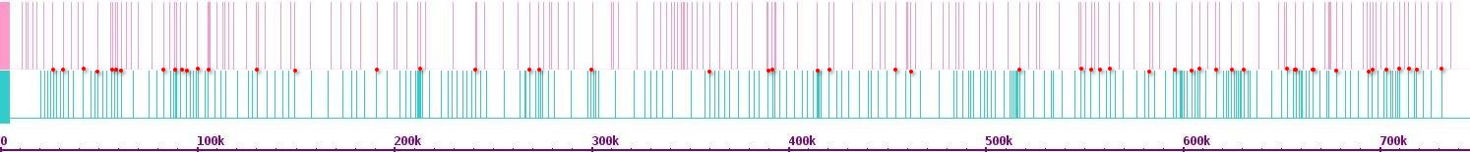Fig. 393. Mapping of Hi-C contact points on chr 10 and chr 5

Chr 6

Chr 10

****Fig. 394. Mapping of Hi-C contact points on chr 10 and chr 6

Chr 7

Chr 10

****Fig. 395. Mapping of Hi-C contact points on chr 10 and chr 7

****Fig. 396. Mapping of Hi-C contact points on chr 10 and chr 8

Chr 8

Chr 10

Chr 9

Chr 10

****Fig. 397. Mapping of Hi-C contact points on chr 10 and chr 9

Chr 10

Chr 10

****Fig. 398. Mapping of Hi-C contact points on chr 10 and chr 10

Chr 11

Chr 10

****Fig. 399. Mapping of Hi-C contact points on chr 10 and chr 11

Chr 12

Chr 10

****Fig. 400. Mapping of Hi-C contact points on chr 10 and chr 12

Chr 13

Chr 10

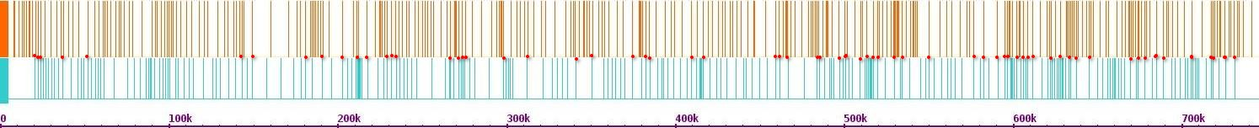Fig. 401. Mapping of Hi-C contact points on chr 10 and chr 13

Chr 14

Chr 10

****Fig. 402. Mapping of Hi-C contact points on chr 10 and chr 14

Chr 15

Chr 10

****Fig. 403. Mapping of Hi-C contact points on chr 10 and chr 15

****Fig. 404. Mapping of Hi-C contact points on chr 10 and chr 16

Chr 16

Chr 10

Chr 1

Chr 11

****Fig. 405. Mapping of Hi-C contact points on chr 11 and chr 1

Chr 2

Chr 11

****Fig. 406. Mapping of Hi-C contact points on chr 11 and chr 2

Chr 3

Chr 11

****Fig. 407. Mapping of Hi-C contact points on chr 11 and chr 3

Chr 4

Chr 11

****Fig. 408. Mapping of Hi-C contact points on chr 11 and chr 4

Chr 5

Chr 11

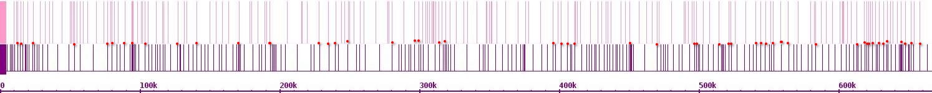Fig. 409. Mapping of Hi-C contact points on chr 11 and chr 5

Chr 6

Chr 11

****Fig. 410. Mapping of Hi-C contact points on chr 11 and chr 6

Chr 7

Chr 11

****Fig. 411. Mapping of Hi-C contact points on chr 11 and chr 7

****Fig. 412. Mapping of Hi-C contact points on chr 11 and chr 8

Chr 8

Chr 11

Chr 9

Chr 11

****Fig. 413. Mapping of Hi-C contact points on chr 11 and chr 9

Chr 10

Chr 11

****Fig. 414. Mapping of Hi-C contact points on chr 11 and chr 10

Chr 11

Chr 11

****Fig. 415. Mapping of Hi-C contact points on chr 11 and chr 11

Chr 12

Chr 11

****Fig. 416. Mapping of Hi-C contact points on chr 11 and chr 12

Chr 13

Chr 11

****Fig. 417. Mapping of Hi-C contact points on chr 11 and chr 13

Chr 14

Chr 11

****Fig. 418. Mapping of Hi-C contact points on chr 11 and chr 14

Chr 15

Chr 11

****Fig. 419. Mapping of Hi-C contact points on chr 11 and chr 15

****Fig. 420. Mapping of Hi-C contact points on chr 11 and chr 16

Chr 16

Chr 11

Chr 1

Chr 12

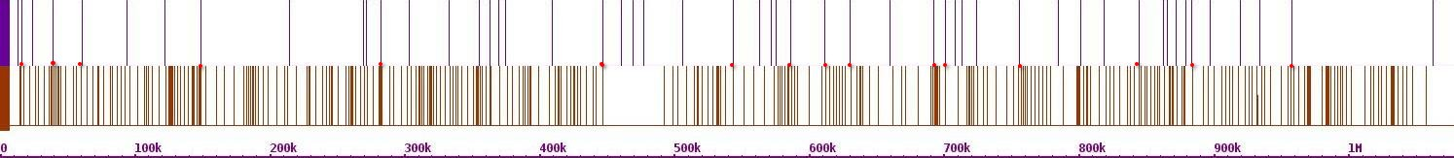Fig. 421. Mapping of Hi-C contact points on chr 12 and chr 1

Chr 2

Chr 12

****Fig. 422. Mapping of Hi-C contact points on chr 12 and chr 2

Chr 3

Chr 12

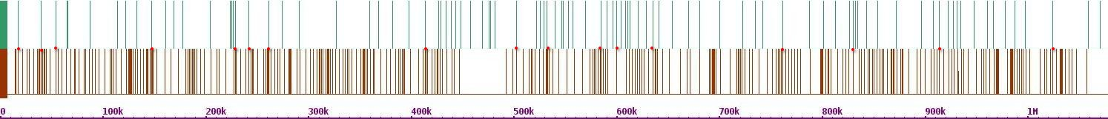Fig. 423. Mapping of Hi-C contact points on chr 12 and chr 3

Chr 4

Chr 12

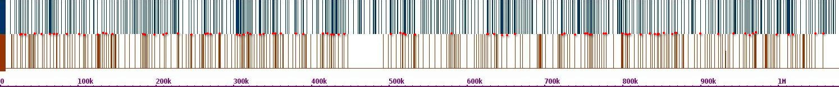Fig. 424. Mapping of Hi-C contact points on chr 12 and chr 4

Chr 5

Chr 12

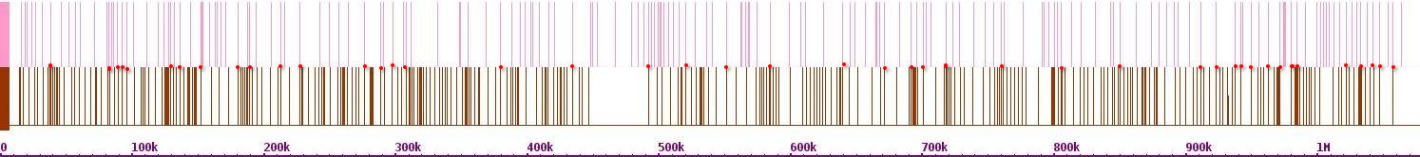Fig. 425. Mapping of Hi-C contact points on chr 12 and chr 5

Chr 6

Chr 12

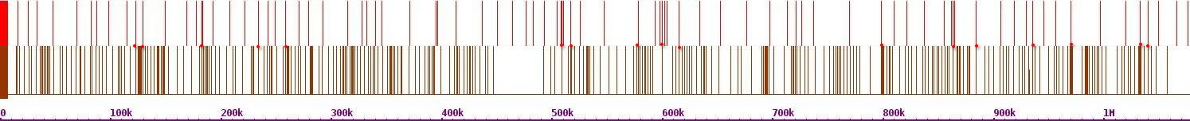Fig. 426. Mapping of Hi-C contact points on chr 12 and chr 6

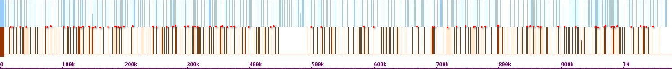Fig. 427. Mapping of Hi-C contact points on chr 12 and chr 7

Chr 7

Chr 12

Chr 8

Chr 12

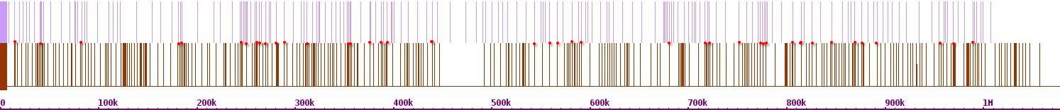Fig. 428. Mapping of Hi-C contact points on chr 12 and chr 8

Chr 9

Chr 12

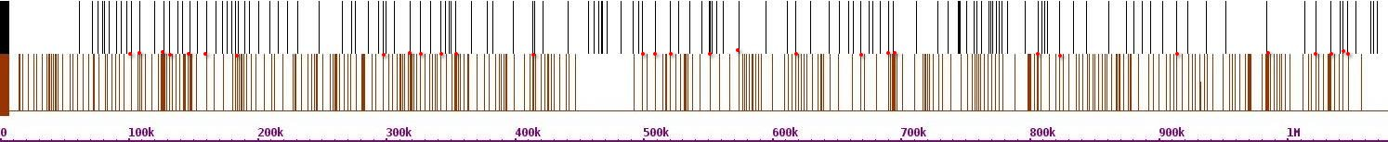Fig. 429. Mapping of Hi-C contact points on chr 12 and chr 9

Chr 10

Chr 12

****Fig. 430. Mapping of Hi-C contact points on chr 12 and chr 10

Chr 11

Chr 12

****Fig. 431. Mapping of Hi-C contact points on chr 12 and chr 11

Chr 12

Chr 12

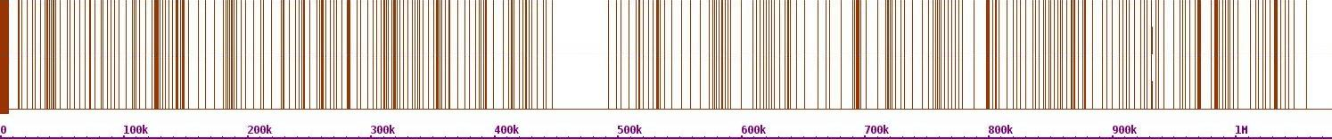Fig. 432. Mapping of Hi-C contact points on chr 12 and chr 12

Chr 13

Chr 12

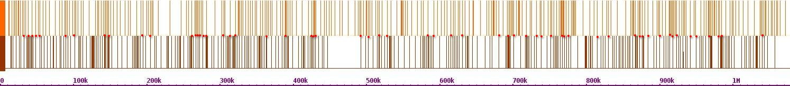

Fig. 433. Mapping of Hi-C contact points on chr 12 and chr 13

****Fig. 434. Mapping of Hi-C contact points on chr 12 and chr 14

Chr 14

Chr 12

Chr 15

Chr 12

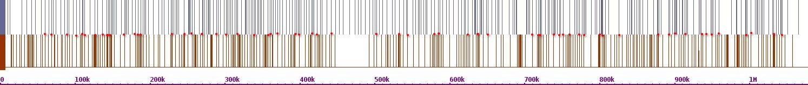Fig. 435. Mapping of Hi-C contact points on chr 12 and chr 15

Chr 16

Chr 12

****Fig. 436. Mapping of Hi-C contact points on chr 12 and chr 16

Chr 1

Chr 13

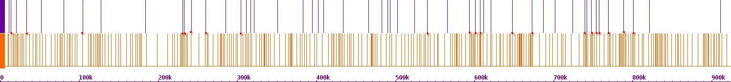Fig. 437. Mapping of Hi-C contact points on chr 13 and chr 1

Chr 2

Chr 13

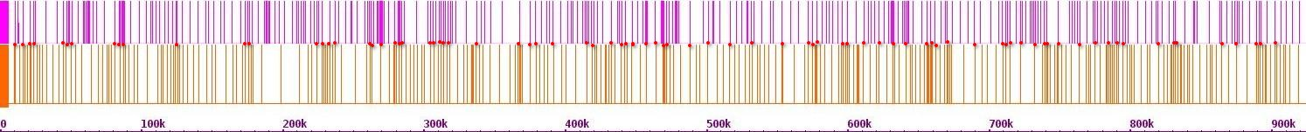Fig. 438. Mapping of Hi-C contact points on chr 13 and chr 2

Chr 3

Chr 13

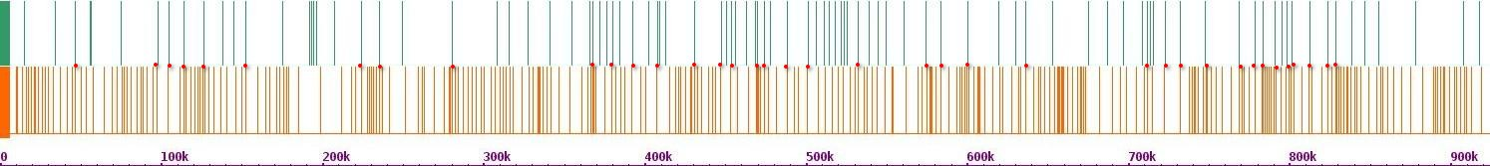Fig. 439. Mapping of Hi-C contact points on chr 13 and chr 3

Chr 4

Chr 13

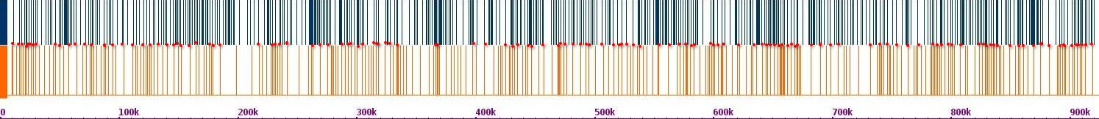Fig. 440. Mapping of Hi-C contact points on chr 13 and chr 4

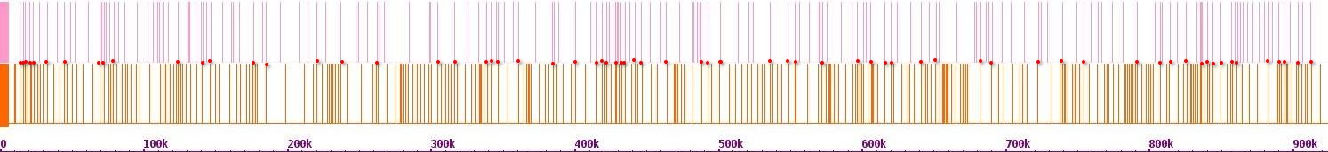Fig. 441. Mapping of Hi-C contact points on chr 13 and chr 5

Chr 5

Chr 13

Chr 6

Chr 13

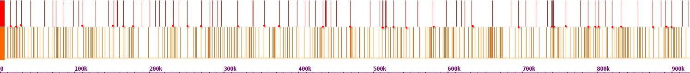Fig. 442. Mapping of Hi-C contact points on chr 13 and chr 6

Chr 7

Chr 13

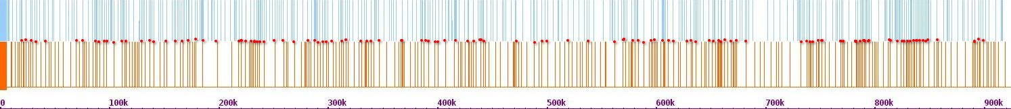Fig. 443. Mapping of Hi-C contact points on chr 13 and chr 7

Chr 8

Chr 13

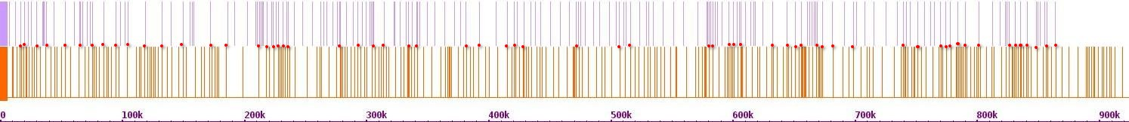Fig. 444. Mapping of Hi-C contact points on chr 13 and chr 8

Chr 9

Chr 13

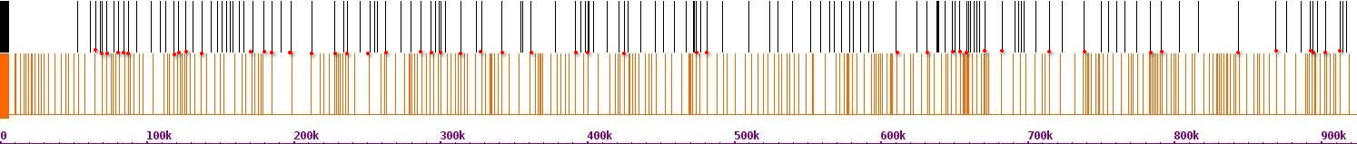Fig. 445. Mapping of Hi-C contact points on chr 13 and chr 9

Chr 10

Chr 13

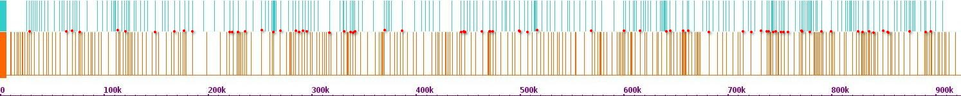Fig. 446. Mapping of Hi-C contact points on chr 13 and chr 10

Chr 11

Chr 13

****Fig. 447. Mapping of Hi-C contact points on chr 13 and chr 11

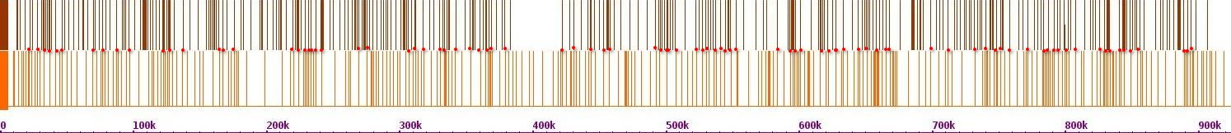Fig. 448. Mapping of Hi-C contact points on chr 13 and chr 12

Chr 12

Chr 13

Chr 13

Chr 13

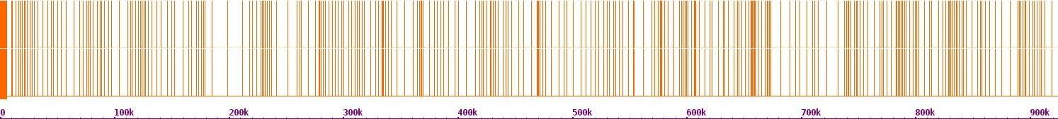Fig. 449. Mapping of Hi-C contact points on chr 13 and chr 13

Chr 14

Chr 13

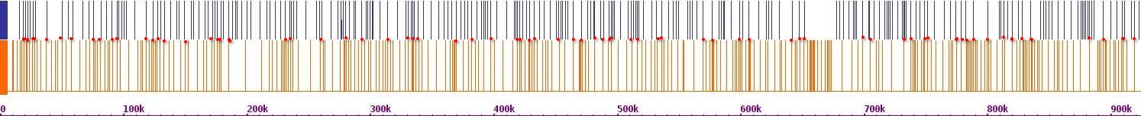Fig. 450. Mapping of Hi-C contact points on chr 13 and chr 14

Chr 15

Chr 13

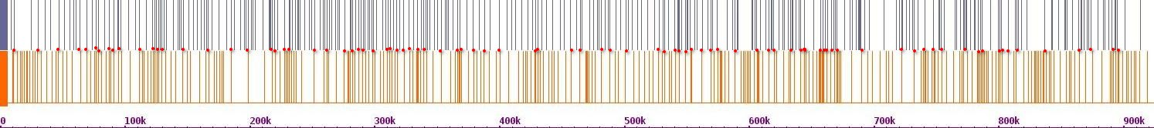Fig. 451. Mapping of Hi-C contact points on chr 13 and chr 15

Chr 16

Chr 13

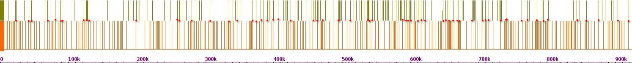Fig. 452. Mapping of Hi-C contact points on chr 13 and chr 16

Chr 1

Chr 14

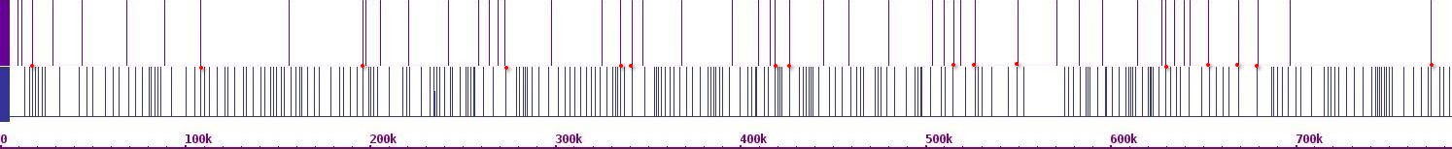Fig. 453. Mapping of Hi-C contact points on chr 14 and chr 1

Chr 2

Chr 14

****Fig. 454. Mapping of Hi-C contact points on chr 14 and chr 2

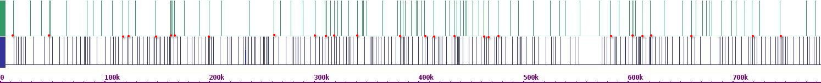Fig. 455. Mapping of Hi-C contact points on chr 14 and chr 3

Chr 3

Chr 14

Chr 4

Chr 14

****Fig. 456. Mapping of Hi-C contact points on chr 14 and chr 4

Chr 5

Chr 14

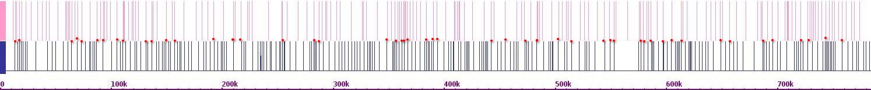Fig. 457. Mapping of Hi-C contact points on chr 14 and chr 5

Chr 6

Chr 14

****Fig. 458. Mapping of Hi-C contact points on chr 14 and chr 6

Chr 7

Chr 14

****Fig. 459. Mapping of Hi-C contact points on chr 14 and chr 7

Chr 8

Chr 14

****Fig. 460. Mapping of Hi-C contact points on chr 14 and chr 8

Chr 9

Chr 14

****Fig. 461. Mapping of Hi-C contact points on chr 14 and chr 9

****Fig. 462. Mapping of Hi-C contact points on chr 14 and chr 10

Chr 10

Chr 14

Chr 11

Chr 14

****Fig. 463. Mapping of Hi-C contact points on chr 14 and chr 11

Chr 12

Chr 14

****Fig. 464. Mapping of Hi-C contact points on chr 14 and chr 12

Chr 13

Chr 14

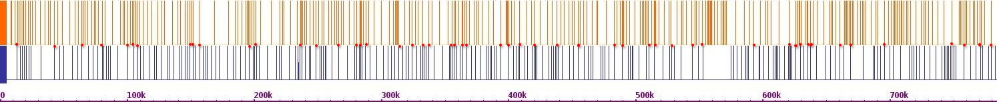Fig. 465. Mapping of Hi-C contact points on chr 14 and chr 13

Chr 14

Chr 14

****Fig. 466. Mapping of Hi-C contact points on chr 14 and chr 14

Chr 15

Chr 14

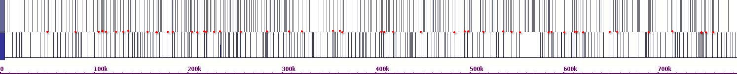Fig. 467. Mapping of Hi-C contact points on chr 14 and chr 15

Chr 16

Chr 14

****Fig. 468. Mapping of Hi-C contact points on chr 14 and chr 16

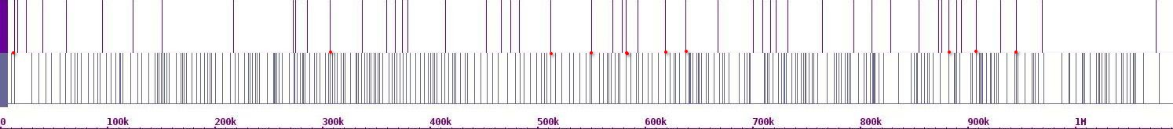Fig. 469. Mapping of Hi-C contact points on chr 15 and chr 1

Chr 1

Chr 15

Chr 2

Chr 15

****Fig. 470. Mapping of Hi-C contact points on chr 15 and chr 2

Chr 3

Chr 15

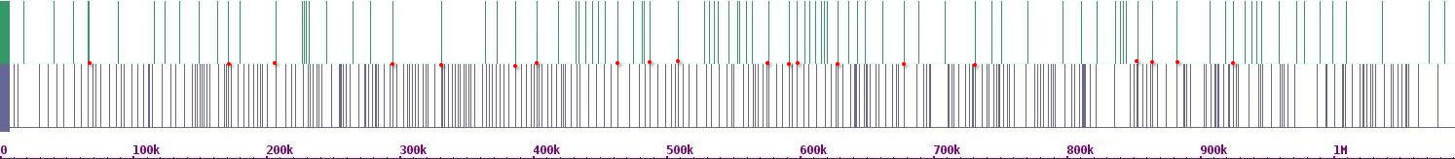Fig. 471. Mapping of Hi-C contact points on chr 15 and chr 3

Chr 4

Chr 15

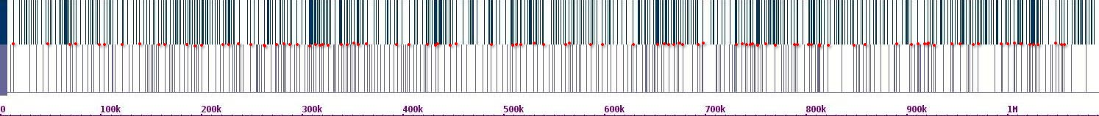Fig. 472. Mapping of Hi-C contact points on chr 15 and chr 4

Chr 5

Chr 15

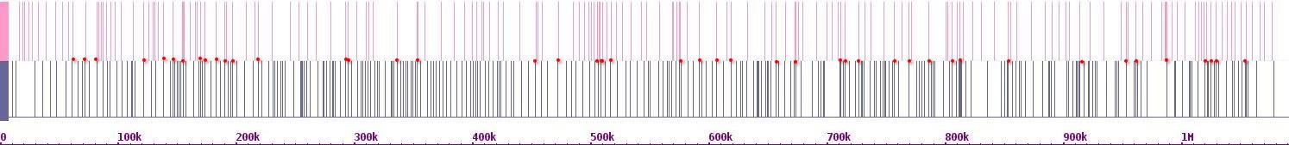Fig. 473. Mapping of Hi-C contact points on chr 15 and chr 5

Chr 6

Chr 15

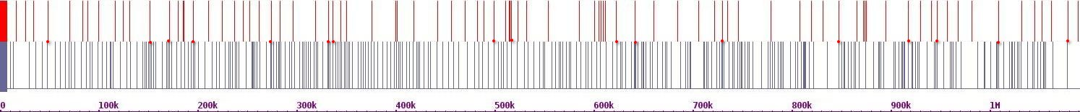Fig. 474. Mapping of Hi-C contact points on chr 15 and chr 6

Chr 7

Chr 15

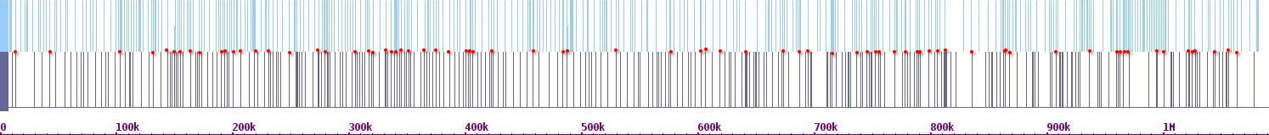Fig. 475. Mapping of Hi-C contact points on chr 15 and chr 7

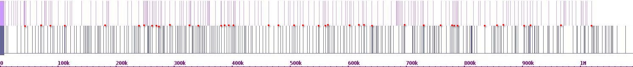Fig. 476. Mapping of Hi-C contact points on chr 15 and chr 8

Chr 8

Chr 15

Chr 9

Chr 15

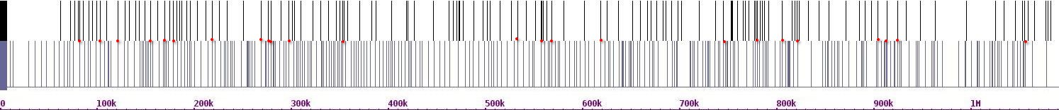Fig. 477. Mapping of Hi-C contact points on chr 15 and chr 9

Chr 10

Chr 15

****Fig. 478. Mapping of Hi-C contact points on chr 15 and chr 10

Chr 11

Chr 15

****Fig. 479. Mapping of Hi-C contact points on chr 15 and chr 11

Chr 12

Chr 15

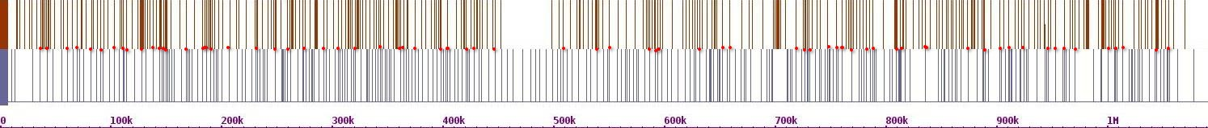Fig. 480. Mapping of Hi-C contact points on chr 15 and chr 12

Chr 13

Chr 15

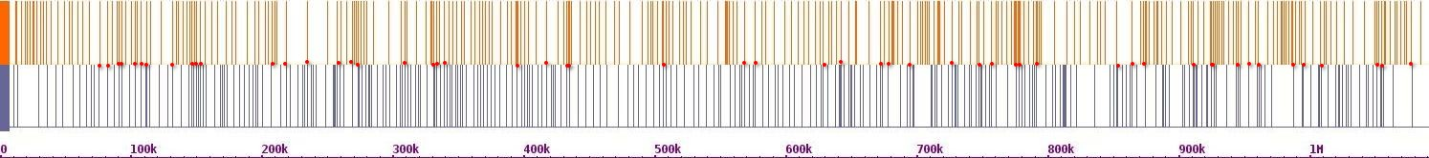Fig. 481. Mapping of Hi-C contact points on chr 15 and chr 13

Chr 14

Chr 15

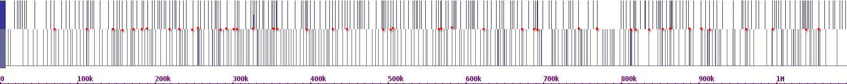Fig. 482. Mapping of Hi-C contact points on chr 15 and chr 14

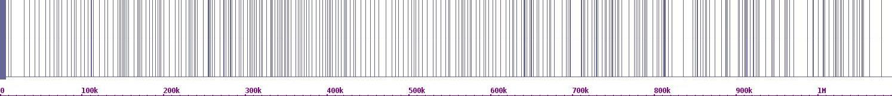Fig. 483. Mapping of Hi-C contact points on chr 15 and chr 15

Chr 15

Chr 15

Chr 16

Chr 15

****Fig. 484. Mapping of Hi-C contact points on chr 15 and chr 16

Chr 1

Chr 16

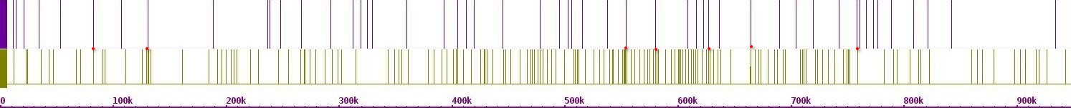Fig. 485. Mapping of Hi-C contact points on chr 16 and chr 1

Chr 2

Chr 16

****Fig. 486. Mapping of Hi-C contact points on chr 16 and chr 2

Chr 3

Chr 16

****Fig. 487. Mapping of Hi-C contact points on chr 16 and chr 3

Chr 4

Chr 16

****Fig. 488. Mapping of Hi-C contact points on chr 16 and chr 4

Chr 5

Chr 16

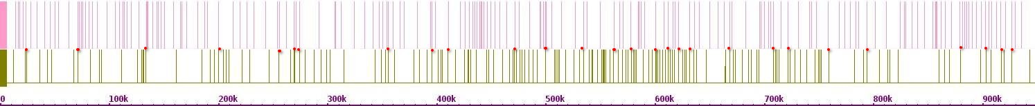Fig. 489. Mapping of Hi-C contact points on chr 16 and chr 5

****Fig. 490. Mapping of Hi-C contact points on chr 16 and chr 6

Chr 6

Chr 16

Chr 7

Chr 16

****Fig. 491. Mapping of Hi-C contact points on chr 16 and chr 7

Chr 8

Chr 16

****Fig. 492. Mapping of Hi-C contact points on chr 16 and chr 8

Chr 9

Chr 16

****Fig. 493. Mapping of Hi-C contact points on chr 16 and chr 9

Chr 10

Chr 16

****Fig. 494. Mapping of Hi-C contact points on chr 16 and chr 10

Chr 11

Chr 16

****Fig. 495. Mapping of Hi-C contact points on chr 16 and chr 11

Chr 12

Chr 16

****Fig. 496. Mapping of Hi-C contact points on chr 16 and chr 12

Chr 13

Chr 16

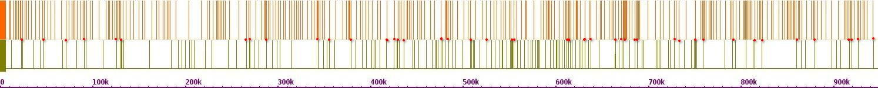Fig. 497. Mapping of Hi-C contact points on chr 16 and chr 13

****Fig. 498. Mapping of Hi-C contact points on chr 16 and chr 14

Chr 14

Chr 16

Chr 15

Chr 16

****Fig. 499. Mapping of Hi-C contact points on chr 16 and chr 15

Chr 16

Chr 16

****Fig. 500. Mapping of Hi-C contact points on chr 16 and chr 16

**Group C. Crosslink between recombination hotspots and Hi-C contact points**

We also investigated crosslinks between Hi-C contact points and recombination hotspots. The Hi-C contact points and recombination hotspots of each chromosome were mapped first and then mapped against the Hi-C contact points of the remaining 15 chromosomes. We calculated the hypergeometric distribution of these crosslinks to determine the statistical significance of distributions. The bars are the Hi-C and recombination hotspots on the chromosome and those that are crosslinked between the two chromosomes are indicated with red dots.

Chr 2(r)

Chr 2(h)

Chr 1(h)

Chr 1

Chr 1

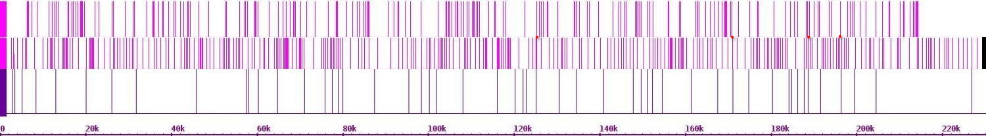Fig.501. Crosslinks between chr 1 and chr 2.

Chr 3(r)

Chr 3(h)

Chr 1(h)

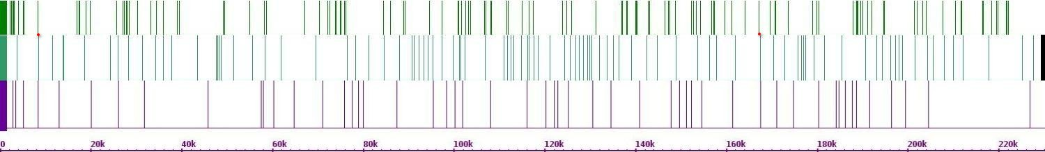Fig. 502. Crosslinks between chr 1 and chr 3.

Chr 4(r)

Chr 4(h)

Chr 1(h)

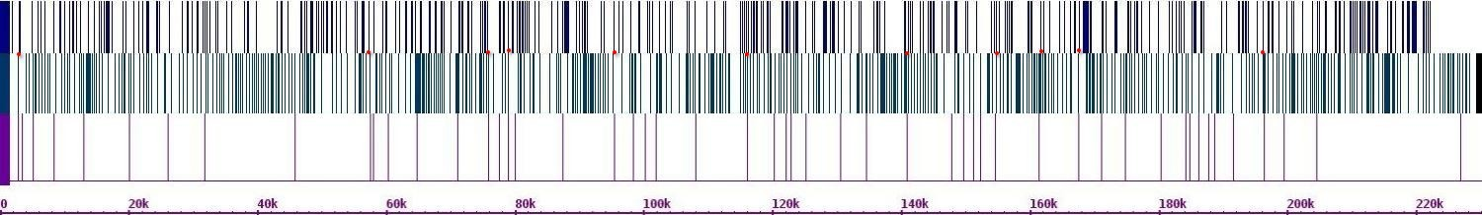Fig. 503. Crosslinks between chr 1 and chr 4.

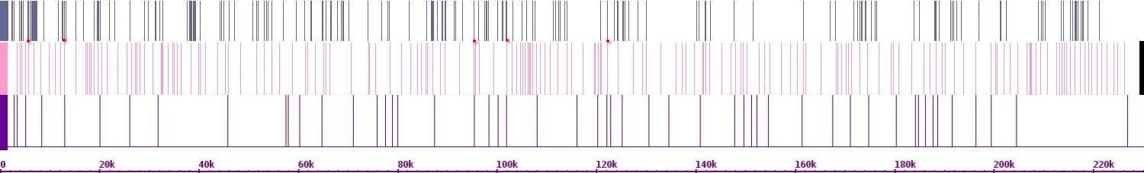Fig. 504. Crosslinks between chr 1 and chr 5.

Chr 5(r)

Chr 5(h)

Chr 1(h)

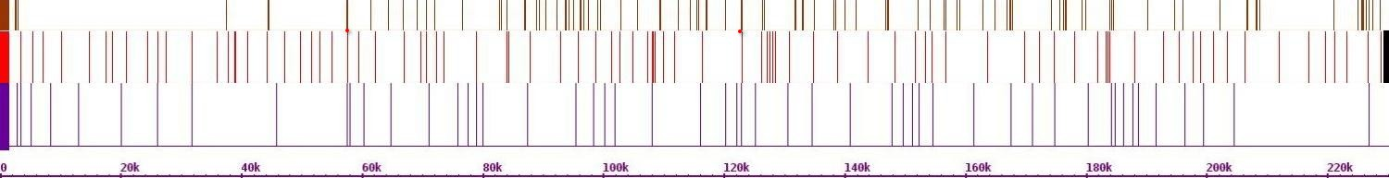Fig. 505. Crosslinks between chr 1 and chr 6.

Chr 6(r)

Chr 6(h)

Chr 1(h)

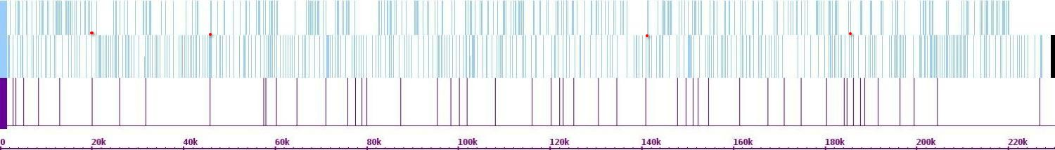Fig. 506. Crosslinks between chr 1 and chr 7.

Chr 7(r)

Chr 7(h)

Chr 1(h)

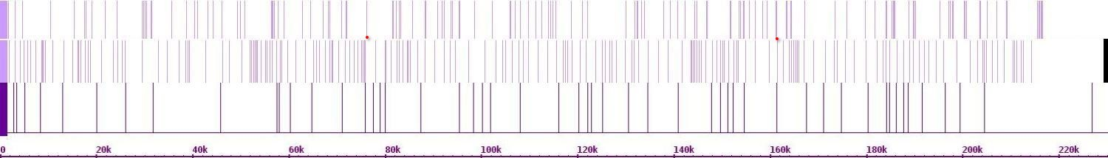Fig. 507. Crosslinks between chr 1 and chr 8.

Chr 8(r)

Chr 8(h)

Chr 1(h)

Chr 9(r)

Chr 9(h)

Chr 1(h)

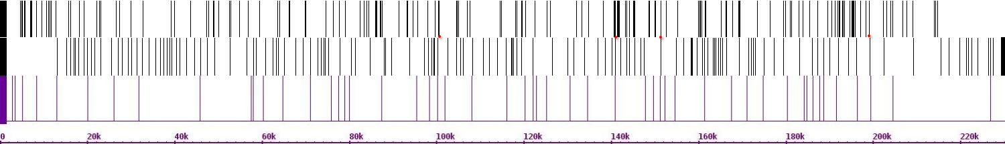Fig. 508. Crosslinks between chr 1and chr 9

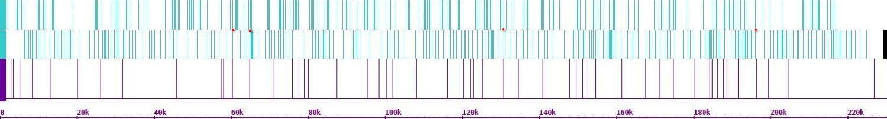Fig. 509. Crosslinks between chr 1 and chr 10.

Chr 10(r)

Chr 10(h)

Chr 1(h)

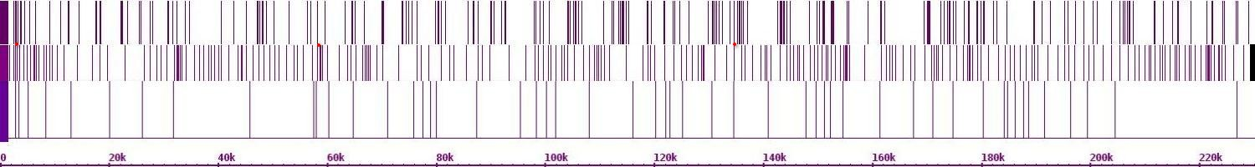Fig. 510. Crosslinks between chr 1 and chr 11.

Chr 11(r)

Chr 11(h)

Chr 1(h)

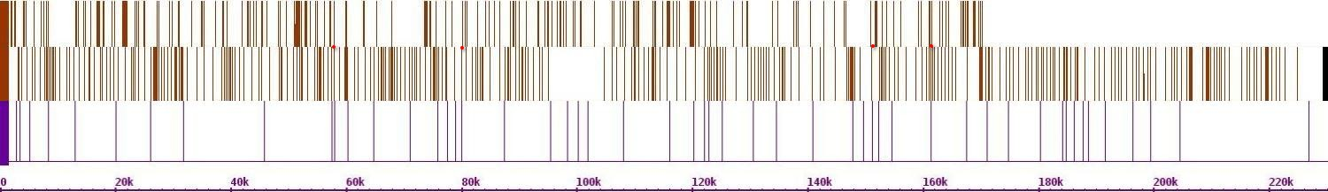Fig. 511. Crosslinks between chr 1 and chr 12

Chr 12(r)

Chr 12(h)

Chr 1(h)

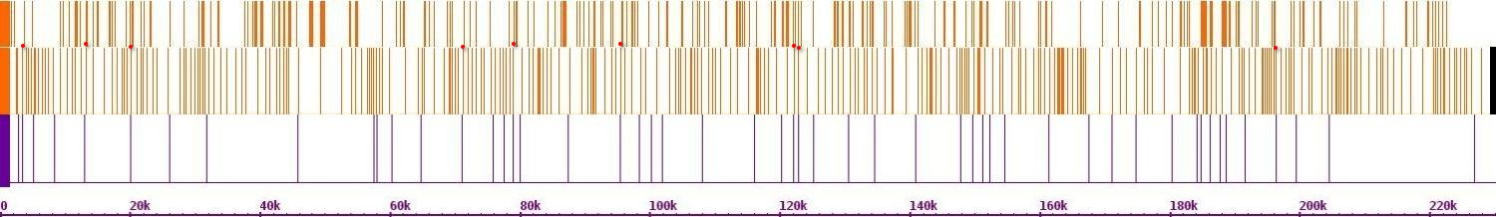Fig. 512. Crosslinks between chr 1 and chr 13

Chr 13(r)

Chr 13(h)

Chr 1(h)

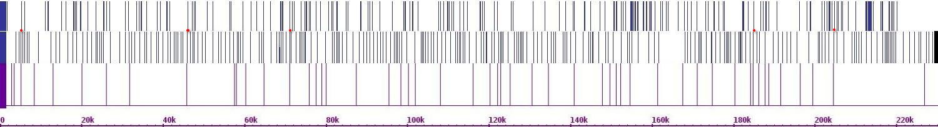Fig. 513. Crosslinks chr 1 and chr 14

Chr 14(r)

Chr 14(h)

Chr 1(h)

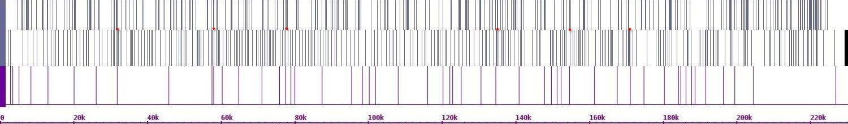Fig.514. Crosslinks between chr 1 and chr 15

Chr 15(r)

Chr 15(h)

Chr 1(h)

Chr 16(r)

Chr 16(h)

Chr 1(h)

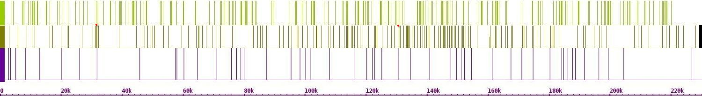Fig.515. Crosslinks between chr 1 and chr 16

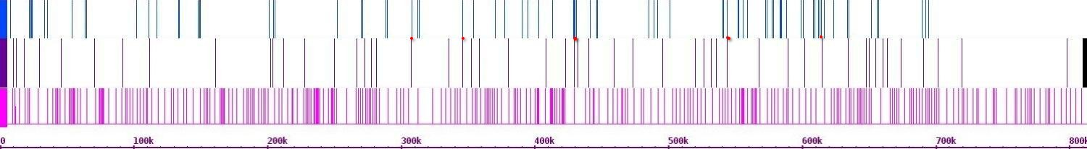Fig. 516. Crosslinks between chr 2 and chr 1

Chr 1(r)

Chr 1(h)

Chr 2(h)

Chr 1

Chr 2

Chr 3(r)

Chr 3(h)

Chr 2(h)

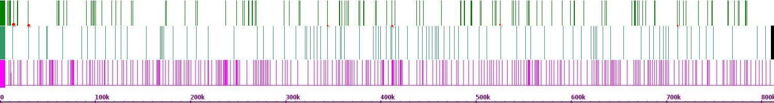Fig. 517. Crosslinks between chr 2 and chr 3

Chr 4(r)

Chr 4(h)

Chr 2(h)

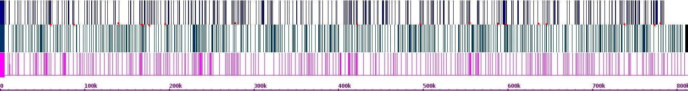Fig. 518. Crosslinks between chr 2 and chr 4

Chr 5(r)

Chr 5(h)

Chr 2(h)

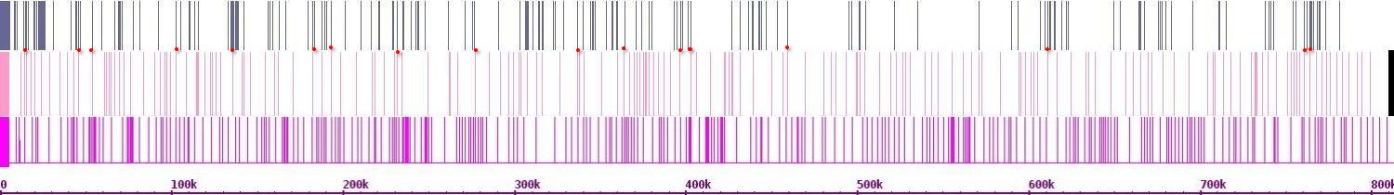Fig. 519. Crosslinks between chr 2 and chr 5

Chr 6(r)

Chr 6(h)

Chr 2(h)

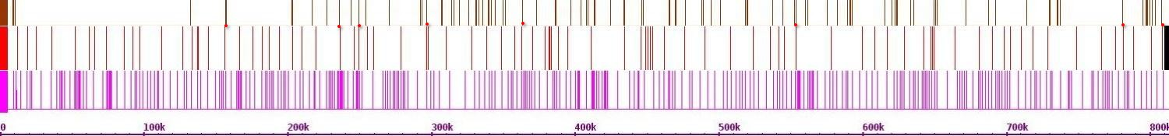Fig.520. Crosslinks between chr 2 and chr 6

Chr 7(r)

Chr 7(h)

Chr 2(h)

Chr 6

Chr 2

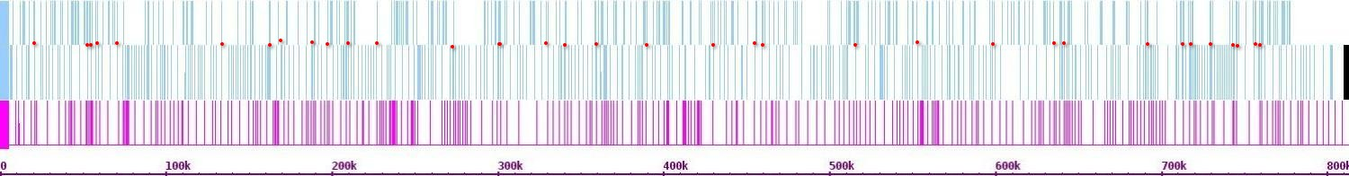Fig. 521. Crosslinks between chr 2 and chr 7

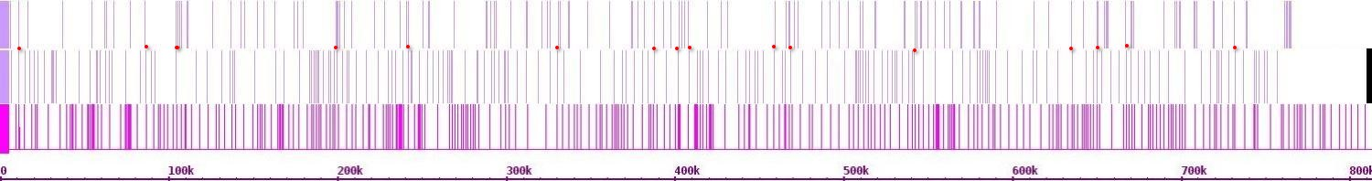Fig. 522. Crosslinks between chr 2 and chr 8

Chr 8(r)

Chr 8(h)

Chr 2(h)

Chr 9(r)

Chr 9(h)

Chr 2(h)

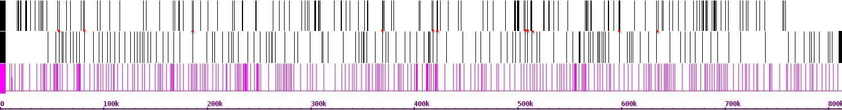Fig. 523. Crosslinks between chr 2 and chr 9

Chr 10(r)

Chr 10(h)

Chr 2(h)

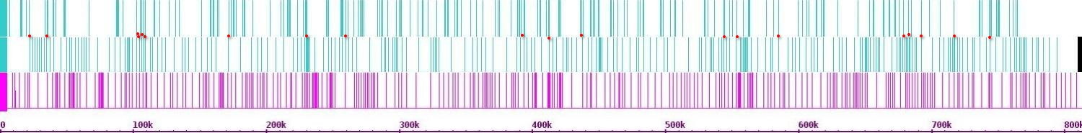Fig. 524. Crosslinks between chr 2 and chr 10

Chr 11(r)

Chr 11(h)

Chr 2(h)

Chr 10

Chr 2

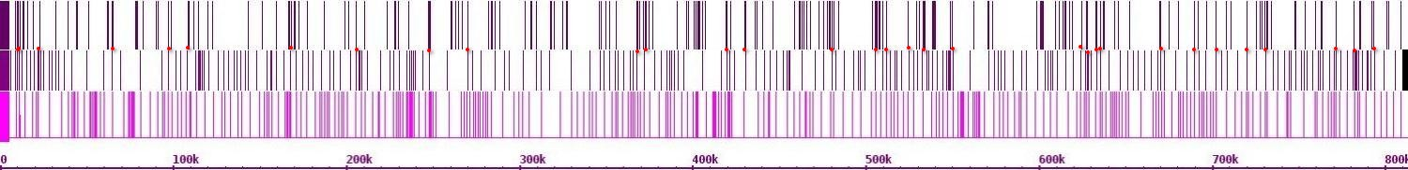Fig. 525. Crosslinks between chr 2 and chr 11

Chr 12(r)

Chr 12(h)

Chr 2(h)

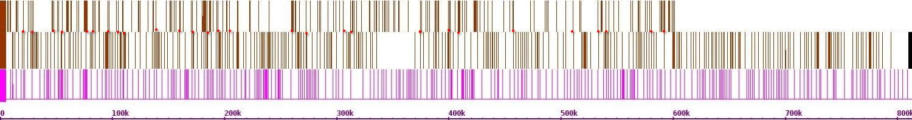Fig. 526. Crosslinks between chr 2 and chr 12

Chr 13(r)

Chr 13(h)

Chr 2(h)

Chr 12

Chr 2

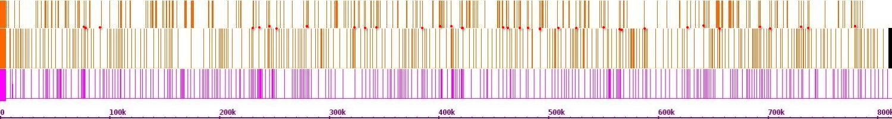Fig. 527. Crosslinks between chr 2 and chr 13

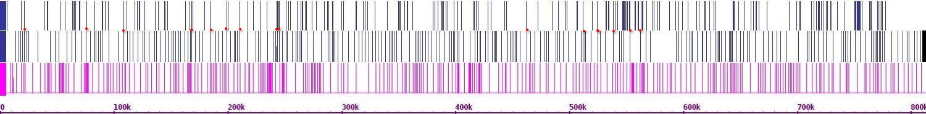Fig. 528. Crosslinks between chr 2 and chr 14

Chr 14(r)

Chr 14(h)

Chr 2(h)

Chr 15(r)

Chr 15(h)

Chr 2(h)

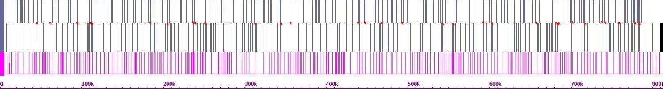Fig. 529. Crosslinks between chr 2 and chr 15

Chr 16(r)

Chr 16(h)

Chr 2(h)

Chr 15

Chr 2

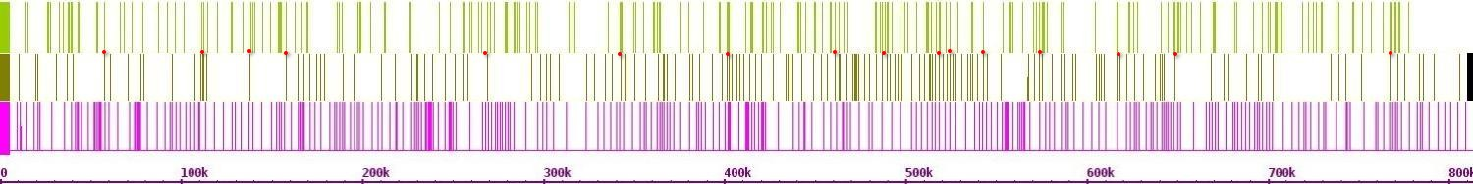Fig. 530. Crosslinks between chr 2 and chr 16

Chr 1(r)

Chr 1(h)

Chr 3(h)

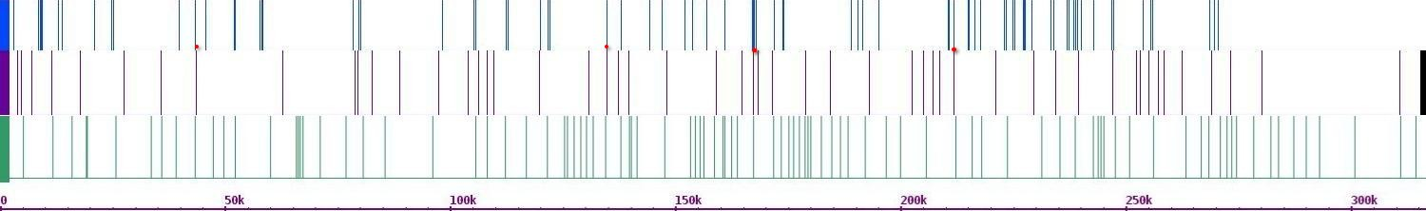Fig. 531. Crosslinks between chr 3 and chr 1

Chr 2(r)

Chr 2(h)

Chr 3(h)

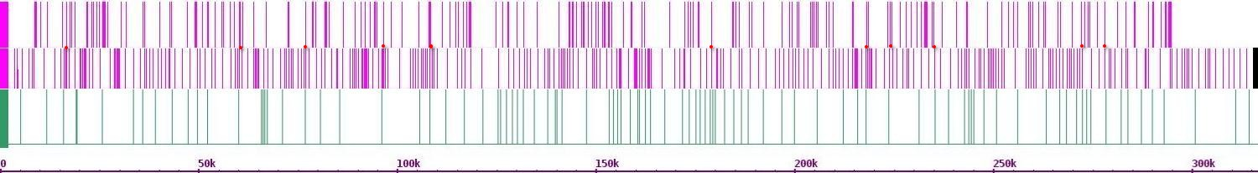Fig. 532. Crosslinks between chr 3 and chr 2

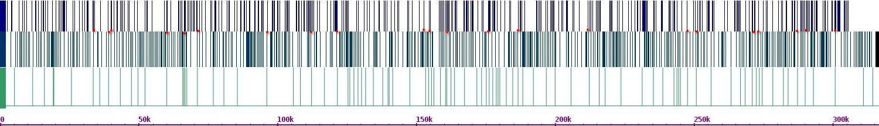Fig. 533. Crosslinks between chr 3 and chr 4

Chr 4(r)

Chr 4(h)

Chr 3(h)

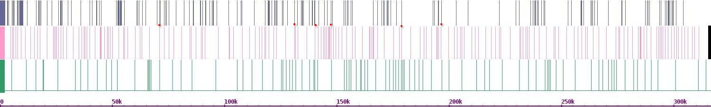Fig.534. Crosslinks between chr 3 and chr 5

Chr 5(r)

Chr 5(h)

Chr 3(h)

Chr 6(r)

Chr 6(h)

Chr 3(h)

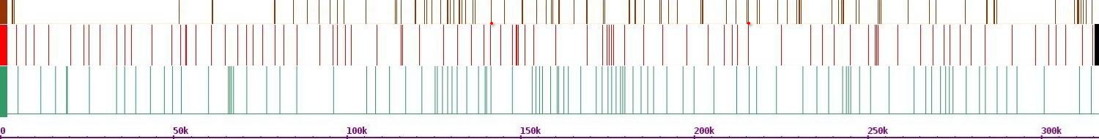Fig. 535. Crosslinks between chr 3 and chr 6

Chr 7(r)

Chr 7(h)

Chr 3(h)

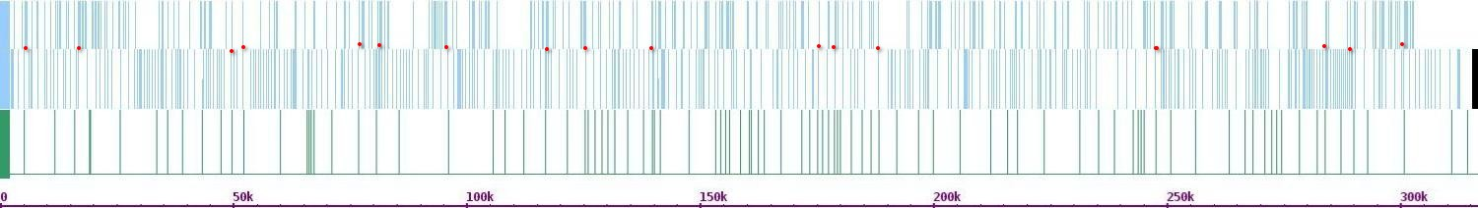Fig. 536. Crosslinks between chr 3 and chr 7

Chr 8(r)

Chr 8(h)

Chr 3(h)

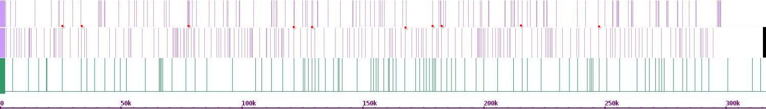Fig. 537. Crosslinks between chr 3 and chr 8

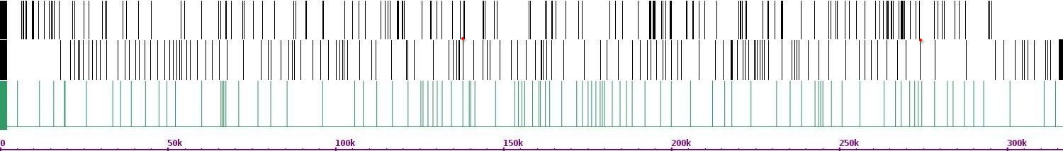Fig. 538. Crosslinks between chr 3 and chr 9

Chr 9(r)

Chr 9(h)

Chr 3(h)

Chr 10(r)

Chr 10(h)

Chr 3(h)

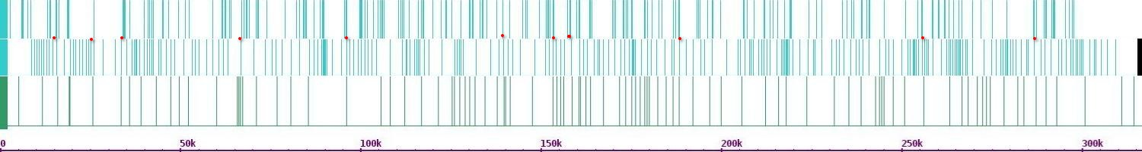Fig. 539. Crosslinks between chr 3 and chr 10

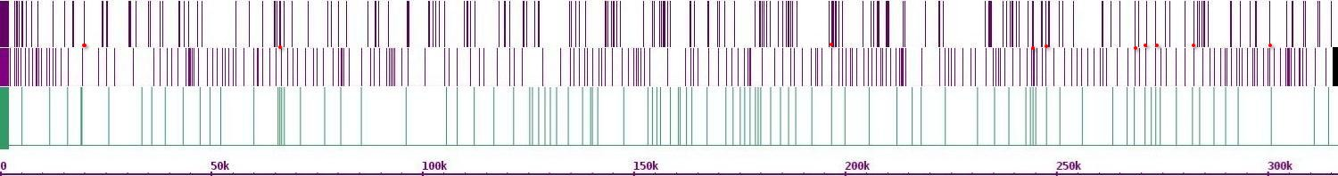Fig. 540. Crosslinks between chr 3 and chr 11

Chr 11(r)

Chr 11(h)

Chr 3(h)

Chr 12(r)

Chr 12(h)

Chr 3(h)

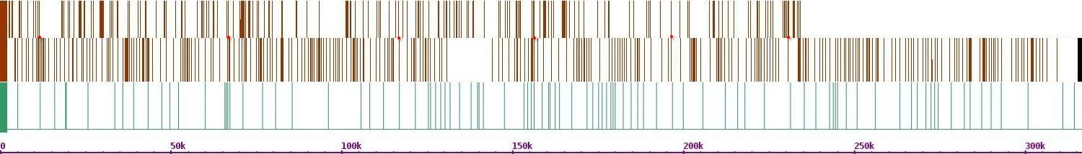Fig. 541. Crosslinks between chr 3 and chr 12

Chr 13(r)

Chr 13(h)

Chr 3(h)

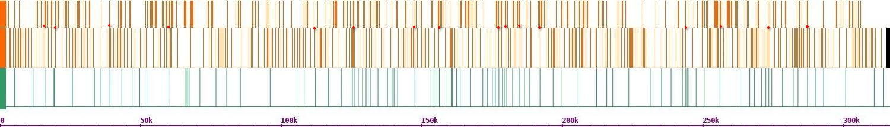Fig. 542. Crosslinks between chr 3 and chr 13

Chr 14(r)

Chr 14(h)

Chr 3(h)

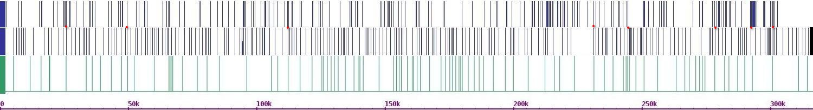Fig. 543. Crosslinks between chr 3 and chr 14

Chr 15(r)

Chr 15(h)

Chr 3(h)

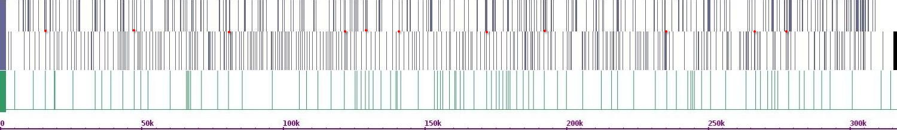Fig. 544. Crosslinks between chr 3 and chr 15

Chr 16(r)

Chr 16(h)

Chr 3(h)

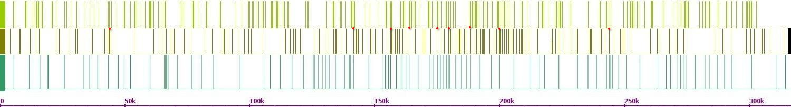Fig. 545. Crosslinks between chr 3 and chr 16

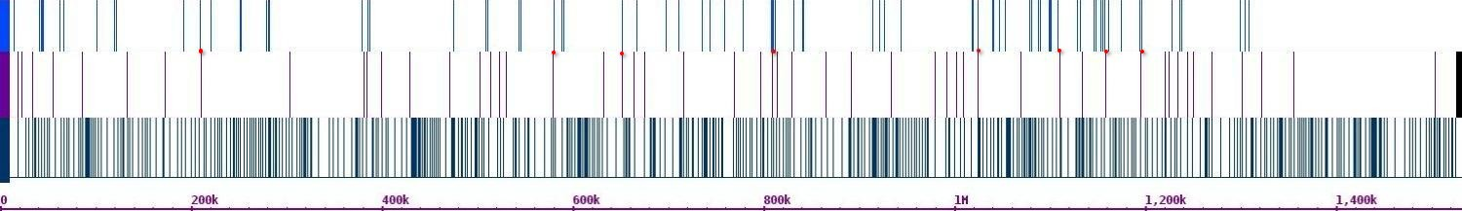Fig. 546. Crosslinks between chr 4 and chr 1

Chr 1(r)

Chr 1(h)

Chr 4(h)

Chr 2(r)

Chr 2(h)

Chr 4(h)

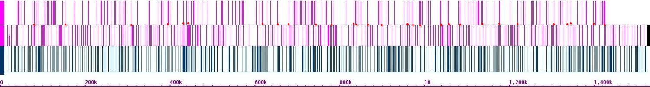Fig. 547. Crosslinks between chr 4 and chr 2

Chr 3(r)

Chr 3(h)

Chr 4(h)

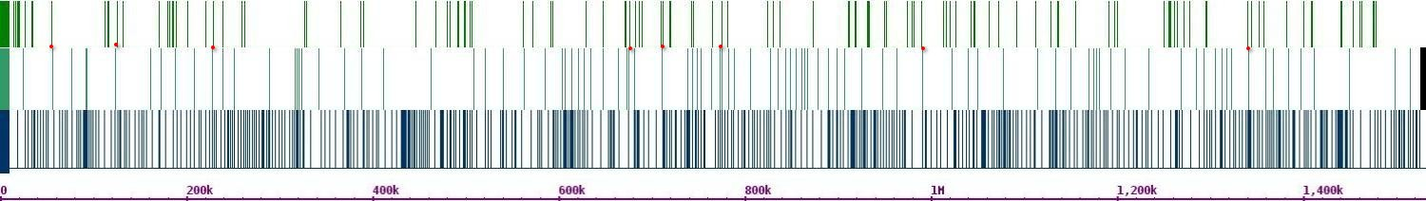Fig. 548. Crosslinks between chr 4 and chr 3

Chr 5(r)

Chr 5(h)

Chr 4(h)

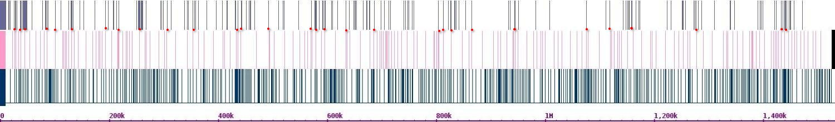Fig. 549. Crosslinks between chr 4 and chr 5

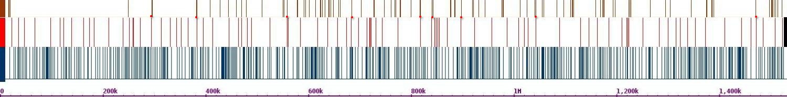Fig. 550. Crosslinks between chr 4 and chr 6

Chr 6(r)

Chr 6(h)

Chr 4(h)

Chr 7(r)

Chr 7(h)

Chr 4(h)

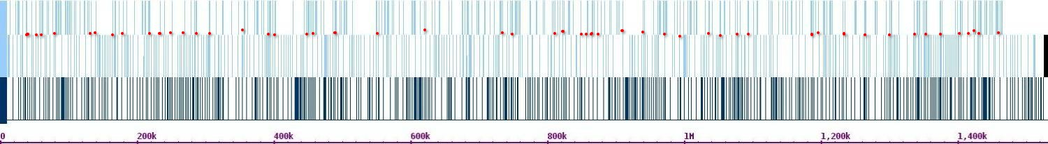Fig. 551. Crosslinks between chr 4 and chr 7

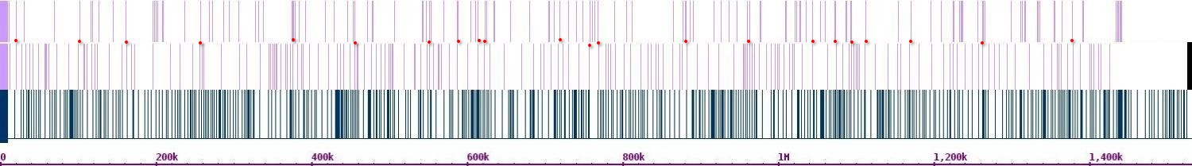Fig. 552. Crosslinks between chr 4 and chr 8

Chr 8(r)

Chr 8(h)

Chr 4(h)

Chr 9(r)

Chr 9(h)

Chr 4(h)

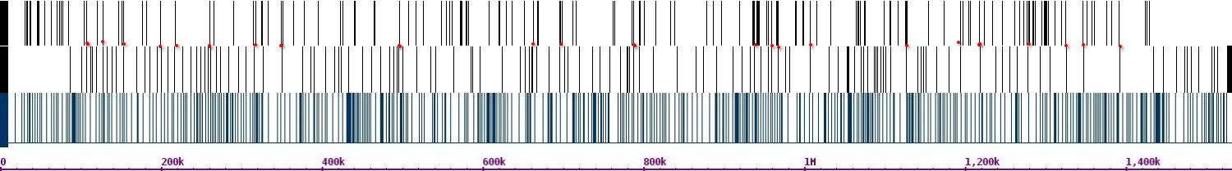Fig. 553 Crosslinks between chr 4 and chr 9

Chr 10(r)

Chr 10(h)

Chr 4(h)

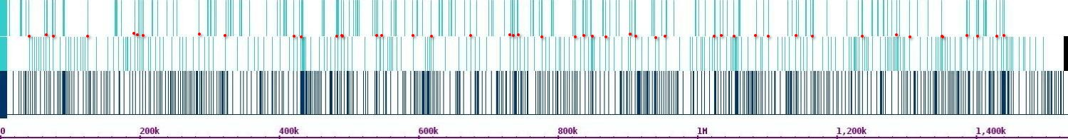Fig. 554. Crosslinks between chr 4 and chr 10

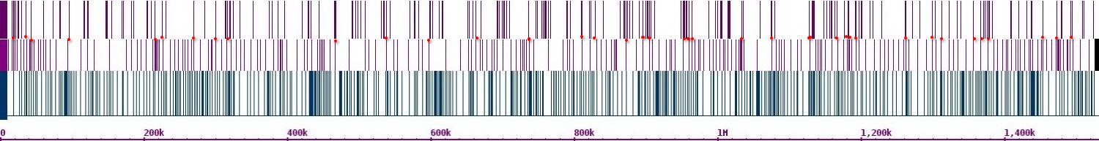Fig. 555. Crosslinks between chr 4 and chr 11

Chr 11(r)

Chr 11(h)

Chr 4(h)

Chr 12(r)

Chr 12(h)

Chr 4(h)

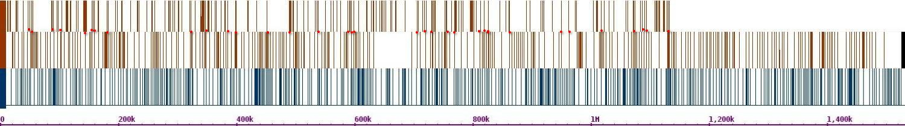Fig. 556. Crosslinks between chr 4 and chr 12

Chr 13(r)

Chr 13(h)

Chr 4(h)

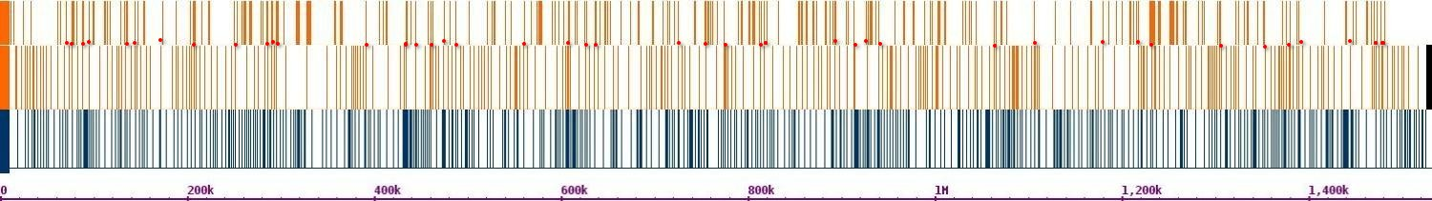Fig. 557. Crosslinks between chr 4 and chr 13

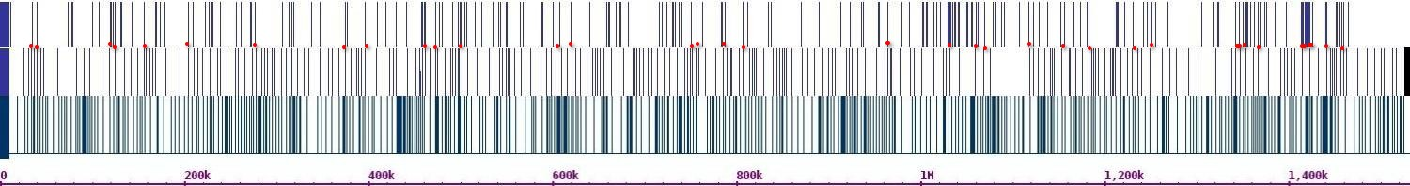Fig. 558. Crosslinks between chr 4 and chr 14

Chr 14(r)

Chr 14(h)

Chr 4(h)

Chr 15(r)

Chr 15(h)

Chr 4(h)

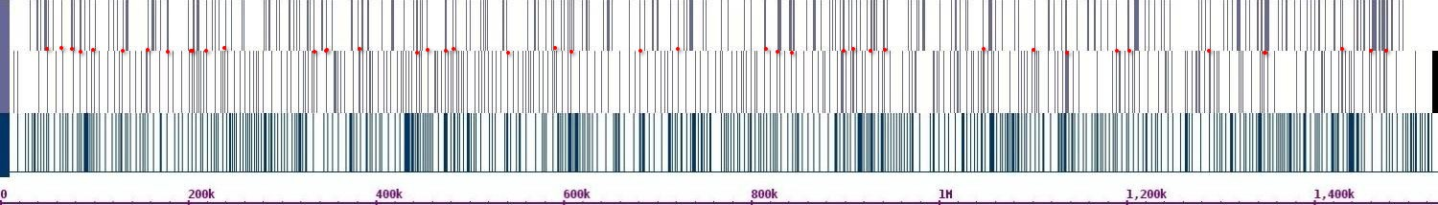Fig. 559. Crosslinks between chr 4 and chr 15

Chr 16(r)

Chr 16(h)

Chr 4(h)

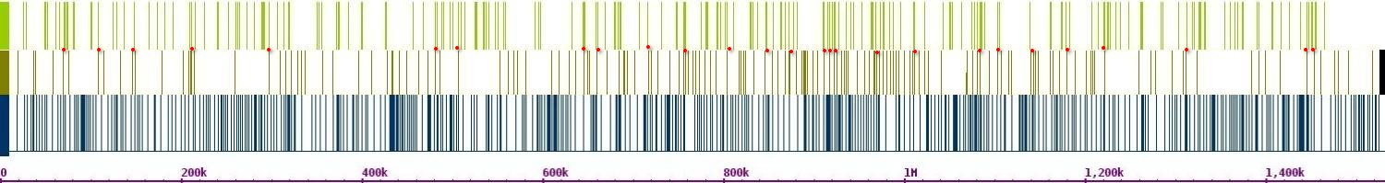Fig. 560. Crosslinks between chr 4 and chr 16

Chr 1(r)

Chr 1(h)

Chr 5(h)

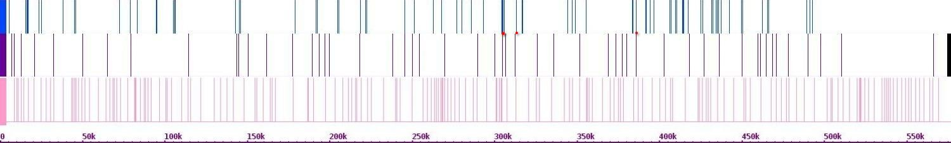Fig. 561. Crosslinks between chr 5 and chr 1

Chr 2(r)

Chr 2(h)

Chr 5(h)

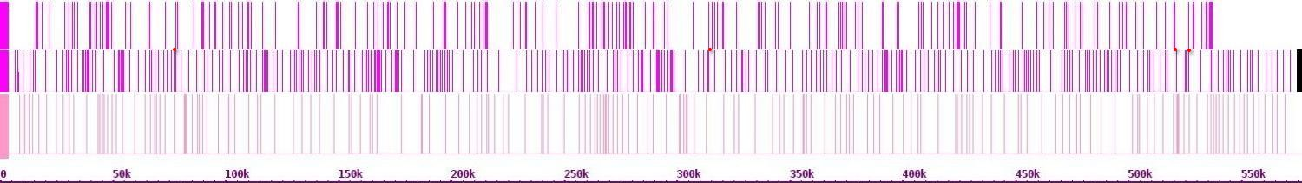Fig. 562. Crosslinks between chr 5 and chr 2

Chr 3(r)

Chr 3(h)

Chr 5(h)

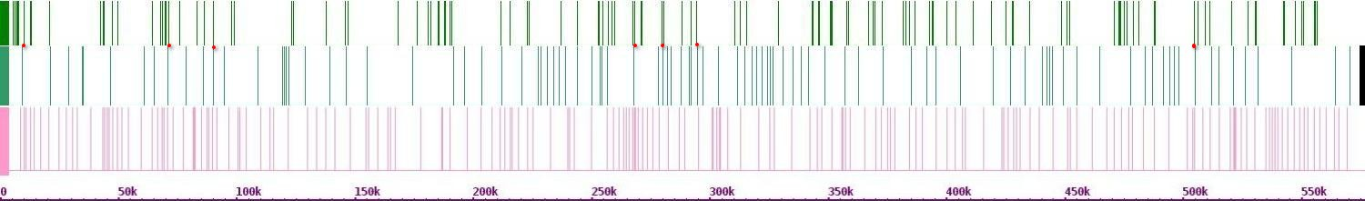Fig. 563. Crosslinks between chr 5 and chr 3

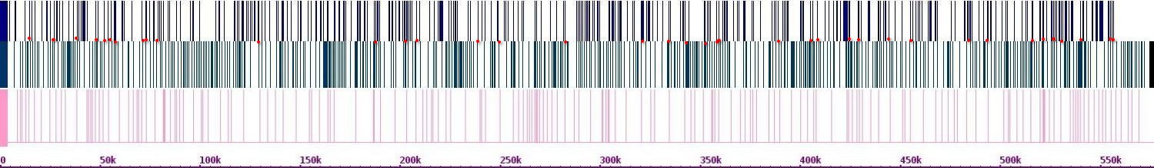Fig.564. Crosslinks between chr 5 and chr 4

Chr 4(r)

Chr 4(h)

Chr 5(h)

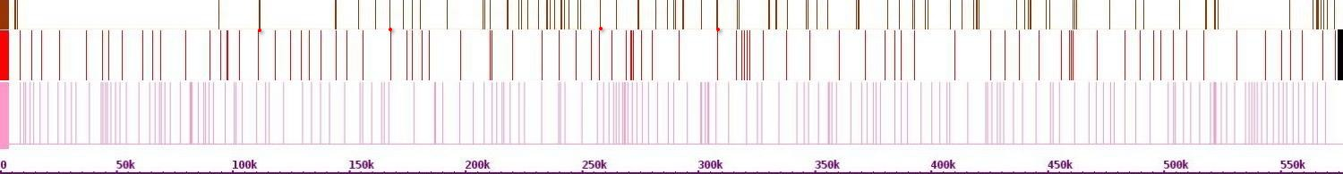Fig. 565. Crosslinks between chr 5 and chr 6

Chr 6(r)

Chr 6(h)

Chr 5(h)

Chr 7(r)

Chr 7(h)

Chr 5(h)

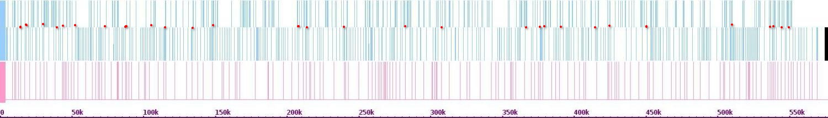Fig. 566. Crosslinks between chr 5 and chr 7

Chr 8(r)

Chr 8(h)

Chr 5(h)

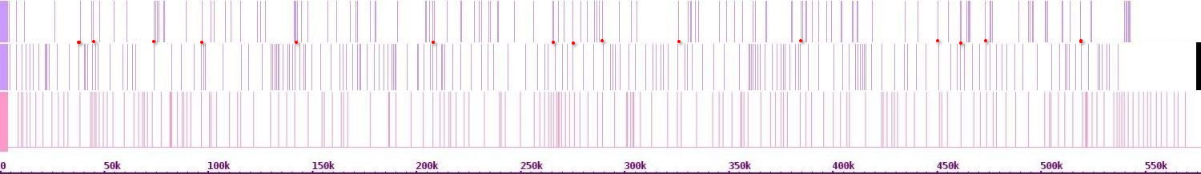Fig. 567. Crosslinks between chr 5 and chr 8

Chr 9(r)

Chr 9(h)

Chr 5(h)

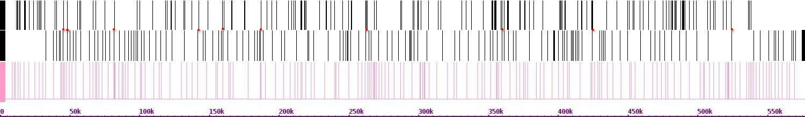Fig. 568. Crosslinks between chr 5 and chr 9

Chr 10(r)

Chr 10(h)

Chr 5(h)

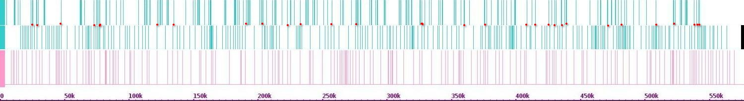Fig. 569. Crosslinks between chr 5 and chr 10

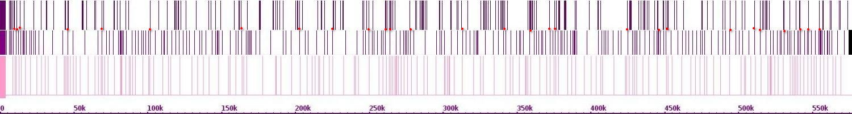Fig. 570. Crosslinks between chr 5 and chr 11

Chr 11(r)

Chr 11(h)

Chr 5(h)

Chr 12(r)

Chr 12(h)

Chr 5(h)

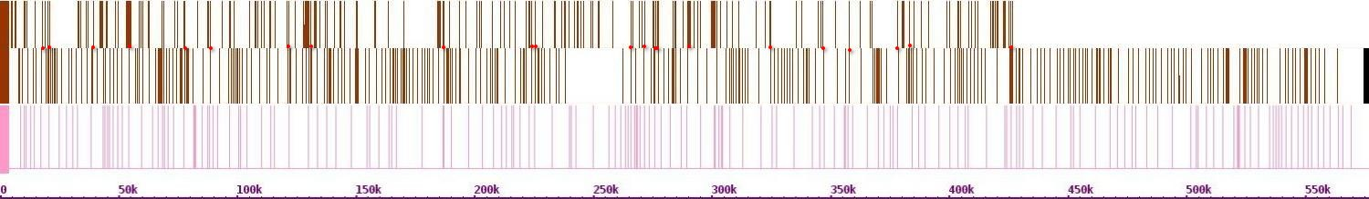Fig. 571. Crosslinks between chr 5 and chr 12

Chr 13(r)

Chr 13(h)

Chr 5(h)

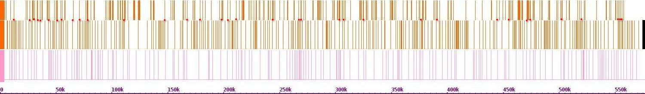Fig. 572. Crosslinks between chr 5 and chr 13

Chr 14(r)

Chr 14(h)

Chr 5(h)

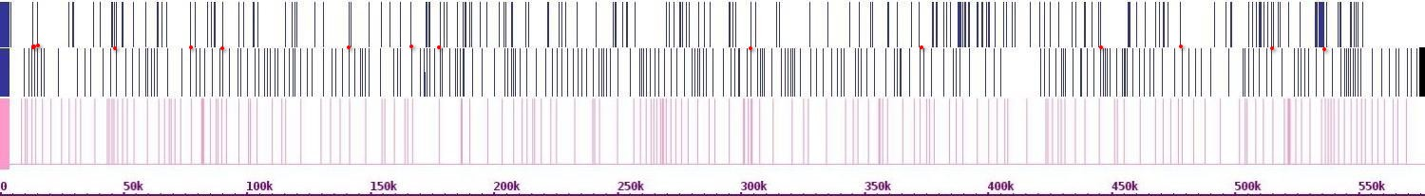Fig. 573. Crosslinks between chr 5 and chr 14

Chr 15(r)

Chr 15(h)

Chr 5(h)

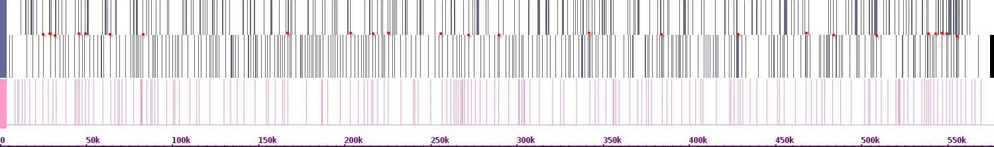Fig. 574. Crosslinks between chr 5 and chr 15

Chr 16(r)

Chr 16(h)

Chr 5(h)

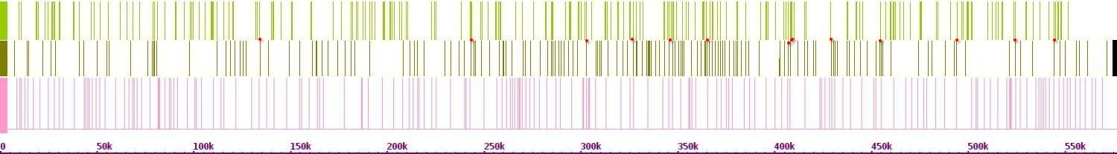

Fig. 575. Crosslinks between chr 5 and chr 16

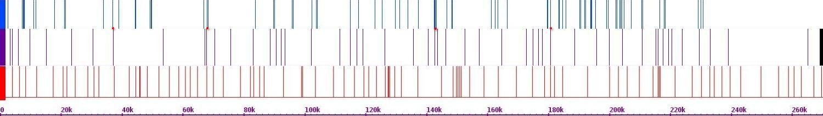Fig. 576. Crosslinks between chr 6 and chr 1

Chr 1(r)

Chr 1(h)

Chr 6(h)

Chr 2(r)

Chr 2(h)

Chr 6(h)

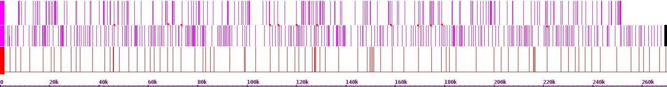Fig. 577. Crosslinks between chr 6 and chr 2

Chr 3(r)

Chr 3(h)

Chr 6(h)

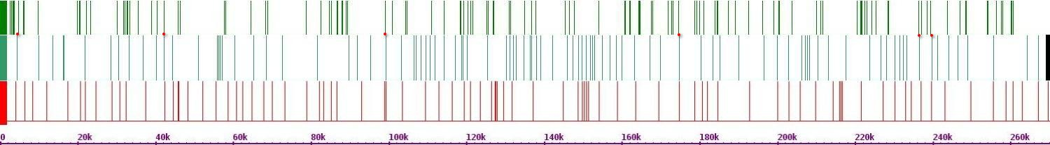Fig. 578. Crosslinks between chr 6 and chr 3

Chr 4(r)

Chr 4(h)

Chr 6(h)

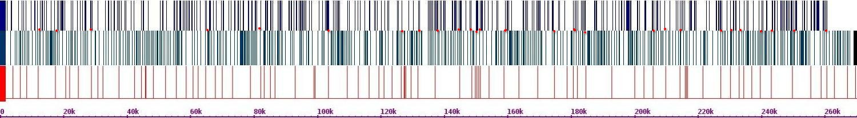Fig. 579. Crosslinks between chr 6 and chr 4

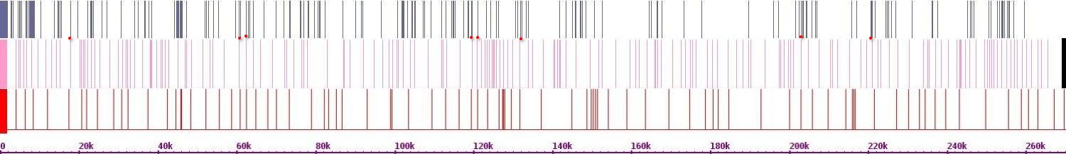Fig. 580. Crosslinks between chr 6 and chr 5

Chr 5(r)

Chr 5(h)

Chr 6(h)

Chr 7(r)

Chr 7(h)

Chr 6(h)

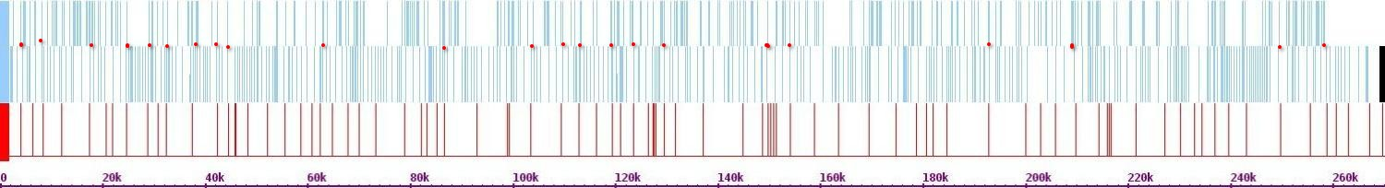Fig. 581. Crosslink between chr 6 and chr 7

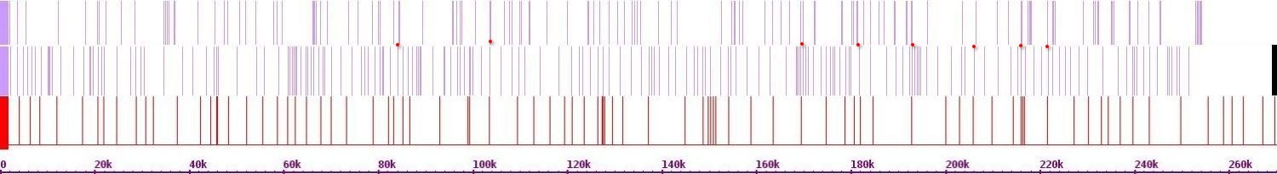Fig. 582. Crosslinks between chr 6 and chr 8

Chr 8(r)

Chr 8(h)

Chr 6(h)

Chr 9(r)

Chr 9(h)

Chr 6(h)

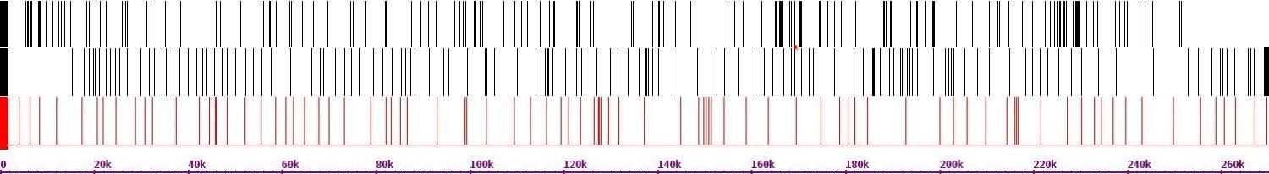Fig. 583. Crosslinks between chr 6 and chr 9

Chr 10(r)

Chr 10(h)

Chr 6(h)

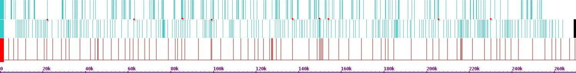Fig. 584. Crosslinks between chr 6 and chr 10

Chr 11(r)

Chr 11(h)

Chr 6(h)

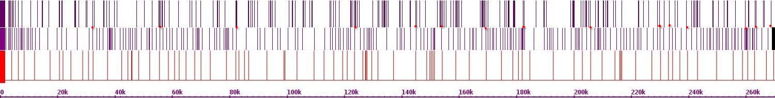Fig. 585. Crosslinks between chr 6 and chr 11

Chr 12(r)

Chr 12(h)

Chr 6(h)

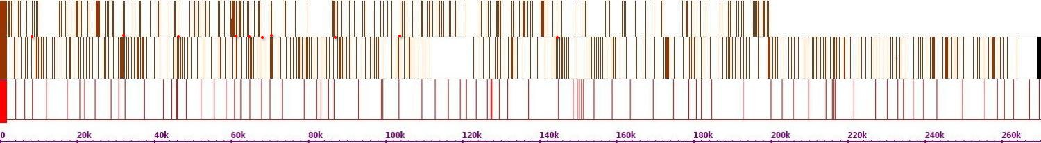Fig. 586. Crosslinks between chr 6 and chr 12

Chr 13(r)

Chr 13(h)

Chr 6(h)

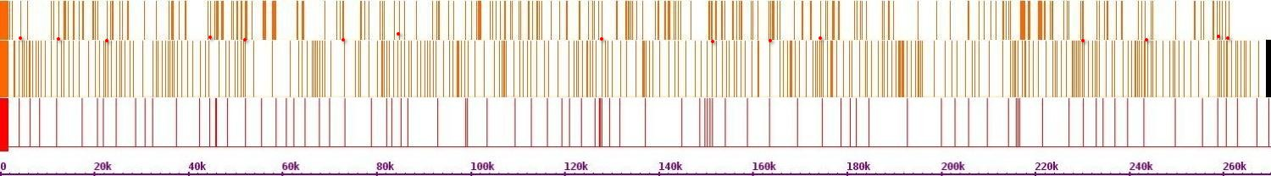Fig. 587. Crosslink between chr 6 and chr 13

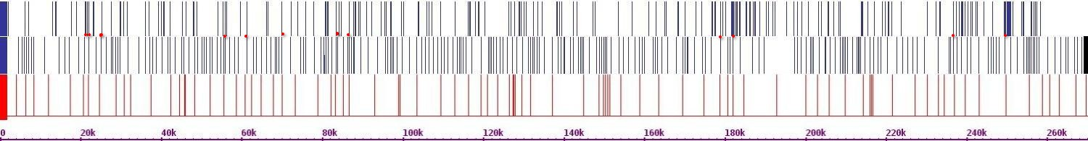Fig. 588. Crosslinks between chr 6 and chr 14

Chr 14(r)

Chr 14(h)

Chr 6(h)

Chr 15(r)

Chr 15(h)

Chr 6(h)

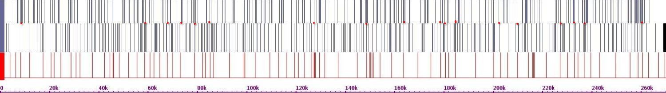Fig. 589. Crosslinks between chr 6 and chr 15

Chr 16(r)

Chr 16(h)

Chr 6(h)

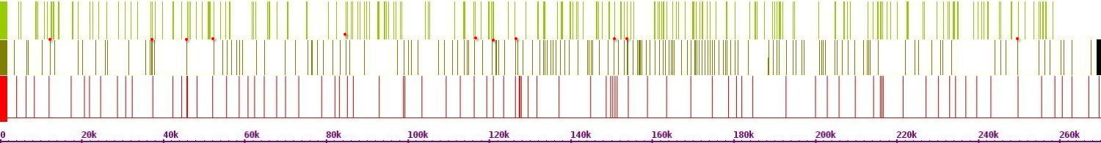Fig. 590. Crosslinks between chr 6 and chr 16

Chr 1(r)

Chr 1(h)

Chr 7(h)

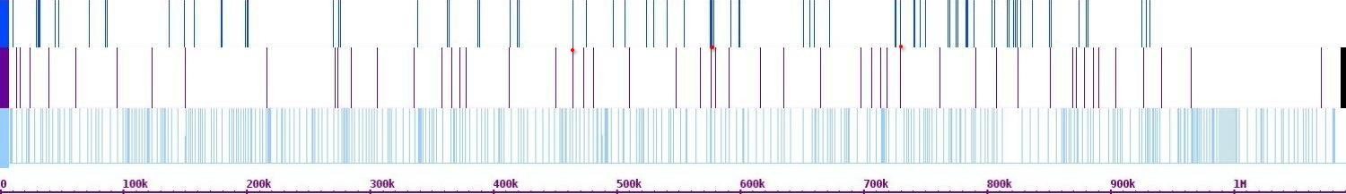Fig. 591. Crosslinks between chr 7 and chr 1

Chr 2(r)

Chr 2(h)

Chr 7(h)

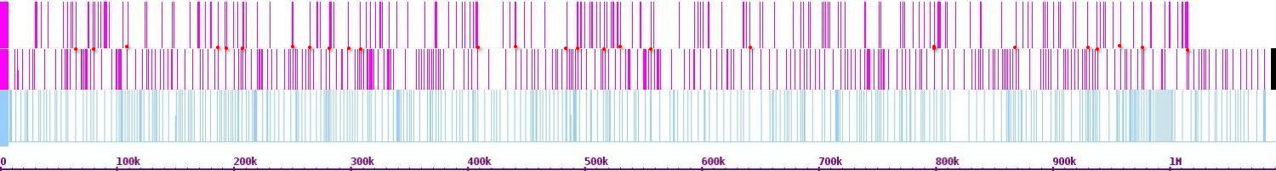Fig. 592. Crosslinks between chr 7 and chr 2

Chr 3(r)

Chr 3(h)

Chr 7(h)

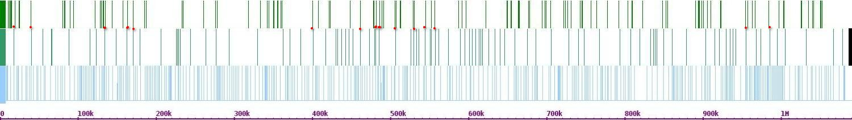Fig. 593. Crosslinks between chr 7 and chr 3

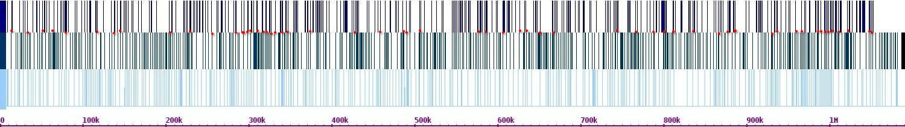Fig. 594. Crosslinks between chr 7 and chr 4

Chr 4(r)

Chr 4(h)

Chr 7(h)

Chr 5(r)

Chr 5(h)

Chr 7(h)

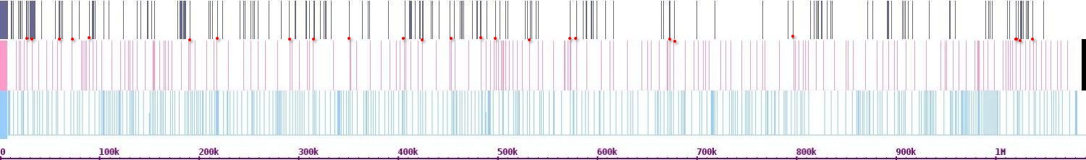Fig. 595. Crosslinks between chr 7 and chr 5

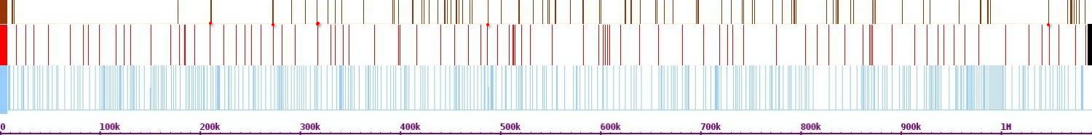Fig. 596. Crosslinks between chr 7 and chr 6

Chr 6(r)

Chr 6(h)

Chr 7(h)

Chr 8(r)

Chr 8(h)

Chr 7(h)

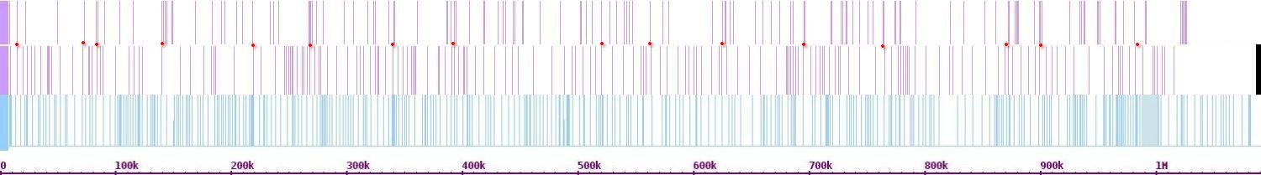Fig. 597. Crosslinks between chr 7 and chr 8

Chr 9(r)

Chr 9(h)

Chr 7(h)

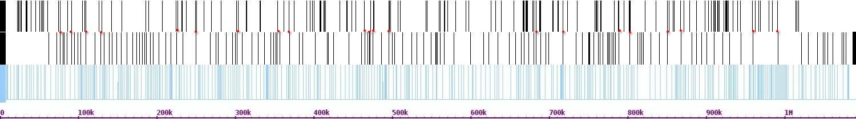 Fig. 598. Crosslinks between chr 7 and chr 9

Chr 10(r)

Chr 10(h)

Chr 7(h)

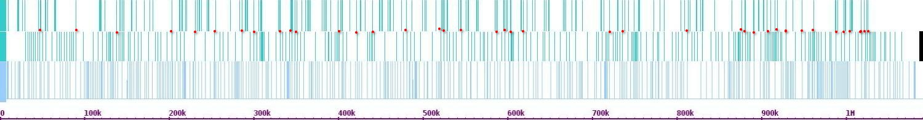Fig. 599. Crosslinks between chr 7 and chr 10

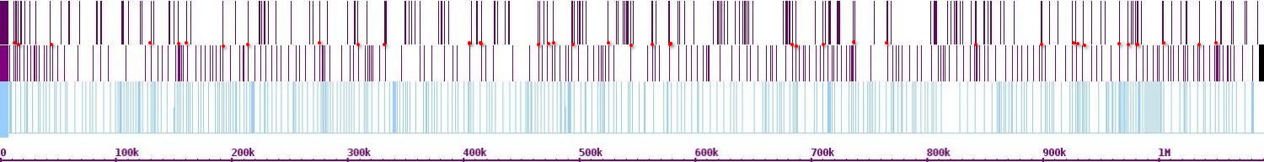Fig.600. Crosslinks between chr 7 and chr 11

Chr 11(r)

Chr 11(h)

Chr 7(h)

Chr 12(r)

Chr 12(h)

Chr 7(h)

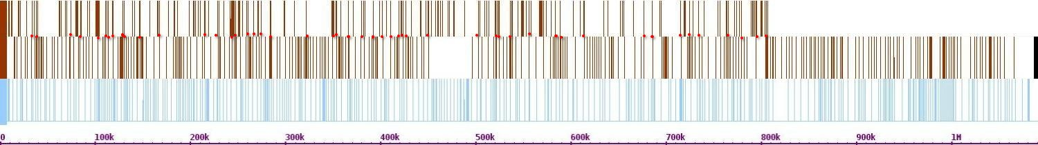Fig.601. Crosslinks between chr 7 and chr 12

Chr 13(r)

Chr 13(h)

Chr 7(h)

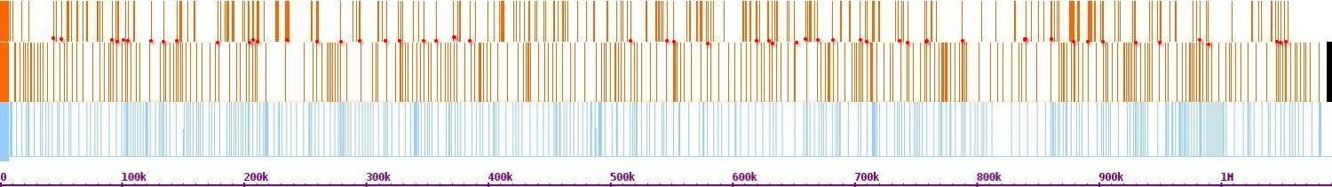Fig.602. Crosslinks between chr 7 and chr 13

Chr 14(r)

Chr 14(h)

Chr 7(h)

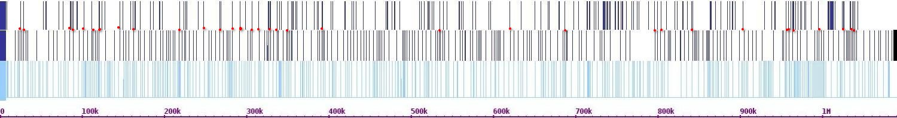Fig.603. Crosslinks between chr 7 and chr 14

Chr 15(r)

Chr 15(h)

Chr 7(h)

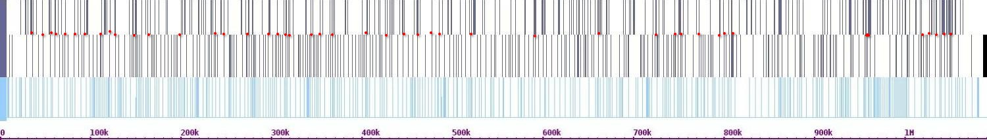Fig.604. Crosslinks between chr 7 and chr 15

Chr 16(r)

Chr 16(h)

Chr 7(h)

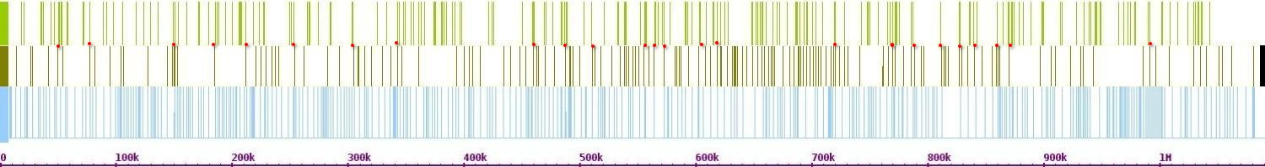Fig.605. Crosslinks between chr 7 and chr 16

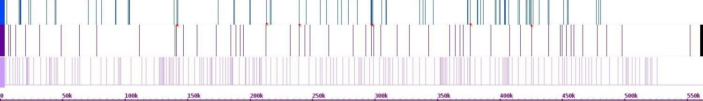 Fig.606. Crosslinks between chr 8 and chr 1

Chr 1(r)

Chr 1(h)

Chr 8(h)

Chr 2(r)

Chr 2(h)

Chr 8(h)

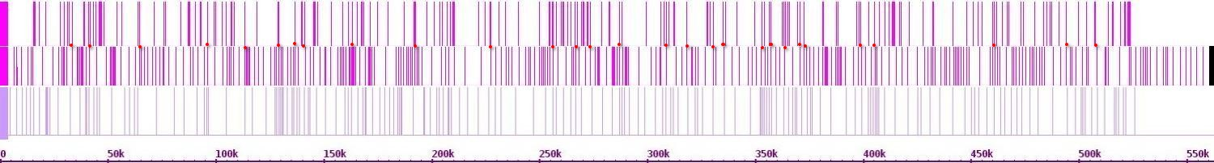Fig.607. Crosslinks between chr 8 and chr 2

Chr 3(r)

Chr 3(h)

Chr 8(h)

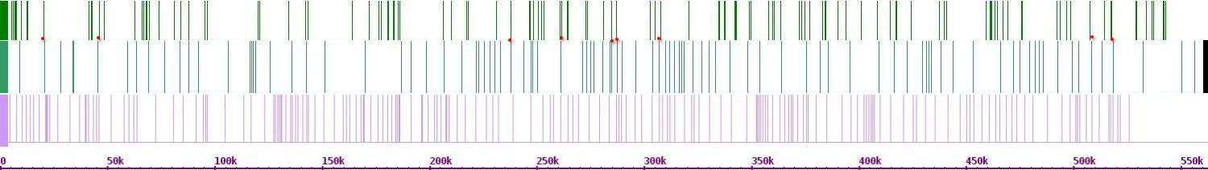 Fig.608. Crosslinks between chr 8 and chr 3

Chr 4(r)

Chr 4(h)

Chr 8(h)

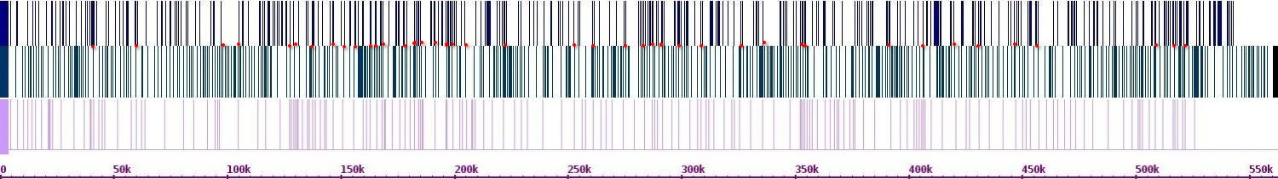

Fig.609. Crosslinks between chr 8 and chr 4

Chr 5(r)

Chr 5(h)

Chr 8(h)

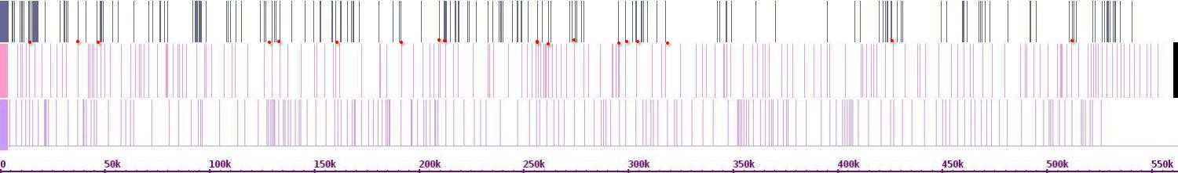

Fig.610. Crosslinks between chr 8 and chr 5

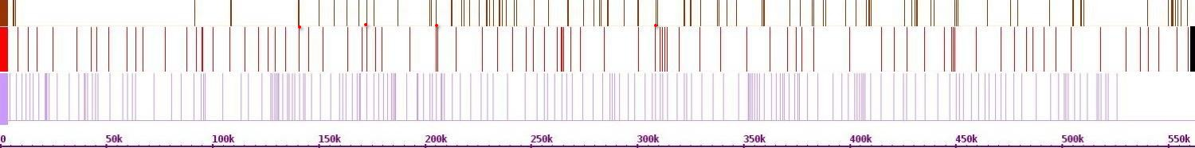

Chr 6(r)

Chr 6(h)

Chr 8(h)

Fig.611. Crosslinks between chr 8 and chr 6

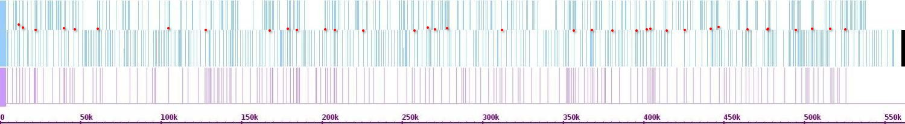 Fig.612. Crosslinks between chr 8 and chr 7

Chr 7(r)

Chr 7(h)

Chr 8(h)

Chr 9(r)

Chr 9(h)

Chr 8(h)

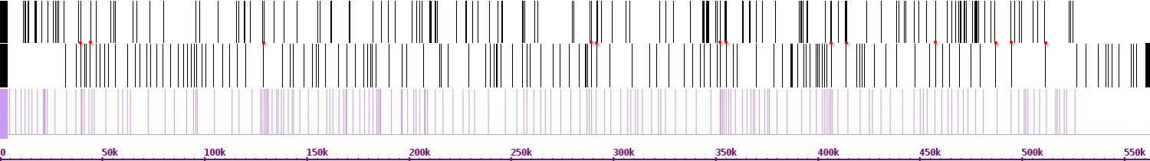Fig.613. Crosslinks between chr 8 and chr 9

Chr 10(r)

Chr 10(h)

Chr 8(h)

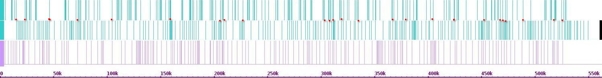

Fig.614. Crosslinks between chr 8 and chr 10

Chr 11(r)

Chr 11(h)

Chr 8(h)

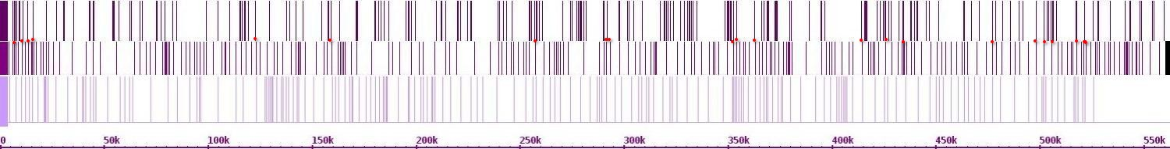 Fig.615. Crosslinks between chr 8 and chr 11

Chr 12(r)

Chr 12(h)

Chr 8(h)

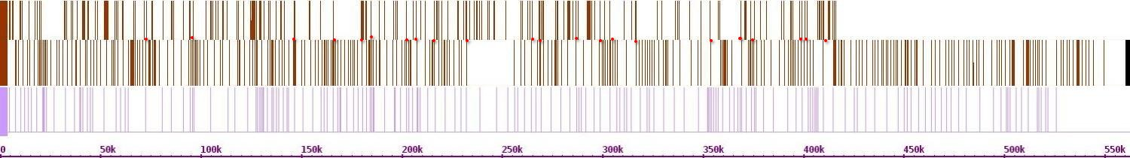 Fig.616. Crosslinks between chr 8 and chr 12

Chr 13(r)

Chr 13(h)

Chr 8(h)

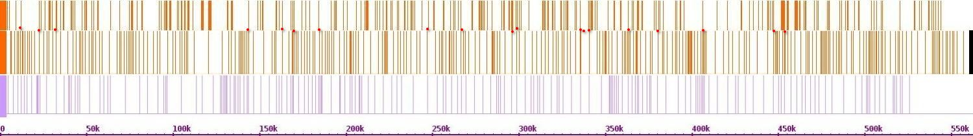Fig.617. Crosslinks between chr 8 and chr 13

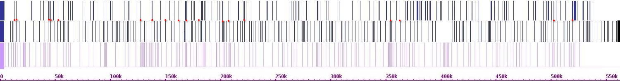 Fig.618. Crosslinks between chr 8 and chr 14

Chr 14(r)

Chr 14(h)

Chr 8(h)

Chr 15(r)

Chr 15(h)

Chr 8(h)

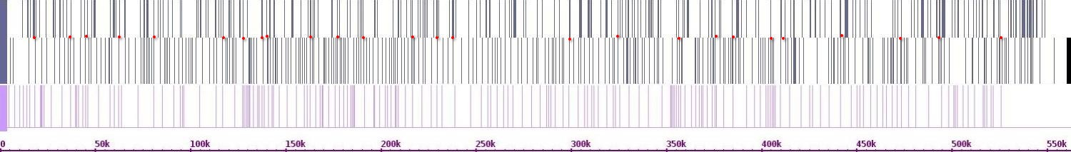Fig.619. Crosslinks between chr 8 and chr 15

Chr 16(r)

Chr 16(h)

Chr 8(h)

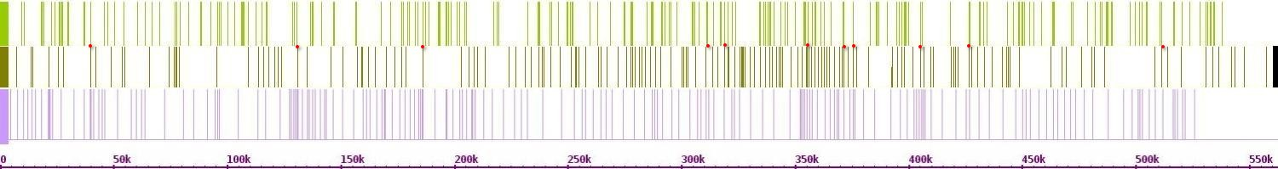Fig.620. Crosslinks between chr 8 and chr 16

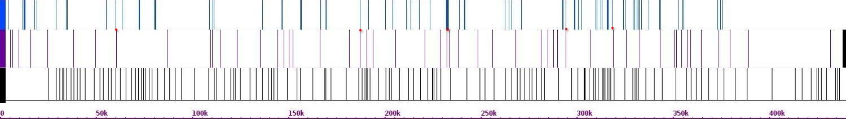Fig.621. Crosslinks between chr 9 and chr 1

Chr 1(r)

Chr 1(h)

Chr 9(h)

Chr 2(r)

Chr 2(h)

Chr 9(h)

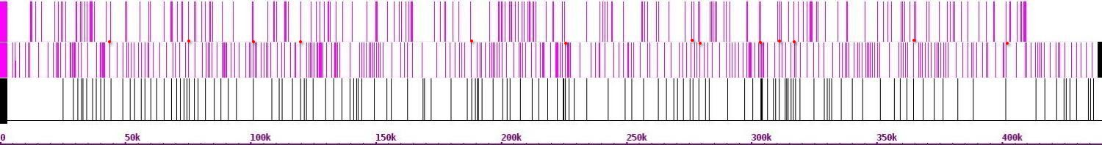 Fig.622. Crosslinks between chr 9 and chr 2

Chr 3(r)

Chr 3(h)

Chr 9(h)

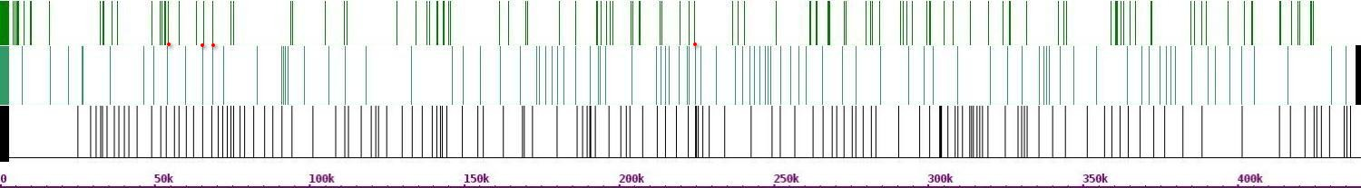Fig.623. Crosslinks between chr 9 and chr 3

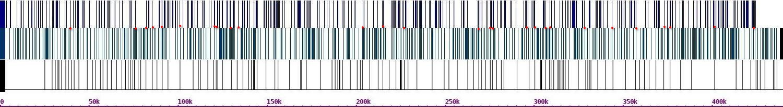 Fig.624. Crosslinks between chr 9 and chr 4

Chr 4(r)

Ch41(h)

Chr 9(h)

Chr 5(r)

Chr 5(h)

Chr 9(h)

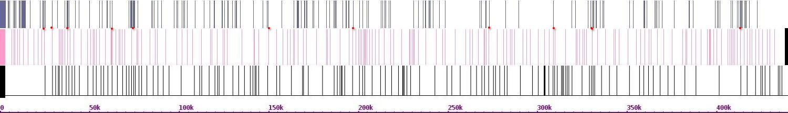Fig.625. Crosslinks between chr 9 and chr 5

Chr 6(r)

Chr 6(h)

Chr 9(h)

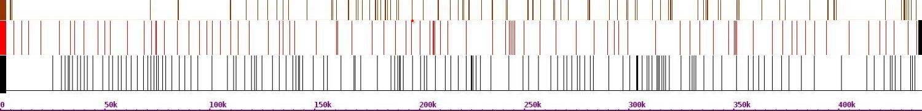Fig.626. Crosslinks between chr 9 and chr 6

Chr 7(r)

Chr 7(h)

Chr 9(h)

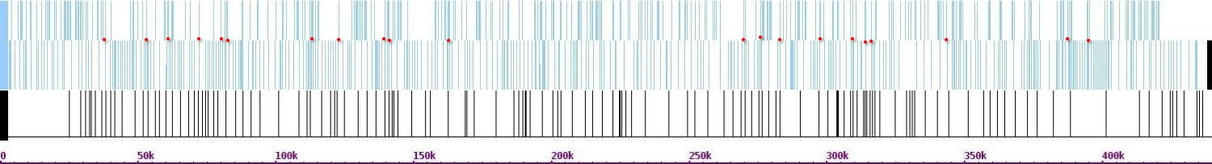Fig.627. Crosslinks between chr 9 and chr 7

Chr 8(r)

Chr 8(h)

Chr 9(h)

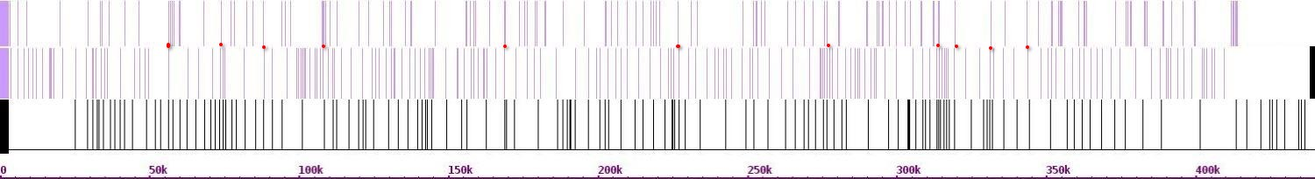Fig.628. Crosslinks between chr 9 and chr 8

Chr 10(r)

Chr 10(h)

Chr 9(h)

Chr 9(r)

Chr 19h)

Chr 9(h)

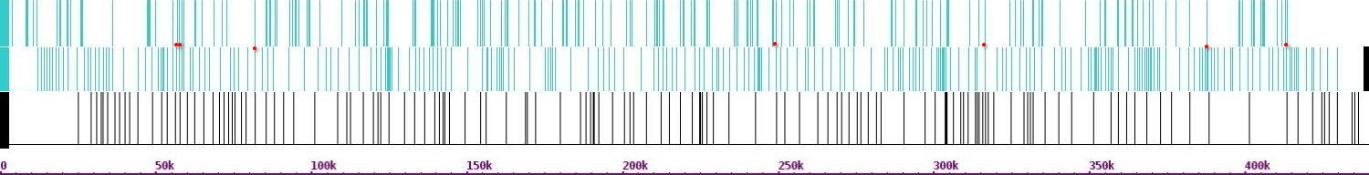Fig.629. Crosslinks between chr 9 and chr 10

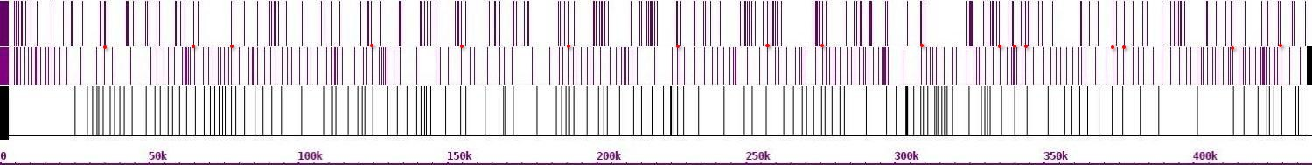 Fig.630. Crosslinks between chr 9 and chr 11

Chr 11(r)

Chr 11(h)

Chr 9(h)

Chr 12(r)

Chr 12(h)

Chr 9(h)

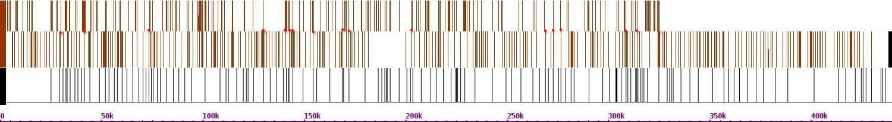Fig.631. Crosslinks between chr 9 and chr 12

Chr 13(r)

Chr 13(h)

Chr 9(h)

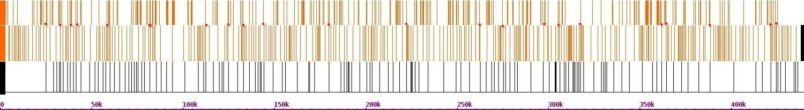 Fig.632. Crosslinks between chr 9 and chr 13

Chr 14(r)

Chr 14(h)

Chr 9(h)

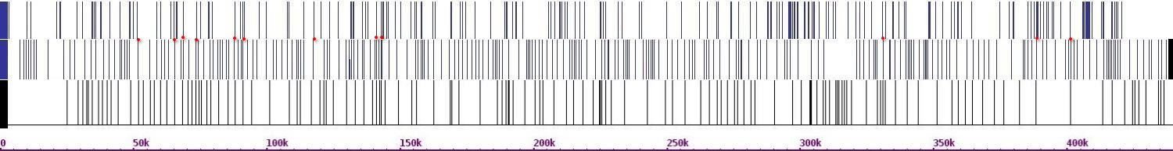 Fig.633. Crosslinks between chr 9 and chr 14

Chr 15(r)

Chr 15(h)

Chr 9(h)

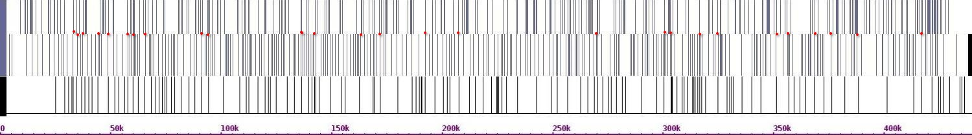 Fig.634. Crosslinks between chr 9 and chr 15

Chr 16(r)

Chr 16(h)

Chr 9(h)

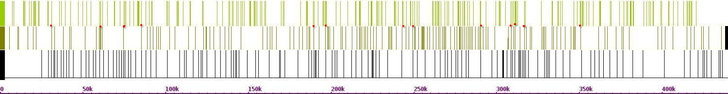 Fig.635. Crosslinks between chr 9 and chr 16

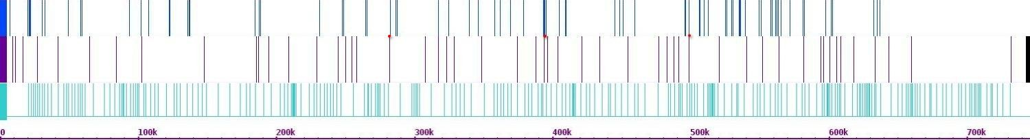 Fig.636. Crosslinks between chr 10 and chr 1

Chr 1(r)

Chr 1(h)

Chr 10(h)

Chr 2(r)

Chr 2(h)

Chr 10(h)

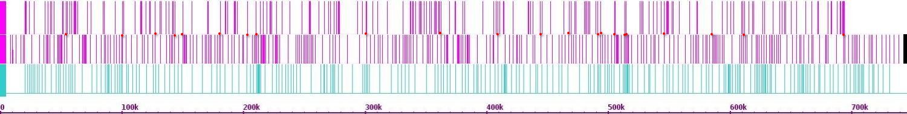 Fig.637. Crosslinks between chr 10 and chr 2

Chr 3(r)

Chr 3(h)

Chr 10(h)

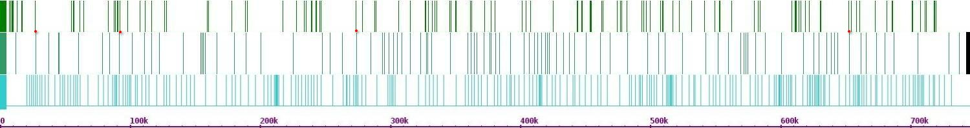 Fig.638. Crosslinks between chr 10 and chr 3

Chr 4(r)

Chr 4(h)

Chr 10(h)

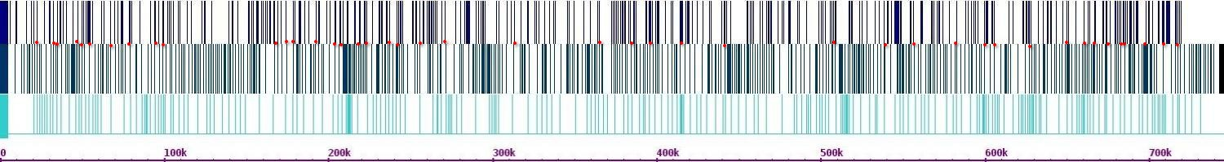 Fig.639. Crosslinks between chr 10 and chr 4

Chr 5(r)

Chr 5(h)

Chr 10(h)

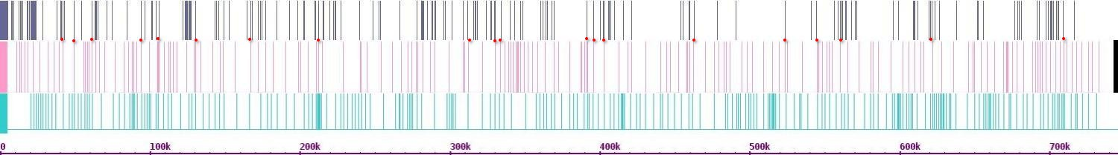 Fig.640. Crosslinks between chr 10 and chr 5

Chr 6(r)

Chr 6(h)

Chr 10(h)

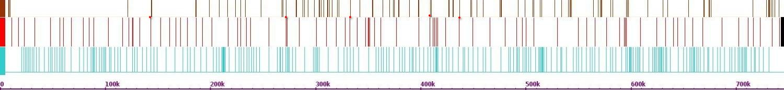 Fig.641. Crosslinks between chr 10 and chr 6

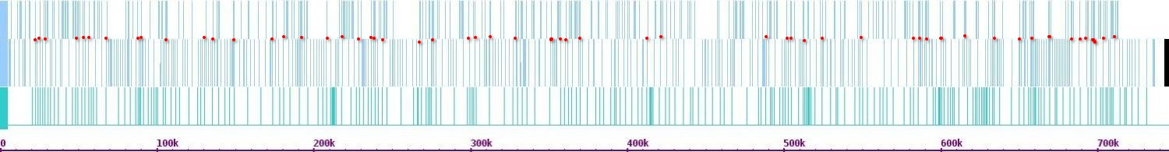 Fig.642. Crosslinks between chr 10 and chr 7

Chr 7(r)

Chr 7(h)

Chr 10(h)

Chr 8(r)

Chr 8(h)

Chr 10(h)

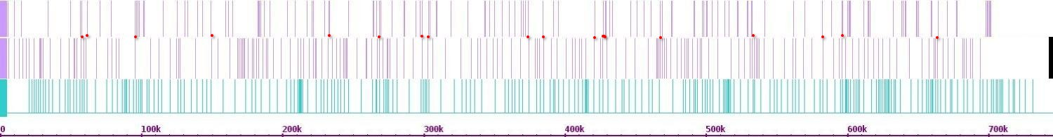 Fig.643. Crosslinks between chr 10 and chr 8

Chr 9(r)

Chr 9(h)

Chr 10(h)

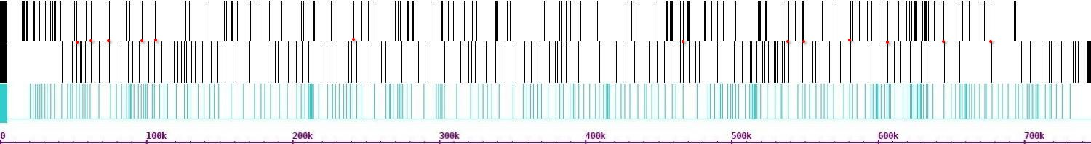 Fig.644. Crosslinks between chr 10 and chr 9

Chr 11(r)

Chr 11(h)

Chr 10(h)

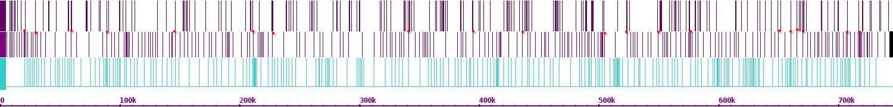Fig.645. Crosslinks between chr 10 and chr 11

Chr 12(r)

Chr 12(h)

Chr 10(h)

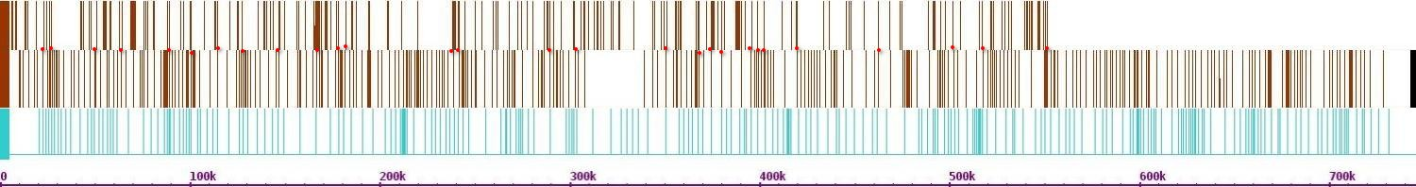 Fig.646. Crosslinks between chr 10 and chr 12

Chr 13(r)

Chr 13(h)

Chr 10(h)

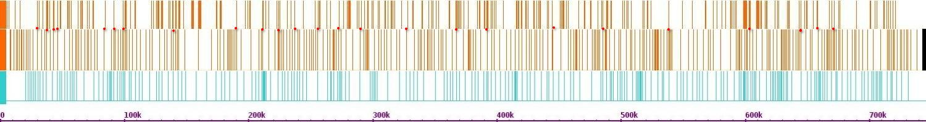Fig.647. Crosslinks between chr 10 and chr 13

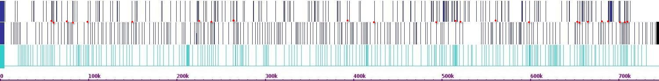 Fig.648. Crosslinks between chr 10 and chr 14

Chr 14(r)

Chr 14(h)

Chr 10(h)

Chr 15(r)

Chr 15(h)

Chr 10(h)

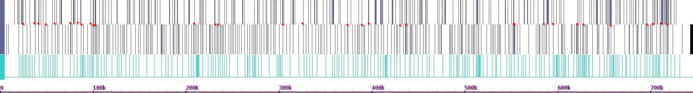

Fig.649. Crosslinks between chr 10 and chr 15

Chr 16(r)

Chr 16(h)

Chr 10(h)

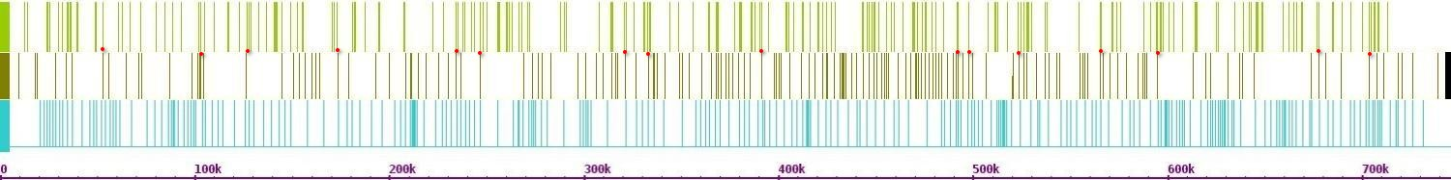 Fig.650. Crosslinks between chr 10 and chr 16

Chr 1(r)

Chr 1(h)

Chr 11(h)

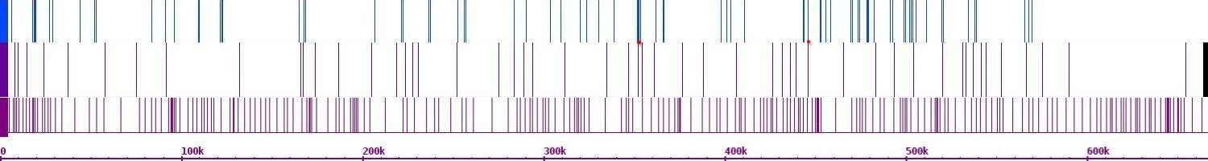 Fig.651. Crosslinks between chr 11 and chr 1

Chr 2(r)

Chr 2(h)

Chr 11(h)

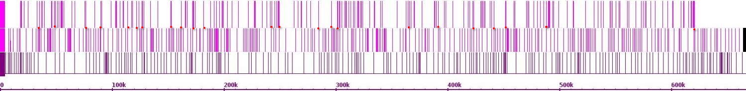 Fig.652. Crosslinks between chr 11 and chr 2

Chr 3(r)

Chr 3(h)

Chr 11(h)

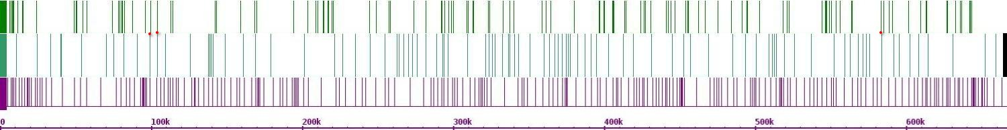 Fig.653. Crosslinks between chr 11 and chr 3

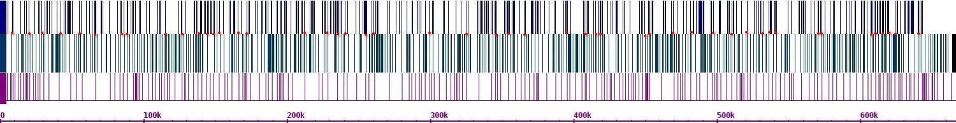 Fig.654. Crosslinks between chr 11 and chr 4

Chr 4(r)

Chr 4(h)

Chr 11(h)

Chr 5(r)

Chr 5(h)

Chr 11(h)

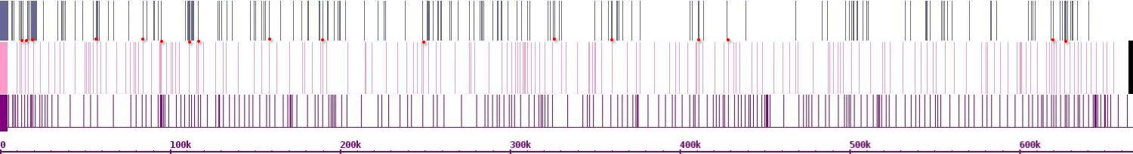 Fig.655. Crosslinks between chr 11 and chr 5

Chr 6(r)

Chr 6(h)

Chr 11(h)

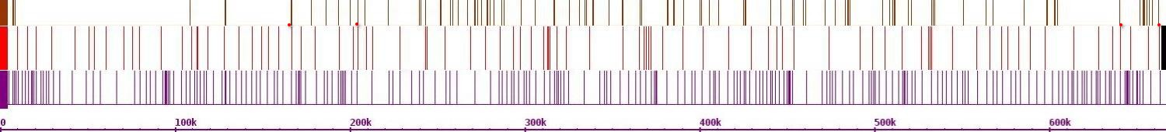 Fig.656. Crosslinks between chr 11 and chr 6

Chr 7(r)

Chr 7(h)

Chr 11(h)

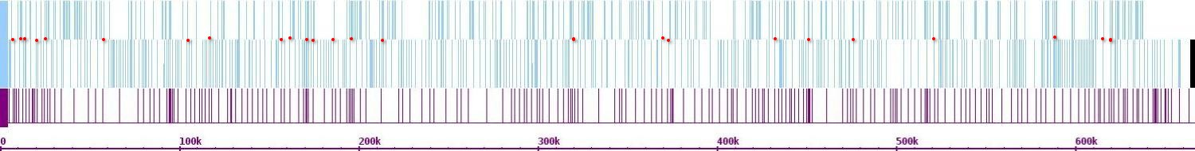 Fig.657. Crosslinks between chr 11 and chr 7

Chr 8(r)

Chr 8(h)

Chr 11(h)

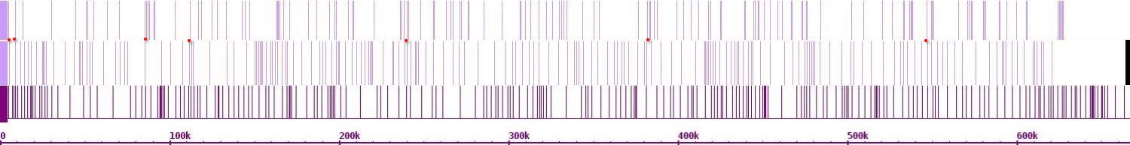 Fig.658. Crosslinks between chr 11 and chr 8

Chr 9(r)

Chr 9(h)

Chr 11(h)

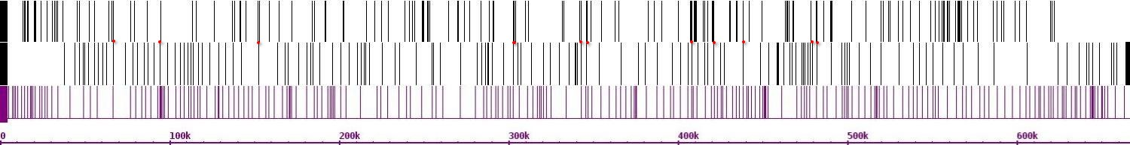 Fig.659. Crosslinks between chr 11 and chr 9

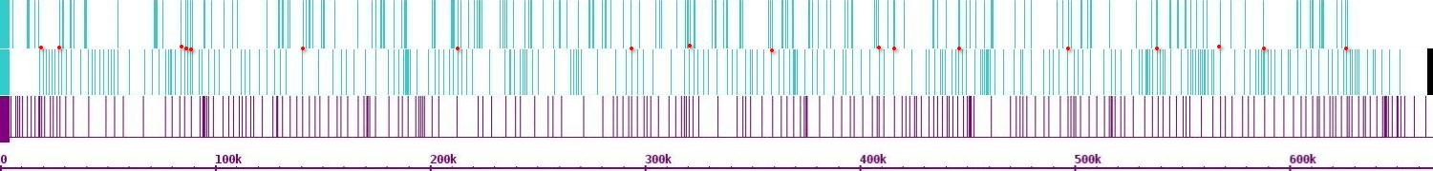 Fig.660. Crosslinks between chr 11 and chr 10

Chr 10(r)

Chr 10(h)

Chr 11(h)

Chr 12(r)

Chr 12(h)

Chr 11(h)

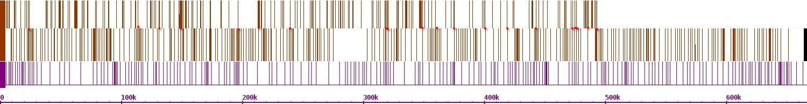 Fig.661. Crosslinks between chr 11 and chr 12

Chr 13(r)

Chr 13(h)

Chr 11(h)

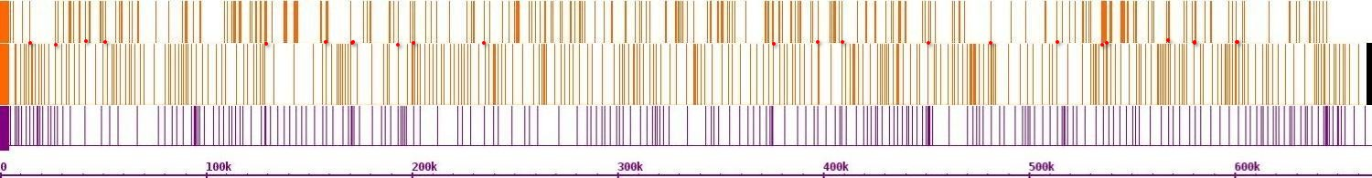 Fig.662. Crosslinks between chr 11 and chr 13

Chr 14(r)

Chr 14(h)

Chr 11(h)

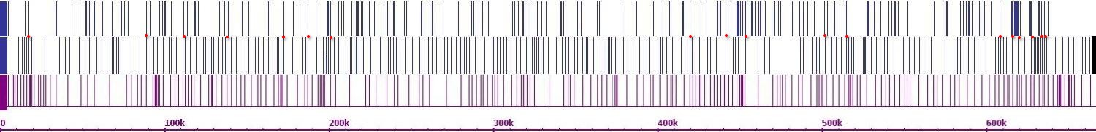 Fig.663. Crosslinks between chr 11 and chr 14

Chr 15(r)

Chr 15(h)

Chr 11(h)

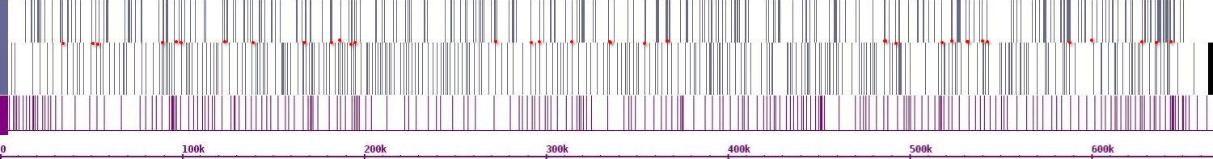 Fig.664. Crosslinks between chr 11 and chr 15

Chr 16(r)

Chr 16(h)

Chr 11(h)

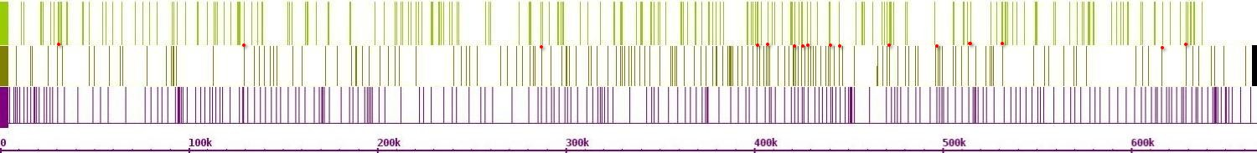 Fig.665. Crosslinks between chr 11 and chr 16

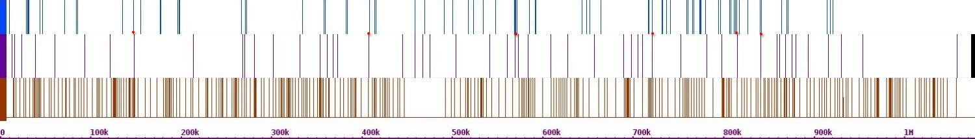 Fig.666. Crosslinks between chr 12 and chr 1

Chr 1(r)

Chr 1(h)

Chr 12(h)

Chr 2(r)

Chr 2(h)

Chr 12(h)

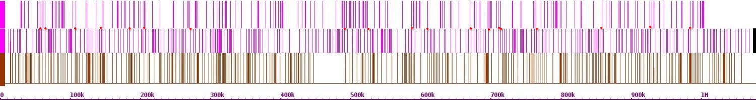

Fig.667. Crosslinks between chr 12 and chr 2

Chr 3(r)

Chr 3(h)

Chr 12(h)

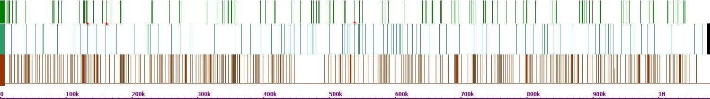

Fig.668. Crosslinks between chr 12 and chr 3

Chr 4(r)

Chr 4(h)

Chr 12(h)

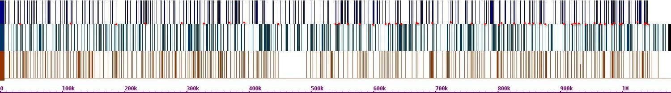

Fig.669. Crosslinks between chr 12 and chr 4

Chr 5(r)

Chr 5(h)

Chr 12(h)

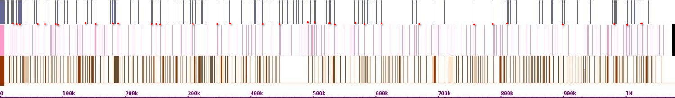

Fig.670. Crosslinks between chr 12 and chr 5

Chr 6(r)

Chr 6(h)

Chr 12(h)

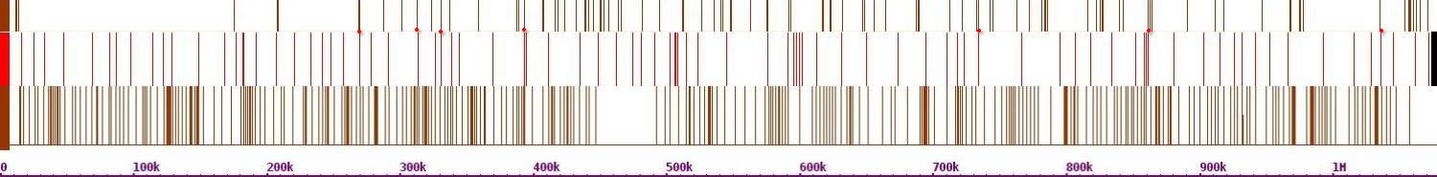 Fig.671. Crosslinks between chr 12 and chr 6

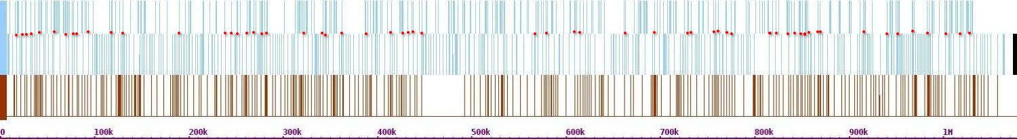Fig.672. Crosslinks between chr 12 and chr 7

Chr 7(r)

Chr 7(h)

Chr 12(h)

Chr 8(r)

Chr 8(h)

Chr 12(h)

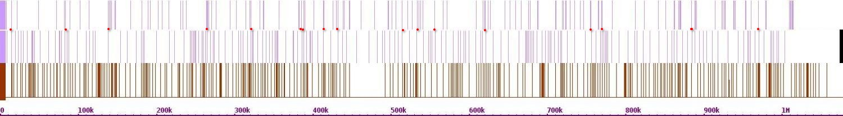

Fig.673. Crosslinks between chr 12 and chr 8

Chr 9(r)

Chr 9(h)

Chr 12(h)

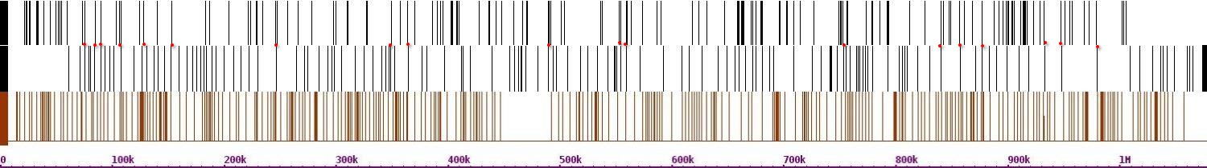 Fig.674. Crosslinks between chr 12 and chr 9

Chr 10(r)

Chr 10(h)

Chr 12(h)

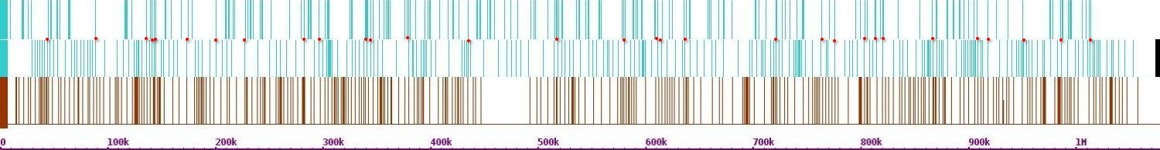 Fig.675. Crosslinks between chr 12 and chr 10

Chr 11(r)

Chr 11(h)

Chr 12(h)

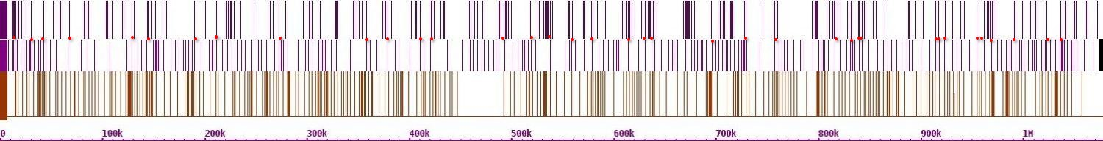 Fig.676. Crosslinks between chr 12 and chr 11

Chr 13(r)

Chr 13(h)

Chr 12(h)

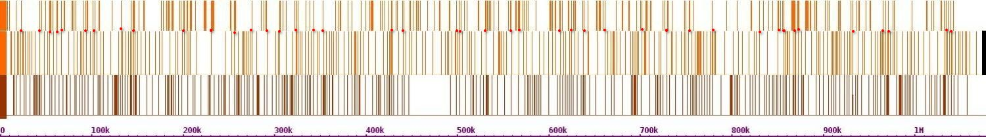 Fig.677. Crosslinks between chr 12 and chr 13

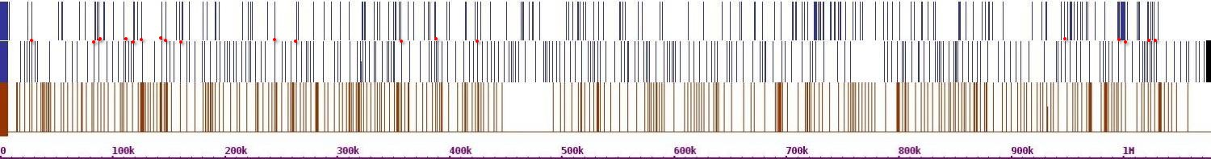

Chr 14(r)

Chr 14(h)

Chr 12(h)

Fig.678. Crosslinks between chr 12 and chr 14

Chr 15(r)

Chr 15(h)

Chr 12(h)

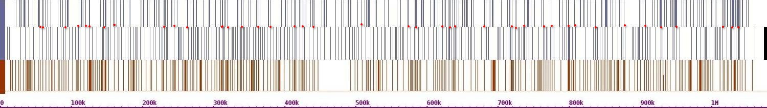 Fig.679. Crosslinks between chr 12 and chr 15

Chr 16(r)

Chr 16(h)

Chr 12(h)

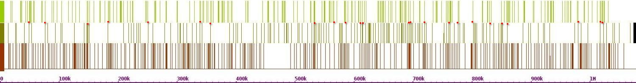 Fig.680. Crosslinks between chr 12 and chr 16

Chr 1(r)

Chr 1(h)

Chr 13(h)

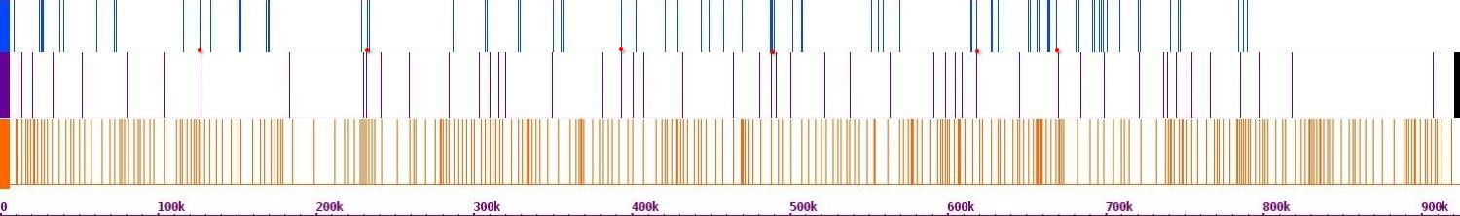Fig.681. Crosslinks between chr 13 and chr 1

Chr 2(r)

Chr 2(h)

Chr 13(h)

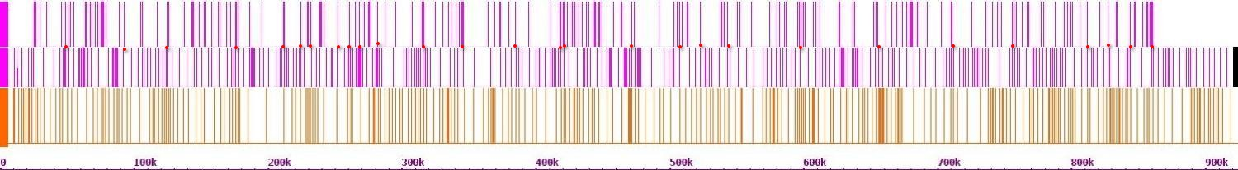Fig.682. Crosslinks between chr 13 and chr 2

Chr 3(r)

Chr 3(h)

Chr 13(h)

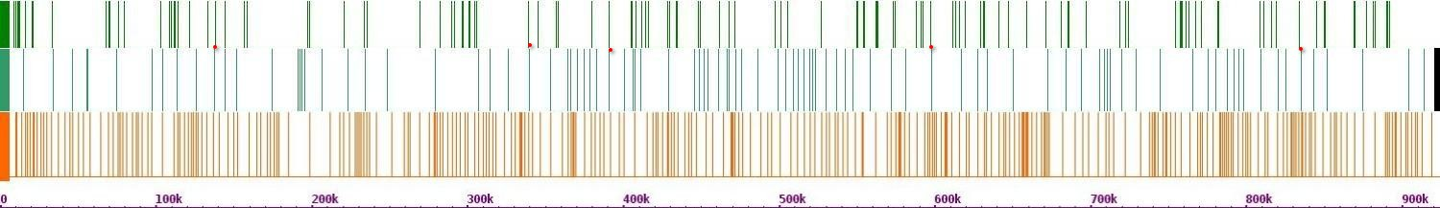 Fig.683. Crosslinks between chr 13 and chr 3

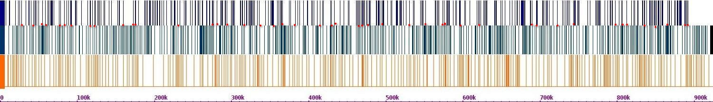 Fig.684. Crosslinks between chr 13 and chr 4

Chr 4(r)

Chr 4(h)

Chr 13(h)

Chr 5(r)

Chr 5(h)

Chr 13(h)

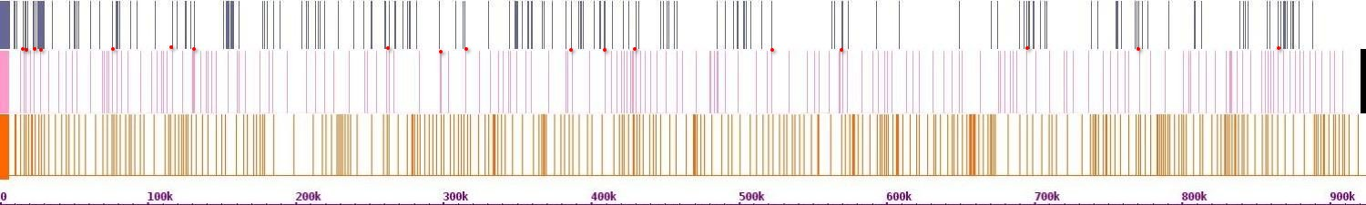Fig.685. Crosslinks between chr 13 and chr 5

Chr 6(r)

Ch6r(h)

Chr 13(h)

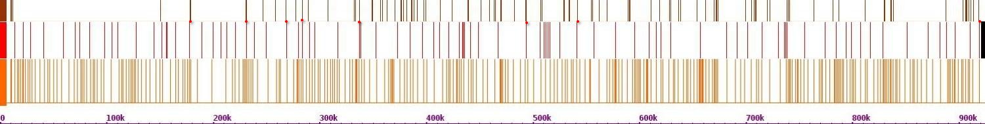Fig.686. Crosslinks between chr 13 and chr 6

Chr 7(r)

Chr 7(h)

Chr 13(h)

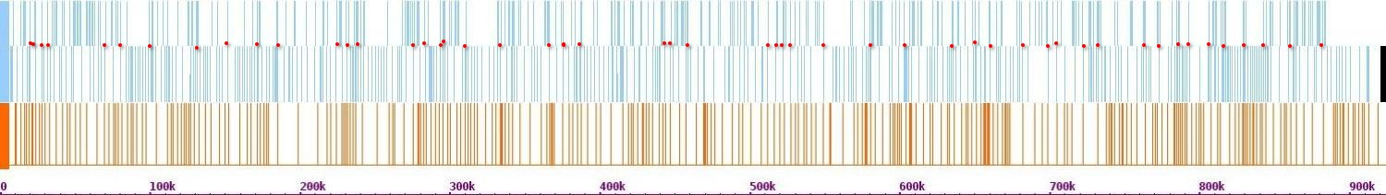 Fig.687. Crosslinks between chr 13 and chr 7

Chr 8(r)

Chr 8(h)

Chr 13(h)

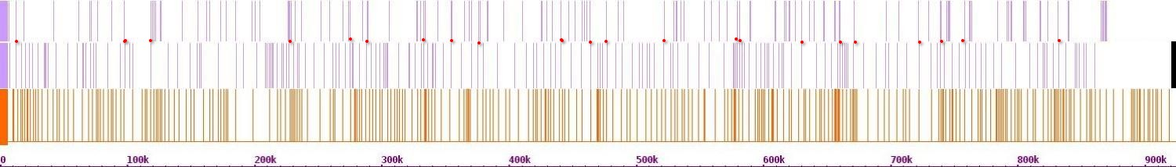 Fig.688. Crosslinks between chr 13 and chr 8

Chr 9(r)

Chr 9(h)

Chr 13(h)

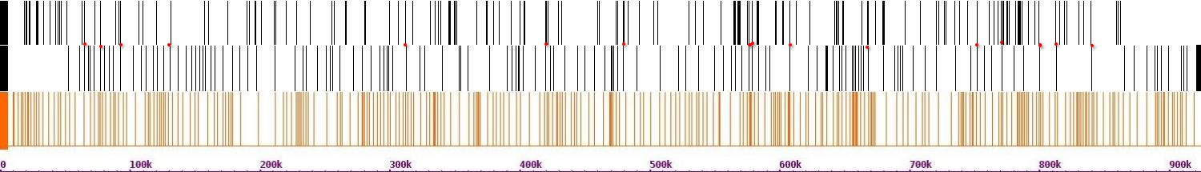 Fig.689. Crosslinks between chr 13 and chr 9

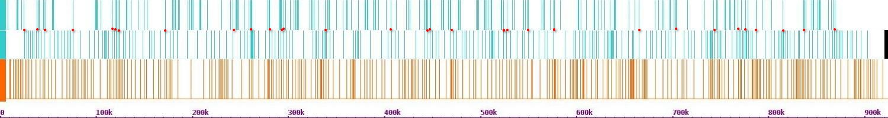Fig.670. Crosslinks between chr 13 and chr 10

Chr 10(r)

Chr 10(h)

Chr 13(h)

Chr 11(r)

Chr 11(h)

Chr 13(h)

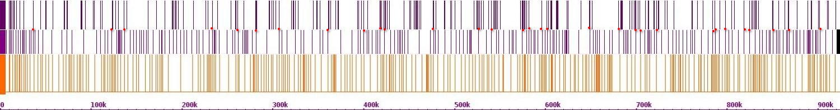 Fig.671. Crosslinks between chr 13 and chr 11

Chr 12(r)

Chr 12(h)

Chr 13(h)

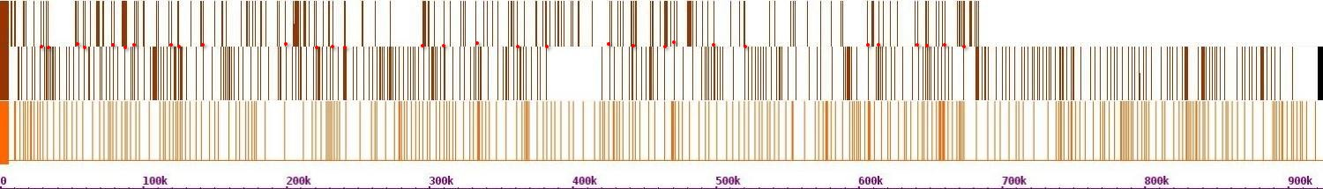 Fig.672. Crosslinks between chr 13 and chr 12

Chr 14(r)

Chr 14(h)

Chr 13(h)

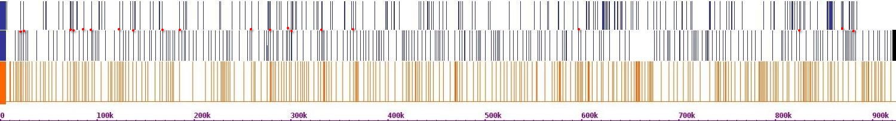Fig.673. Crosslinks between chr 13 and chr 14

Chr 15(r)

Chr 15(h)

Chr 13(h)

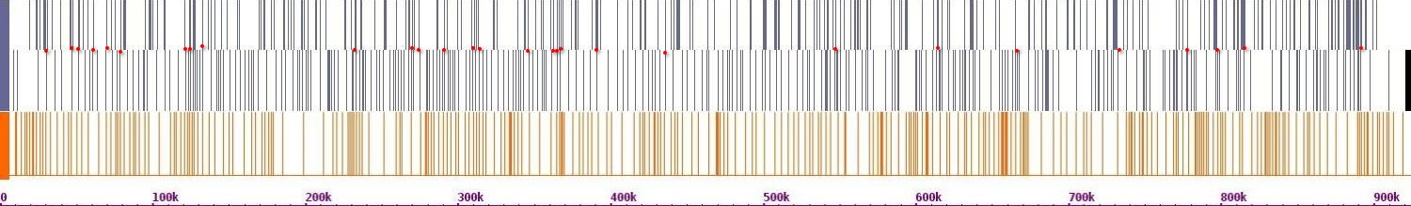Fig.674. Crosslinks between chr 13 and chr 15

Chr 16(r)

Chr 16(h)

Chr 13(h)

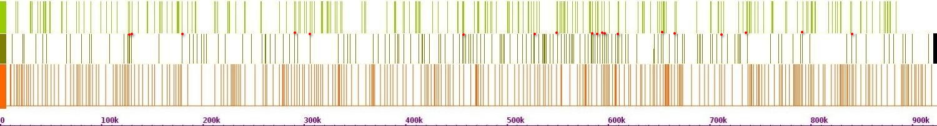 Fig.675. Crosslinks between chr 13 and chr 16

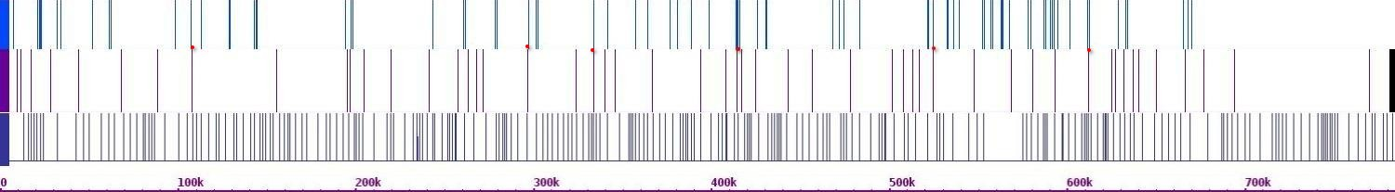Fig.676. Crosslinks between chr 14 and chr 1

Chr 1(r)

Chr 1(h)

Chr 14(h)

Chr 2(r)

Chr 2(h)

Chr 14(h)

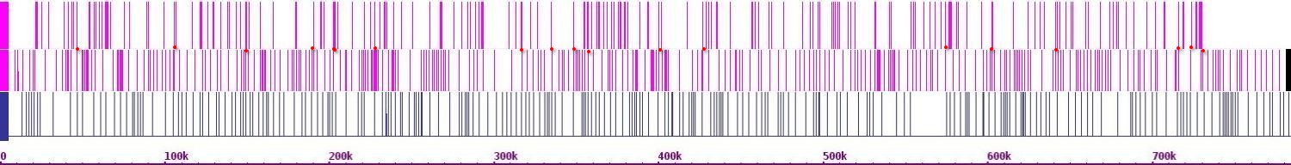 Fig.677. Crosslinks between chr 14 and chr 2

Chr 3(r)

Chr 3(h)

Chr 14(h)

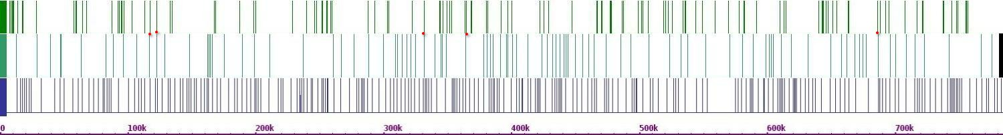Fig.678. Crosslinks between chr 14 and chr 3

Chr 4(r)

Chr 4(h)

Chr 14(h)

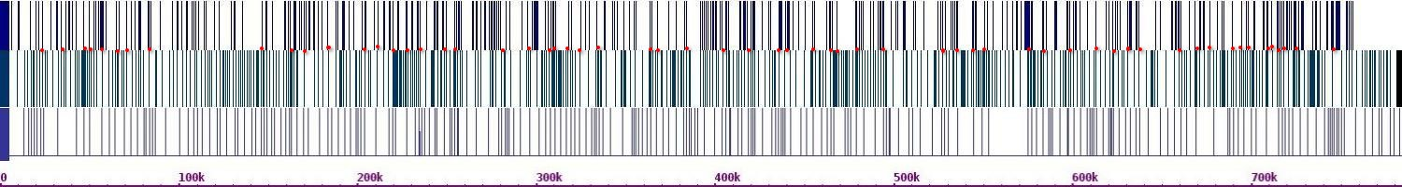 Fig.679. Crosslinks between chr 14 and chr 4

Chr 5(r)

Chr 5(h)

Chr 14(h)

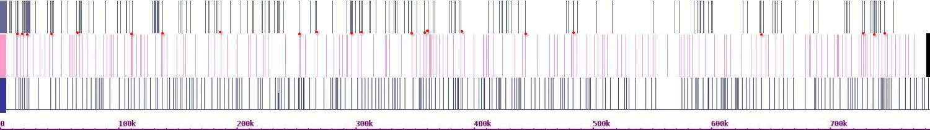 Fig.680. Crosslinks between chr 14 and chr 5

Chr 6(r)

Chr 6(h)

Chr 14(h)

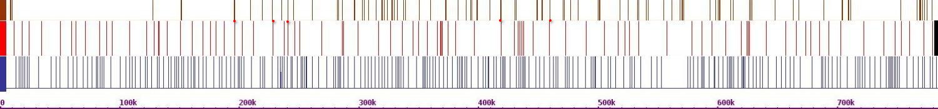 Fig.681. Crosslinks between chr 14 and chr 6

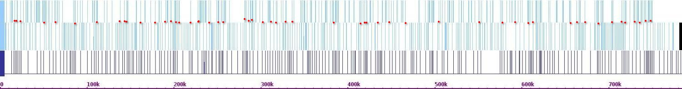 Fig.682. Crosslinks between chr 14 and chr 7

Chr 7(r)

Chr 7(h)

Chr 14(h)

Chr 8(r)

Chr 8(h)

Chr 14(h)

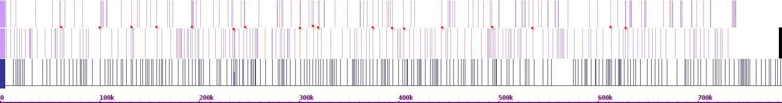Fig.683. Crosslinks between chr 14 and chr 8

Chr 9(r)

Chr 9(h)

Chr 14(h)

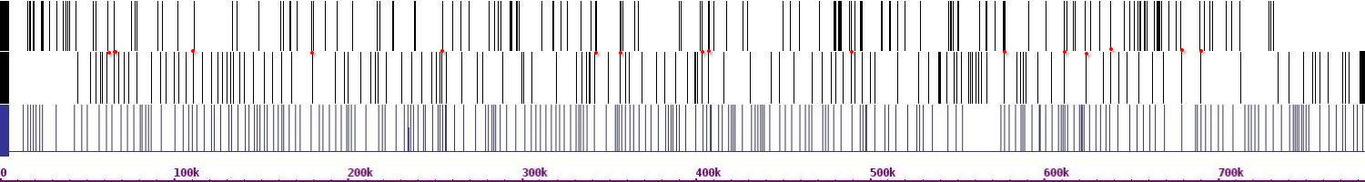Fig.684. Crosslinks between chr 14 and chr 9

Chr 10(r)

Chr 10(h)

Chr 14(h)

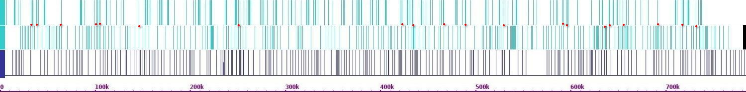 Fig.685. Crosslinks between chr 14 and chr 10

Chr 11(r)

Chr 11(h)

Chr 14(h)

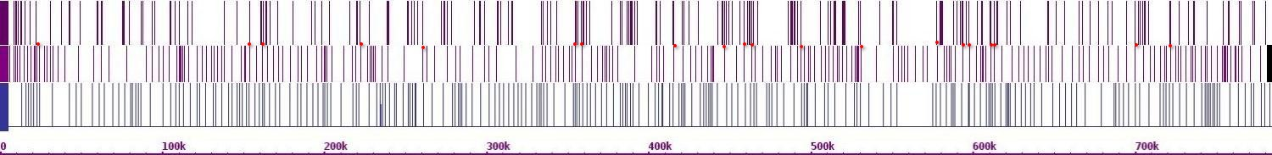Fig.686. Crosslinks between chr 14 and chr 11

Chr 12(r)

Chr 12(h)

Chr 14(h)

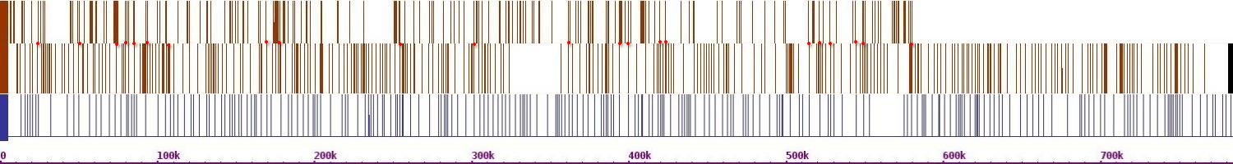Fig.687. Crosslinks between chr 14 and chr 12

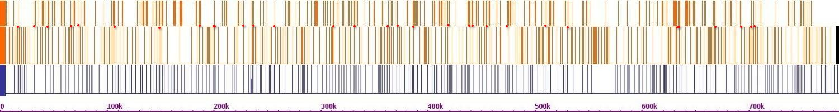 Fig.688. Crosslinks between chr 14 and chr 13

Chr 13(r)

Chr 13(h)

Chr 14(h)

Chr 15(r)

Chr 15(h)

Chr 14(h)

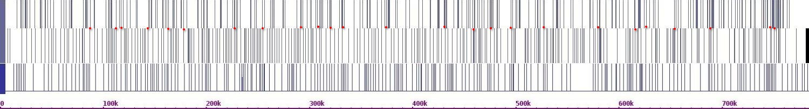 Fig.689. Crosslinks between chr 14 and chr 15

Chr 16(r)

Ch16r(h)

Chr 14(h)

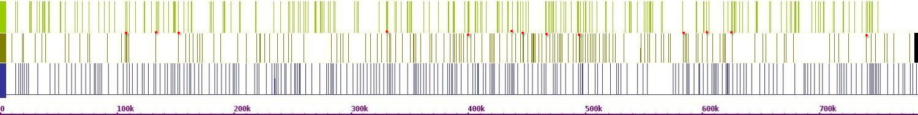Fig.690. Crosslinks between chr 14 and chr 16

Chr 1(r)

Chr 1(h)

Chr 15(h)

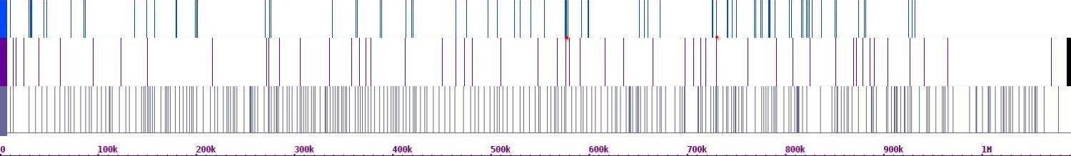 Fig.691. Crosslinks between chr 15 and chr 1

Chr 2(r)

Chr 2(h)

Chr 15(h)

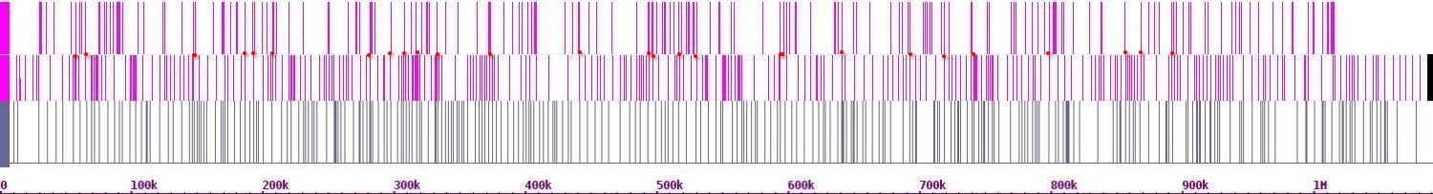Fig.692. Crosslinks between chr 15 and chr 2

Chr 3(r)

Chr 3(h)

Chr 15(h)

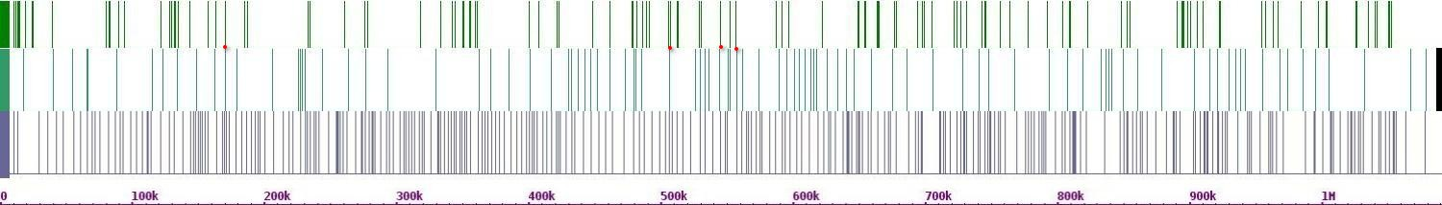Fig.693. Crosslinks between chr 15 and chr 3

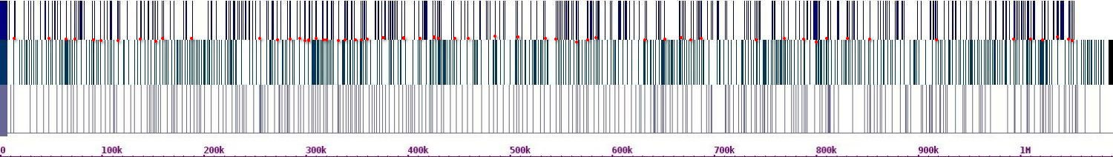 Fig.694. Crosslinks between chr 15 and chr 4

Chr 4(r)

Chr 4(h)

Chr 15(h)

Chr 5(r)

Chr 5(h)

Chr 15(h)

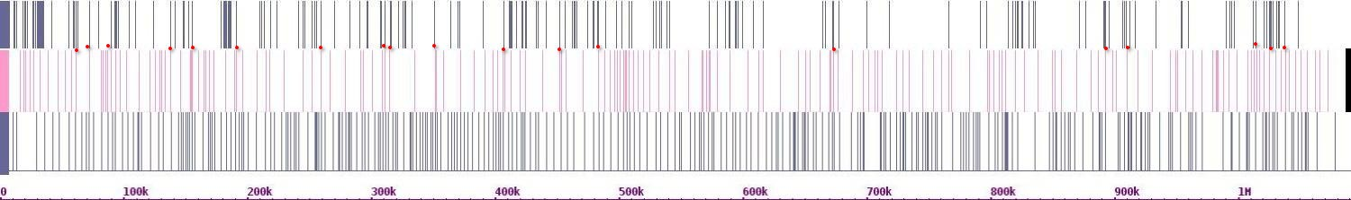 Fig.695. Crosslinks between chr 15 and chr 5

Chr 6(r)

Chr 6(h)

Chr 15(h)

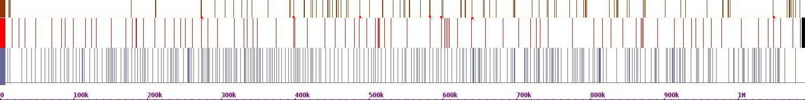 Fig.696. Crosslinks between chr 15 and chr 6

Chr 7(r)

Chr 7(h)

Chr 15(h)

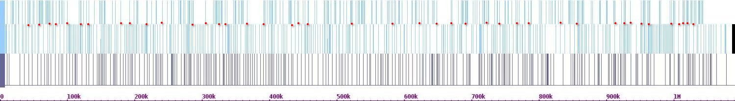 Fig.697. Crosslinks between chr 15 and chr 7

Chr 8(r)

Chr 8(h)

Chr 15(h)

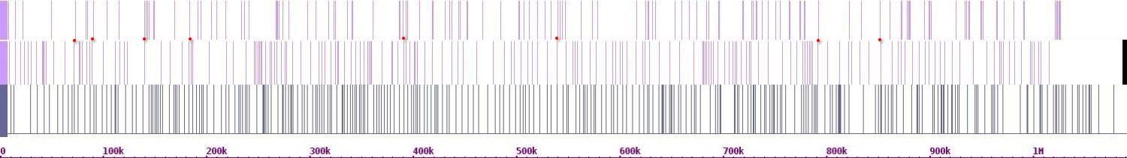Fig.698. Crosslinks between chr 15 and chr 8

Chr 9(r)

Chr 9(h)

Chr 15(h)

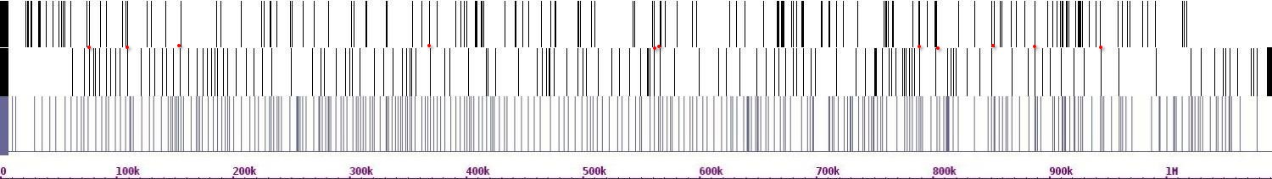 Fig.699. Crosslinks between chr 15 and chr 9

Chr 10(r)

Chr 10(h)

Chr 15(h)

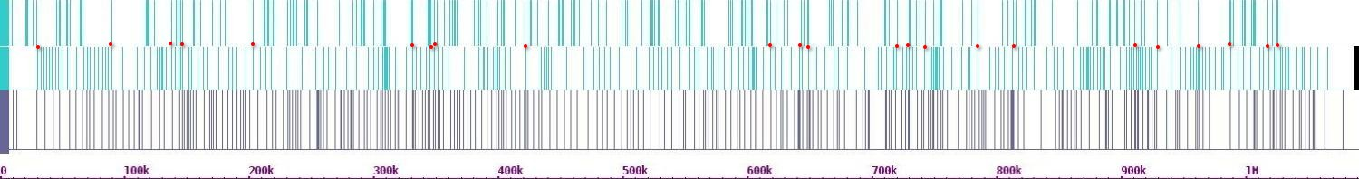Fig.700. Crosslinks between chr 15 and chr 10

Chr 11(r)

Chr 11(h)

Chr 15(h)

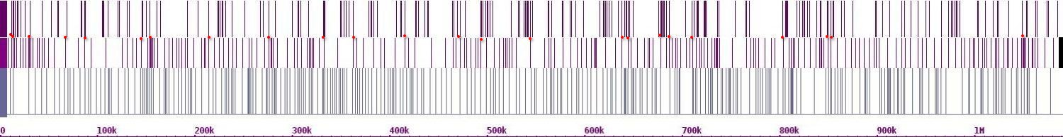Fig.701. Crosslinks between chr 15 and chr 11

Chr 12(r)

Chr 12(h)

Chr 15(h)

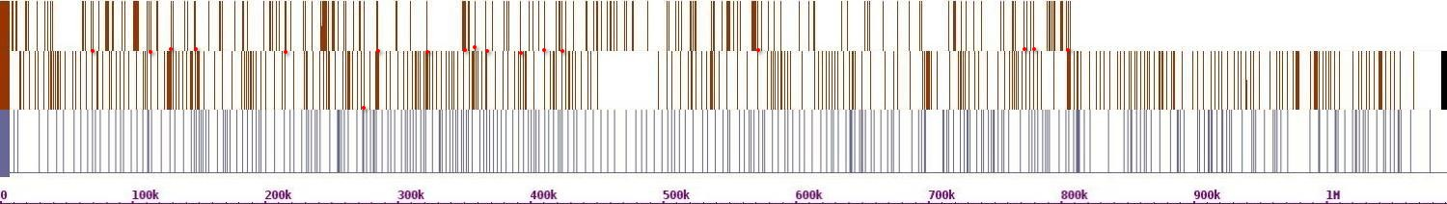Fig.702. Crosslinks between chr 15 and chr 12

Chr 13(r)

Chr 13(h)

Chr 15(h)

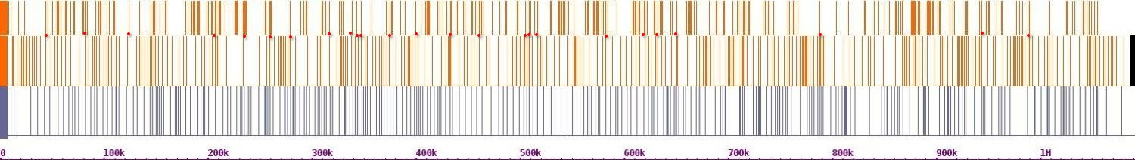Fig.703. Crosslinks between chr 15 and chr 13

Chr 14(r)

Chr 14(h)

Chr 15(h)

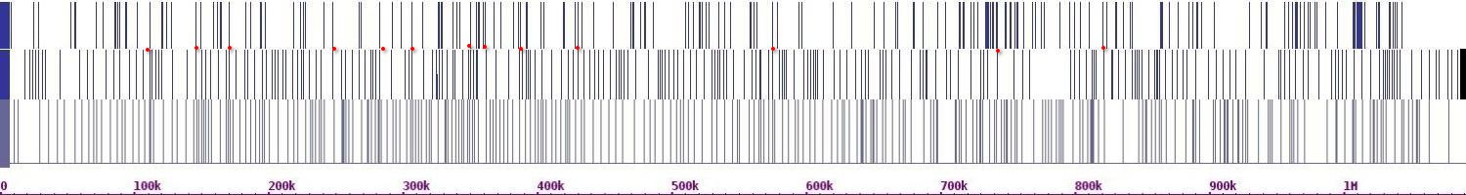

Fig.704. Crosslinks between chr 15 and chr 14

Chr 16(r)

Chr 16(h)

Chr 15(h)

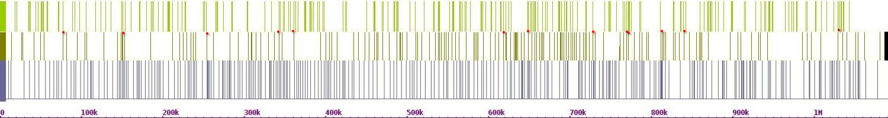

Fig.705. Crosslinks between chr 15 and chr 16

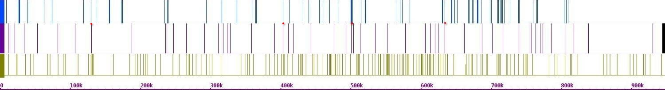

Chr 1(r)

Chr 1(h)

Chr 16(h)

Fig.706. Crosslinks between chr 16 and chr 1

Chr 2(r)

Chr 2(h)

Chr 16(h)

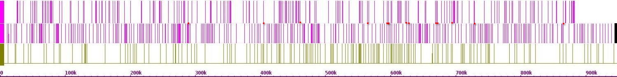

Fig.707. Crosslinks between chr 16 and chr 2

Chr 3(r)

Chr 3(h)

Chr 16(h)

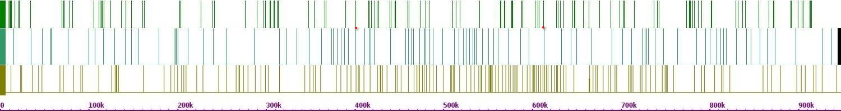

Fig.708. Crosslinks between chr 16 and chr 3

Chr 4(r)

Chr 4(h)

Chr 16(h)

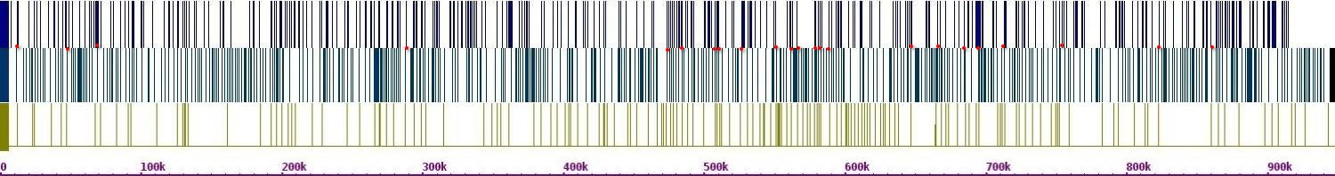

Fig.709. Crosslinks between chr 16 and chr 4

Chr 5(r)

Chr 5(h)

Chr 16(h)

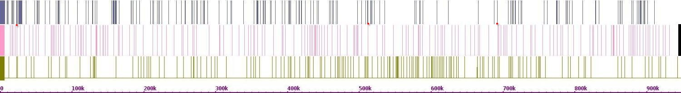

Fig.710. Crosslinks between chr 16 and chr 5

Chr 6(r)

Chr 6(h)

Chr 16(h)

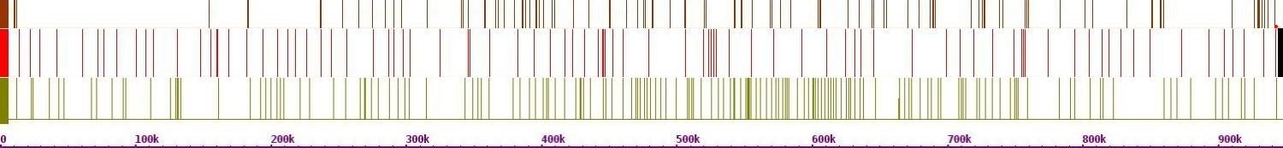

Fig.711. Crosslinks between chr 16 and chr 6

Chr 7(r)

Chr 7(h)

Chr 16(h)

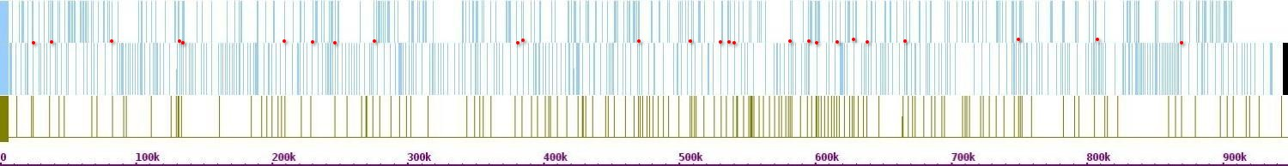

Fig.712. Crosslinks between chr 16 and chr 7

Chr 8(r)

Chr 8(h)

Chr 16(h)

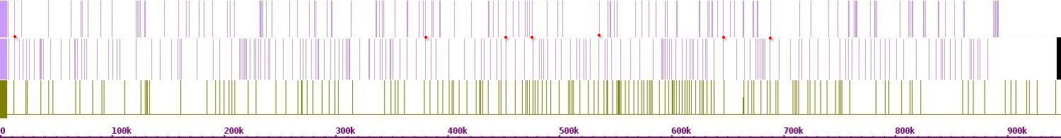

Fig.713. Crosslinks between chr 16 and chr 8

Chr 9(r)

Chr 9(h)

Chr 16(h)

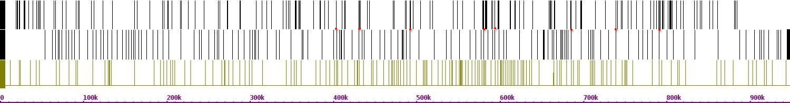

Fig.714. Crosslinks between chr 16 and chr 9

Chr 10(r)

Chr 10(h)

Chr 16(h)

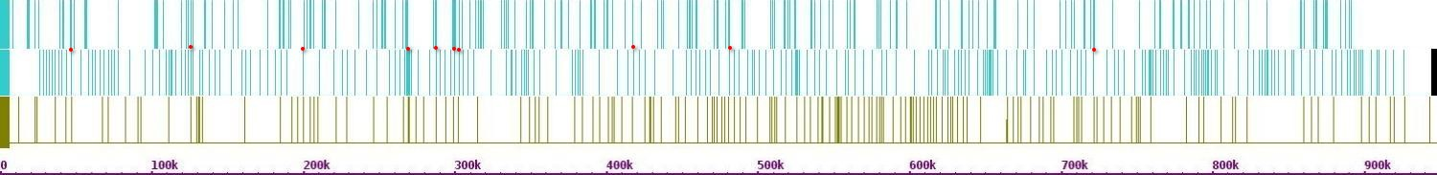

Fig.715. Crosslinks between chr 16 and chr 10

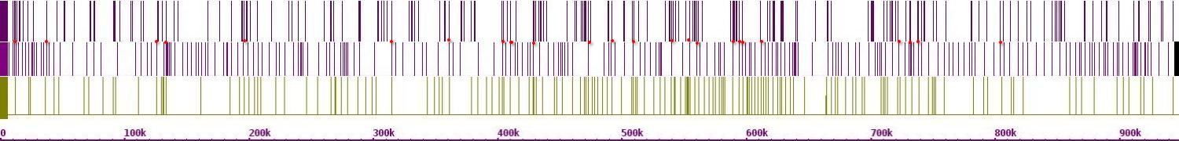

Chr 11(r)

Chr 11(h)

Chr 16(h)

Fig.716. Crosslinks between chr 16 and chr 11

Chr 12(r)

Chr 12(h)

Chr 16(h)

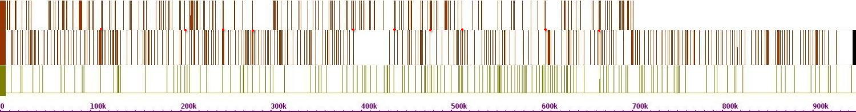

Fig.717. Crosslinks between chr 16 and chr 12

Ch13r(r)

Chr 13(h)

Chr 16(h)

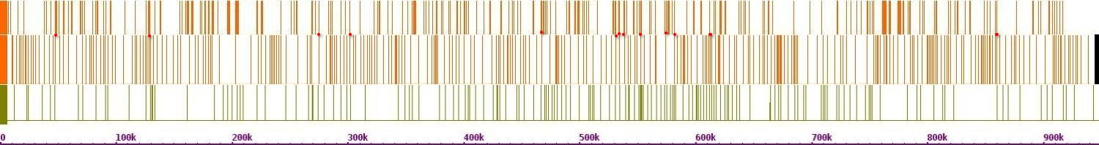

Fig.718. Crosslinks between chr 16 and chr 13

Chr 14(r)

Chr 14(h)

Chr 16(h)

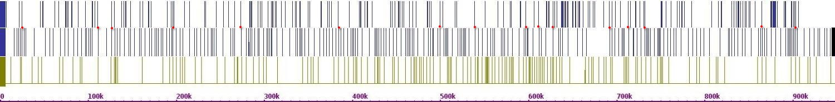

Fig.719. Crosslinks between chr 16 and chr 14

Chr 15(r)

Chr 15(h)

Chr 16(h)

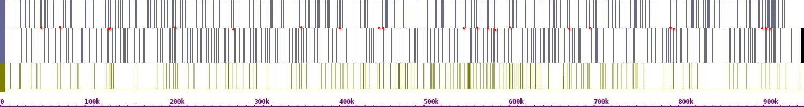

Fig.720. Crosslinks between chr 16 and chr 15

**Linear Regression Analysis**.

To determine the relationship between recombination hotspots and Hi-C contact points, linear regression analysis was done on all 16 chromosomes. The strength of the relationship was determined using the Spearman Rank-order coefficient and p-value. A strong positive monotonic relationship existed between the data points on all chromosomes except chromosome 16. The graphs for the analysis are shown below.

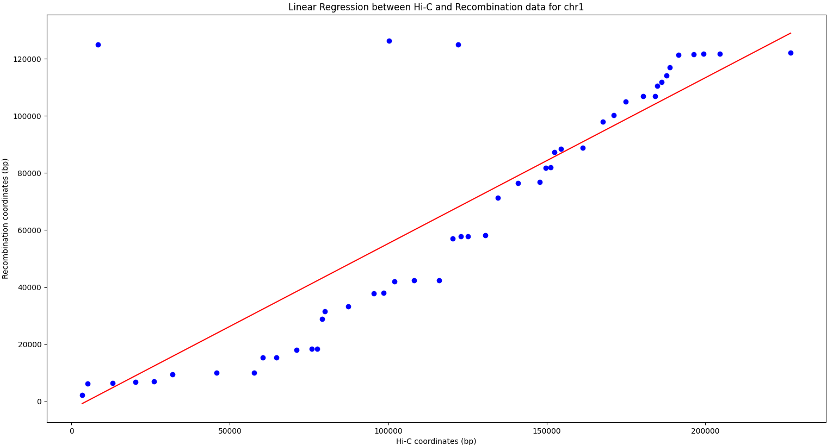Fig. 721. A strong correlation was observed between Recombination Hotspots and Hi-C contact points on chromosome 1 (Spearman's ρ = 0.82, p < 0.01)

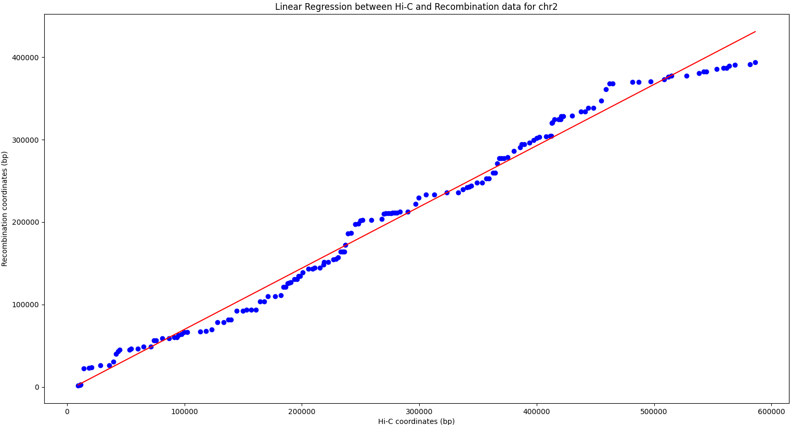

Fig. 722. A scatterplot of Recombination Hotspots and Hi-C Contact Points on chromosome 2 demonstrating a strong positive correlation (Spearman's ρ = 0.98, p < 0.01)

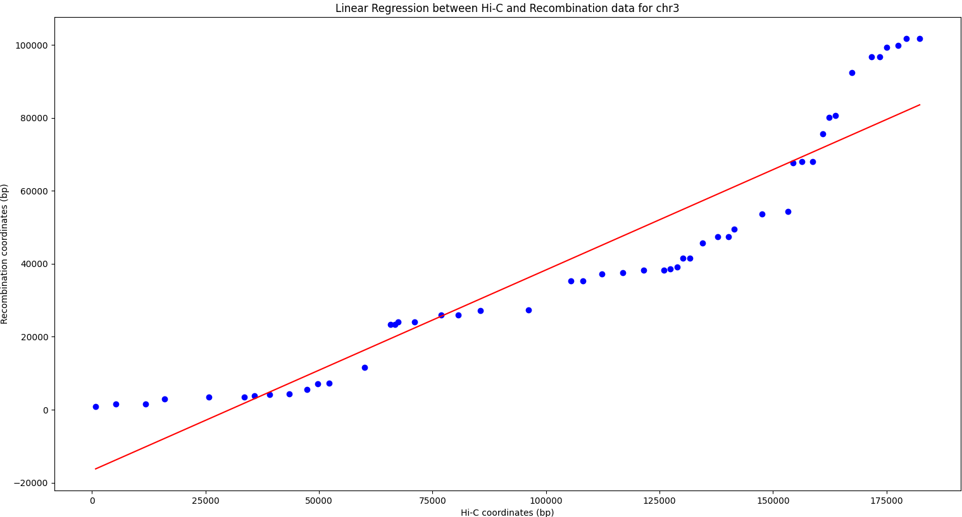

Fig. 723. A significant positive correlation observed between Recombination Hotspots and Hi-C contact frequencies on chromosome 3 (Spearman's ρ = 0.0.99, p < 0.01)

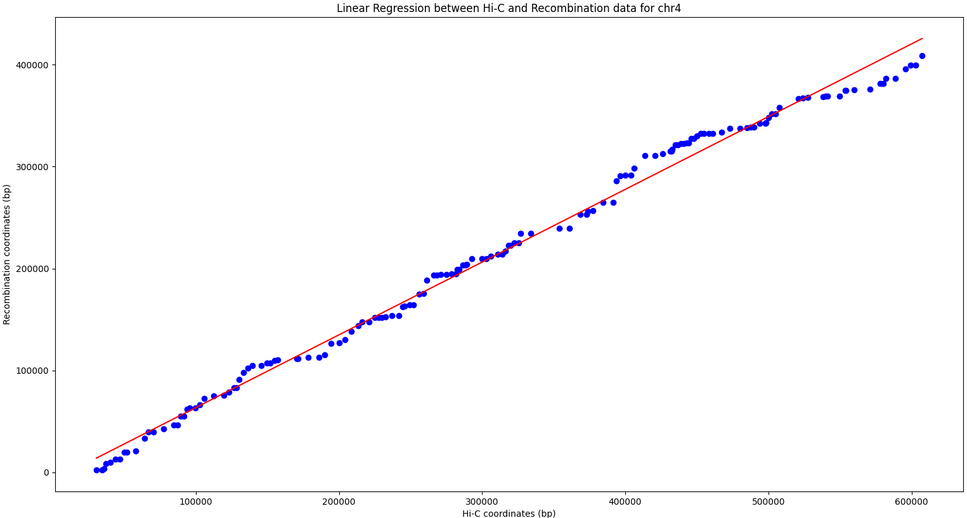

Fig. 724. Recombination Hotspots are strongly correlated with Hi-C contact points across chromosome 4 (Spearman Correlation Coefficient ρ = 0.99, p < 0.01)

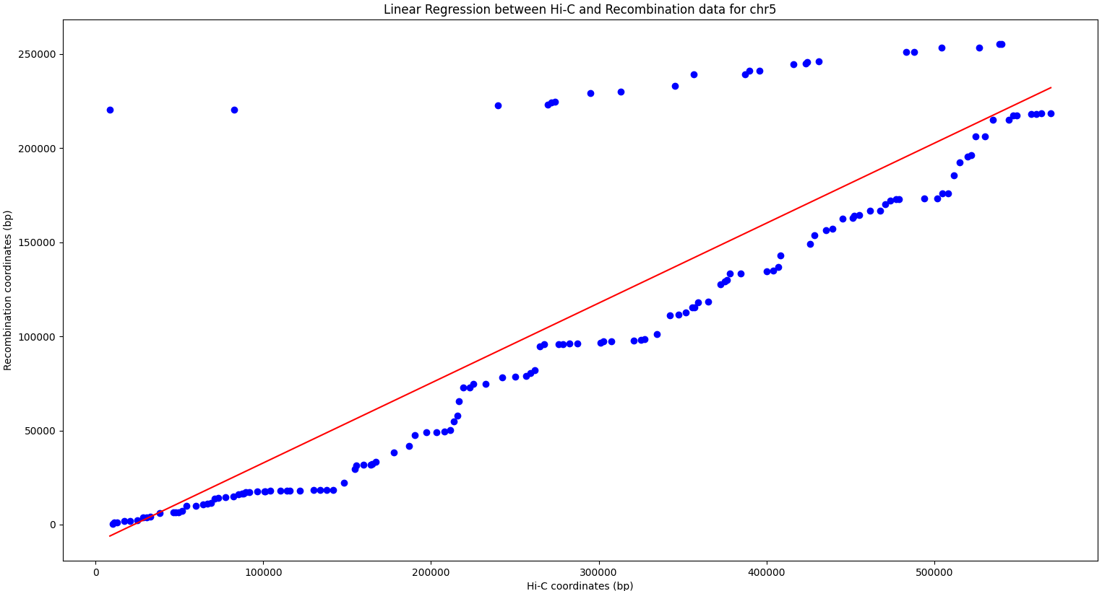

Fig. 725. Recombination Hotspots are strongly correlated with Hi-C contact points across chromosome 5 (Spearman Correlation Coefficient ρ = 0.86, p < 0.01)"

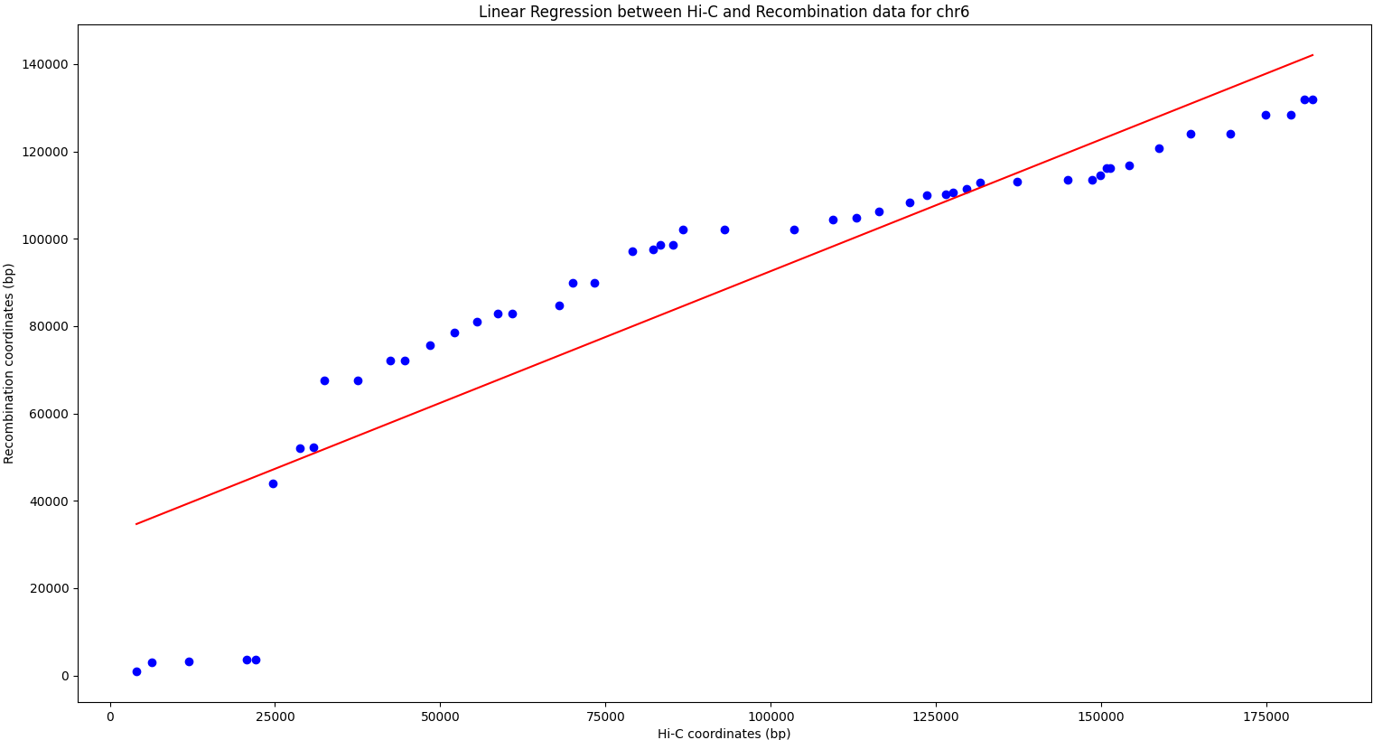

Fig. 726. A significant positive correlation was observed between Recombination Hotspots and Hi-C contact frequencies on chromosome 6 (Spearman's ρ = 0.99, p < 0.01)

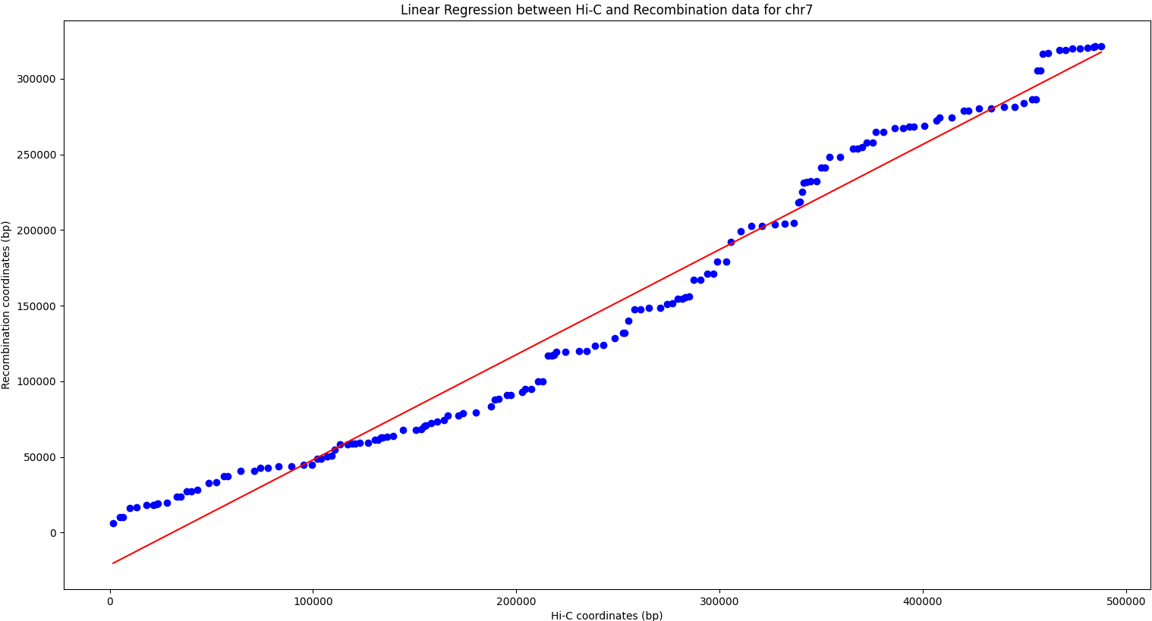

Fig. 727. Strong Correlation between Recombination Hotspots and Hi-C contact points on chromosome 7 (Spearman's ρ = 0.99, p < 0.01)

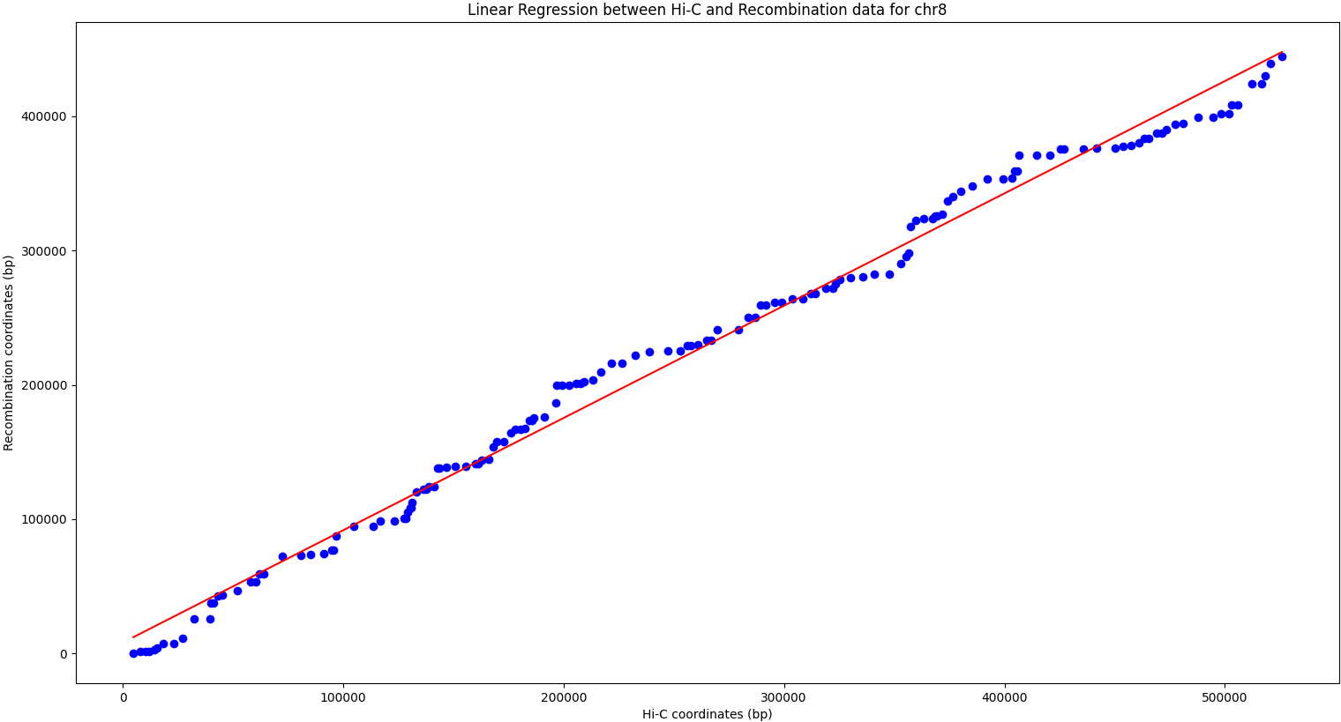

Fig. 728. Spearman Correlation analysis reveals a strong association between Recombination Hotspots and Hi-C contact points on chromosome 8 (ρ = 0.99, p < 0.01)

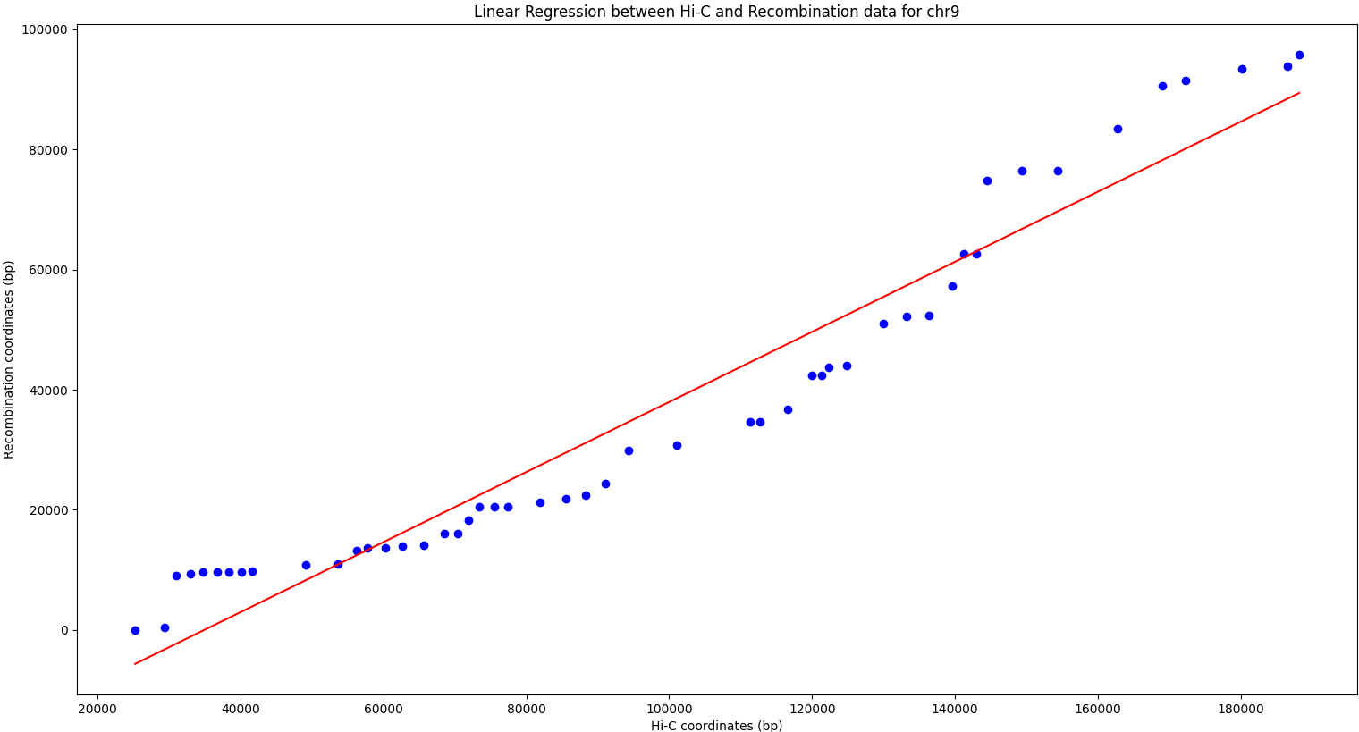

Fig. 729. A Spearman Correlation Analysis reveals a strong association between Recombination Hotspots and Hi-C contact points on chromosome 9 (ρ = 0.9, p < 0.01)

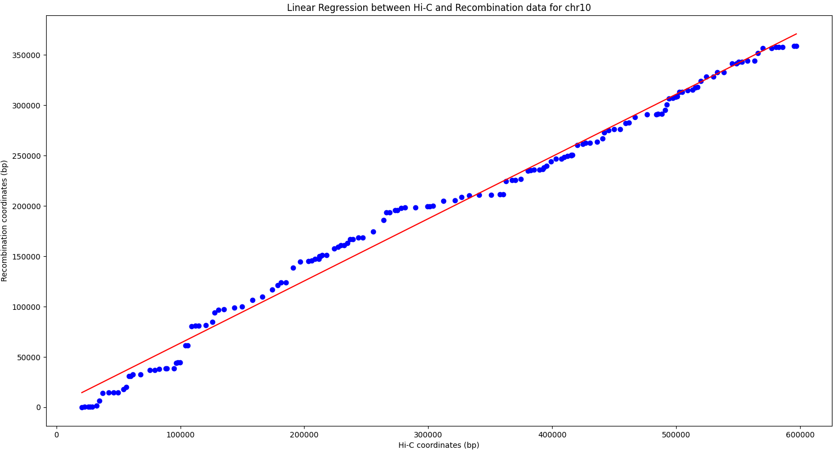

Fig. 730. Recombination Hotspots are strongly correlated with Hi-C contact Points across chromosome 10 (Spearman Correlation Coefficient ρ = 0.99, p < 0.01)

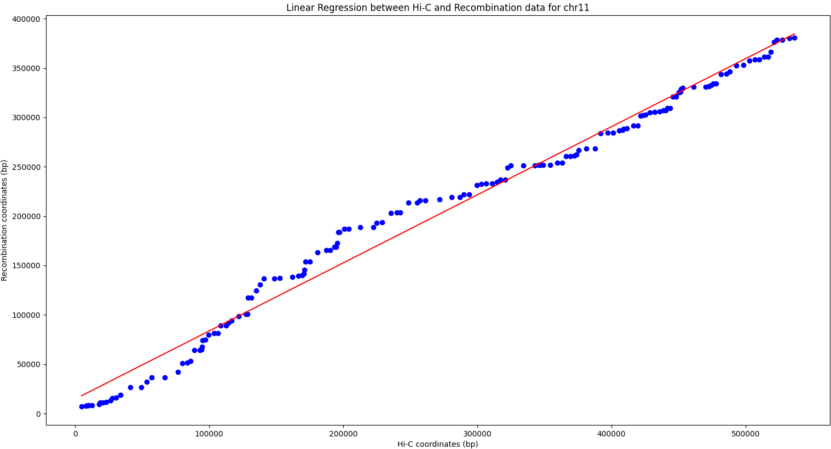

Fig. 731. Recombination Hotspots are also strongly correlated with Hi-C contact points across chromosome 11 (Spearman Correlation Coefficient ρ = 0.99, p < 0.01)

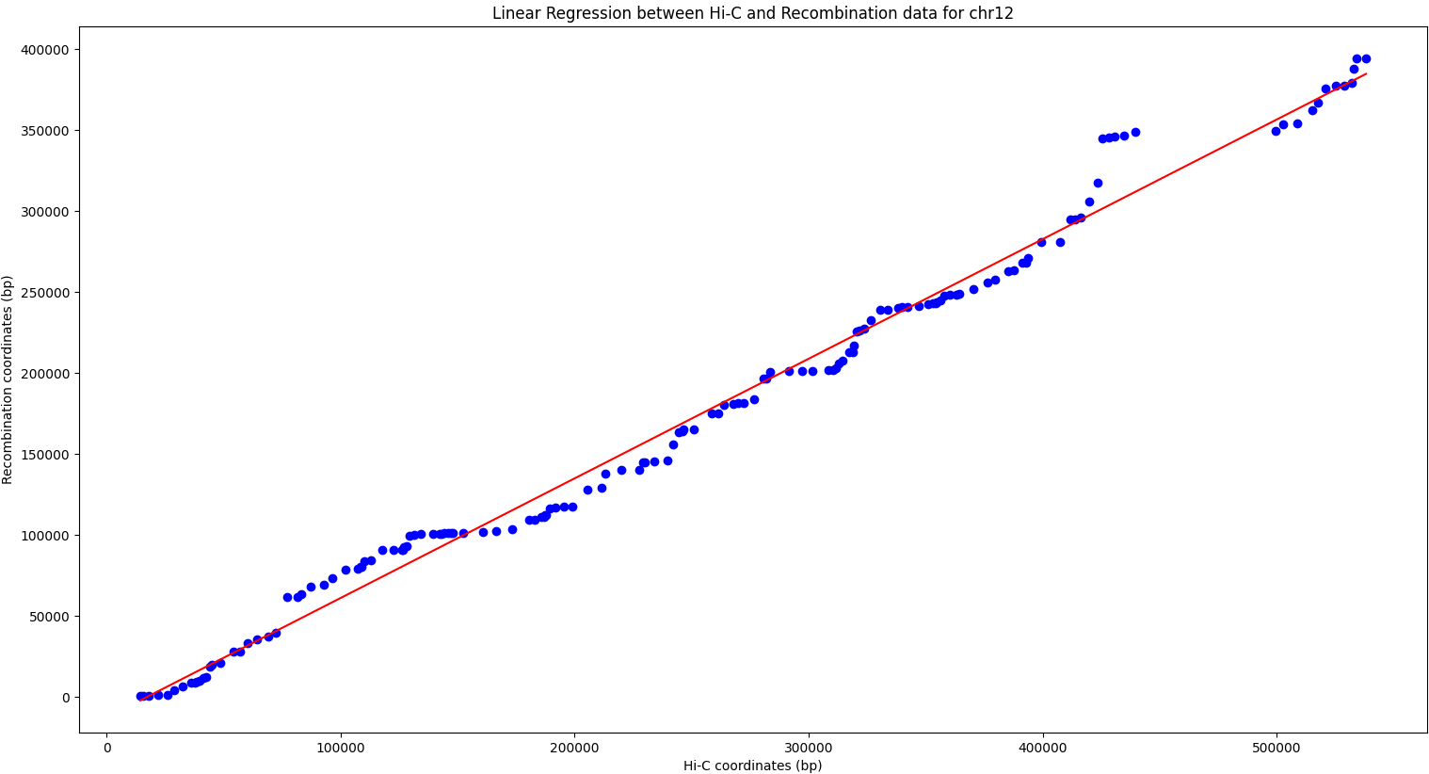

Fig. 732. Recombination Hotspots are strongly correlated with Hi-C contact points across chromosome 12 (Spearman Correlation Coefficient ρ = 0.99, p < 0.01)

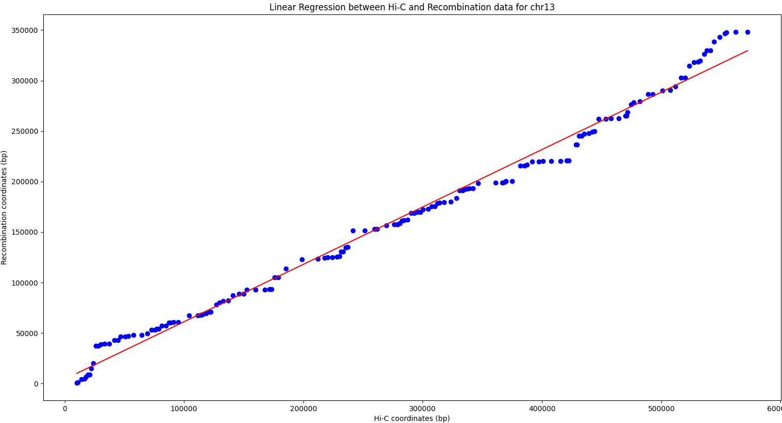

Fig. 733. Recombination Hotspots are strongly correlated with Hi-C contact points Across chromosome 13 (Spearman Correlation Coefficient ρ = 0.99, p < 0.01)

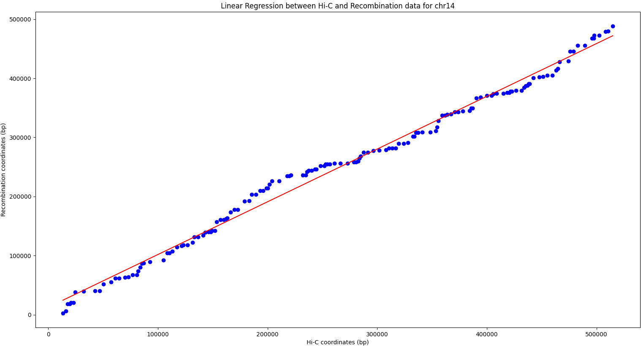

Fig. 734. A Scatterplot of Recombination Hotspots and Hi-C Contact Points on chromosome 14 demonstrating a strong positive correlation (Spearman's ρ = 0.99, p < 0.01)

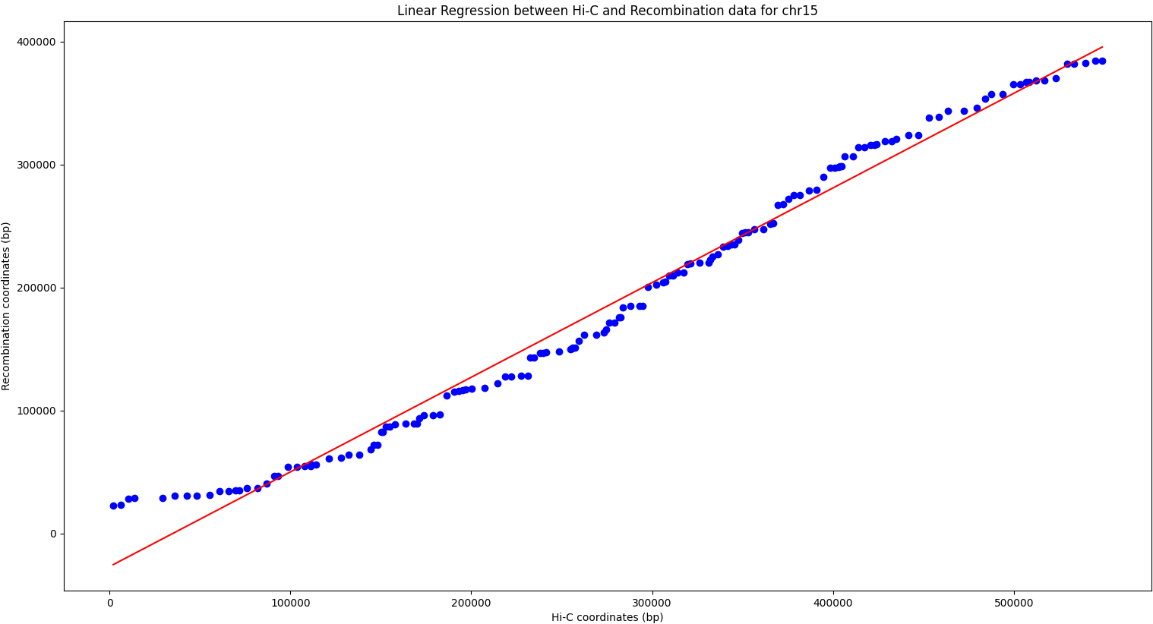

Fig. 735. A Scatterplot of Recombination Hotspots and Hi-C Contact Points on chromosome 15 demonstrating a strong positive correlation (Spearman's ρ = 0.98, p < 0.01)

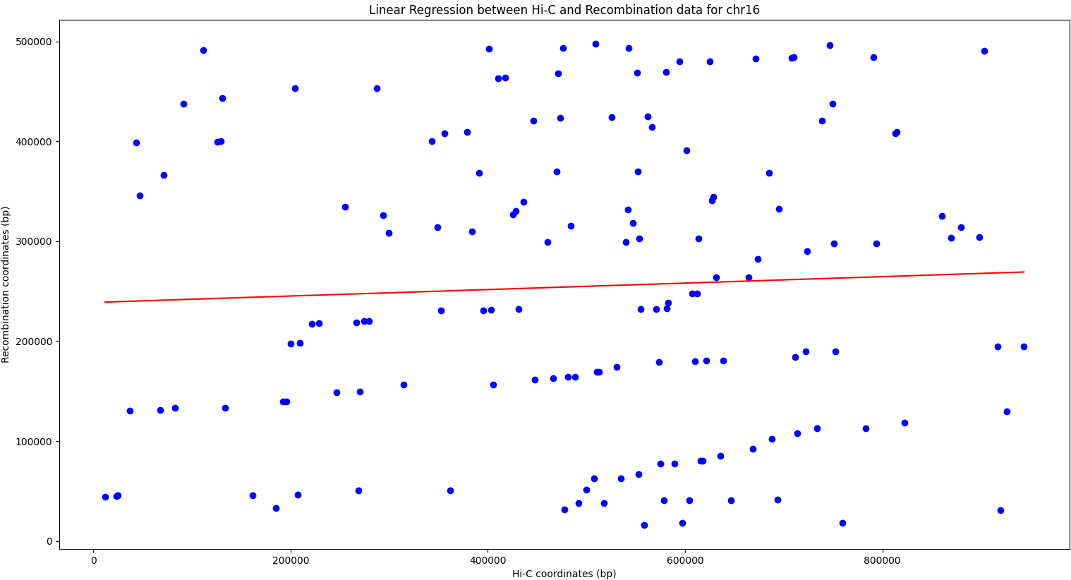

Fig. 735. A Scatterplot of Recombination Hotspots and Hi-C Contact Points on chromosome 16 demonstrating a weak Positive non-significant Correlation (Spearman's ρ = 0.02, p = 0.74)